Contents

DOCKER 2

Types of software architecture: 2

DOCKER INSTALLATION – 3 APPROACH 11

1. Docker in Linux machine (on Ubuntu) 11

2. Docker for windows 11

3. Docker playground 11

DOCKER installation Approach 1: Docker in Linux machine (on Ubuntu) 12

Docker archietecture workflow explained 15

Practical 1: Create 1st Container – Hello World 16

Docker archietecture workflow explained in SSH code 17

Practical 2 – Run Jenkin on docker container 17

Lets try creating a VM. 19

Practical 3: Creating a virtual Machine via Hypervisor. Just to see its downside (Outadated approach) 19

Practical 4: Create 2nd Container – Ubuntu 22

NGINX 26

Practical. Application 1: Pull and run nginx application with docker. 26

Practical. Application 2: Create a webserver – nginx application with docker 27

DOCKER FILE 34

Create Docker file 34

Now to create and build docker image 36

docker login 37

DOCKER PUSH 38

Change/give a name to image 38

Docker push 38

To Pull Docker 39

More Docker codes (advanced level) 40

Daily Operation activity of docker 42

Save img using tar file. 42

Docker workflow explained 43

Trouble shooting/Monitoring commands: 43

# DOCKER

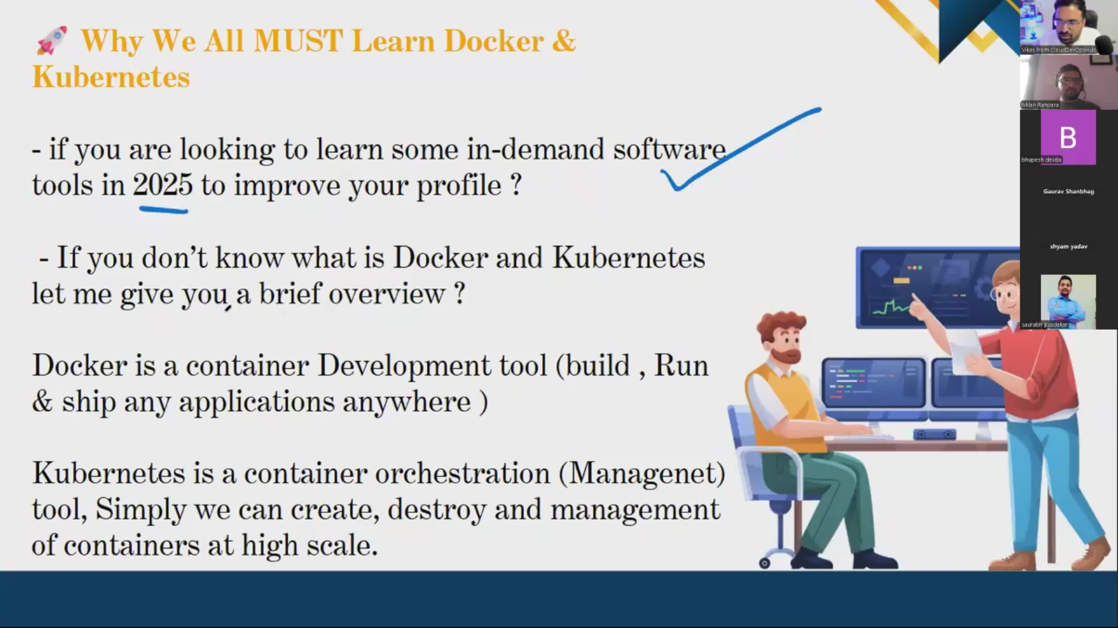

Docker image – binary dependancy config of runnning application is packed.

Commands:

Docker build - Docker image is published/built/Created with help of code form docker file.

docker push - Saved in docker hub

Docker pull – Pull/downloads the image from Docker hub.

Docker run – Pulls image+container creation (img becomes application/container) – running application.

If number/size of containers increase, multiple containers need a container management system – Kubernetes, need cloud to manage infrastructure.

Ex: Netfilx launches approx 3 million container per week

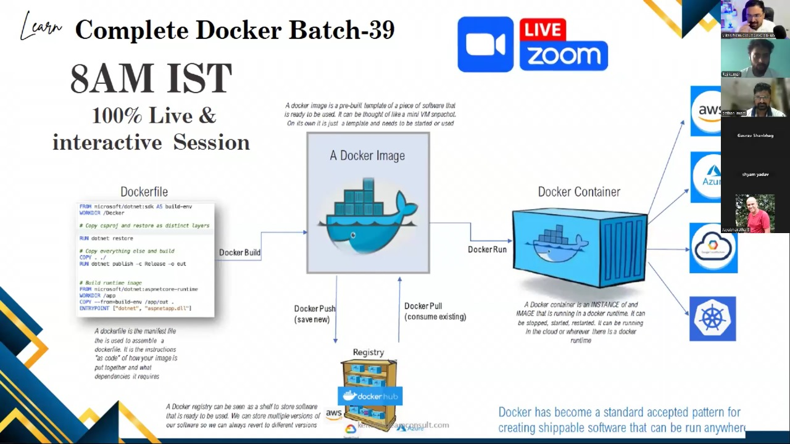

### Types of software architecture:

Event driven, layered, monolith, **microservise based**, master slave, MVC.

Lets conc on micro servise based arch cause its running in a containarized way and containers are running and created here.

Lets develop this architecture with help of containerisation in this section.

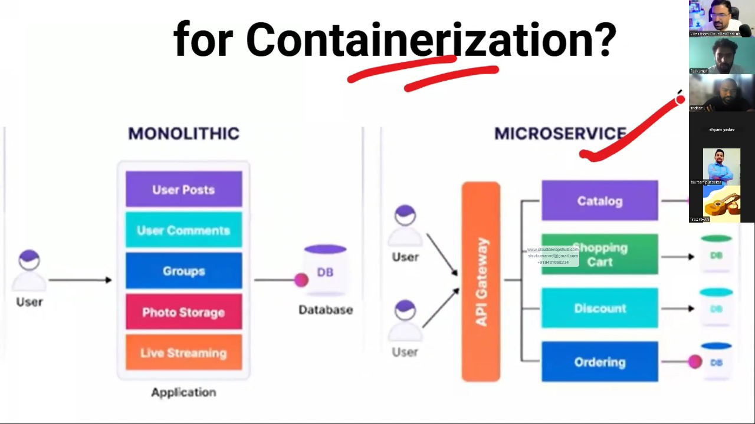

Why VM failed?

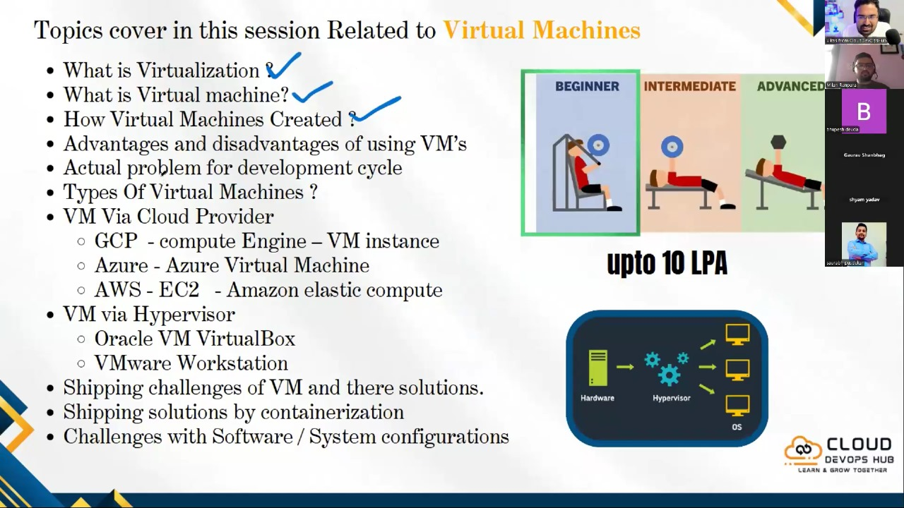

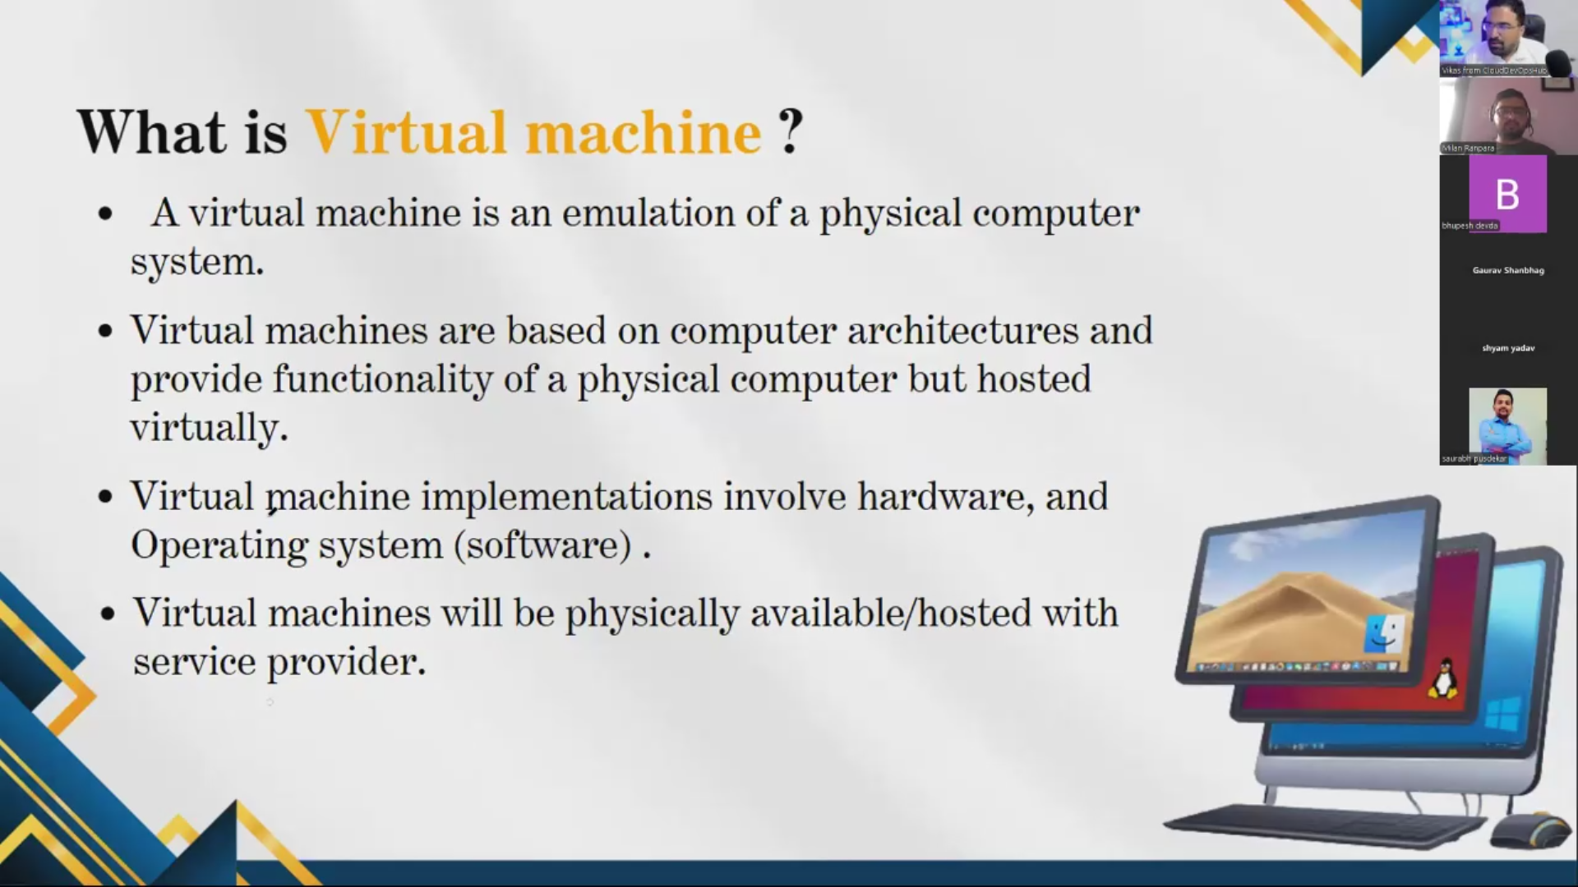

2 tools for hypervisor layer – VM ware, Oracle.

Over hypervisor, we need to create an OS, and App to have 1 VM = Node

Node - When an app or software is installed in VM its called Node.

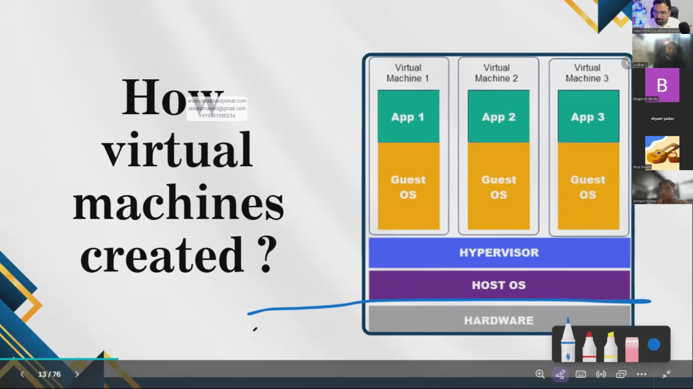

Use case? Why do we have to test in different VM environment?

When we have an app, we need to test in various environment. Not possible to test in doff machine, so its possible in VM.

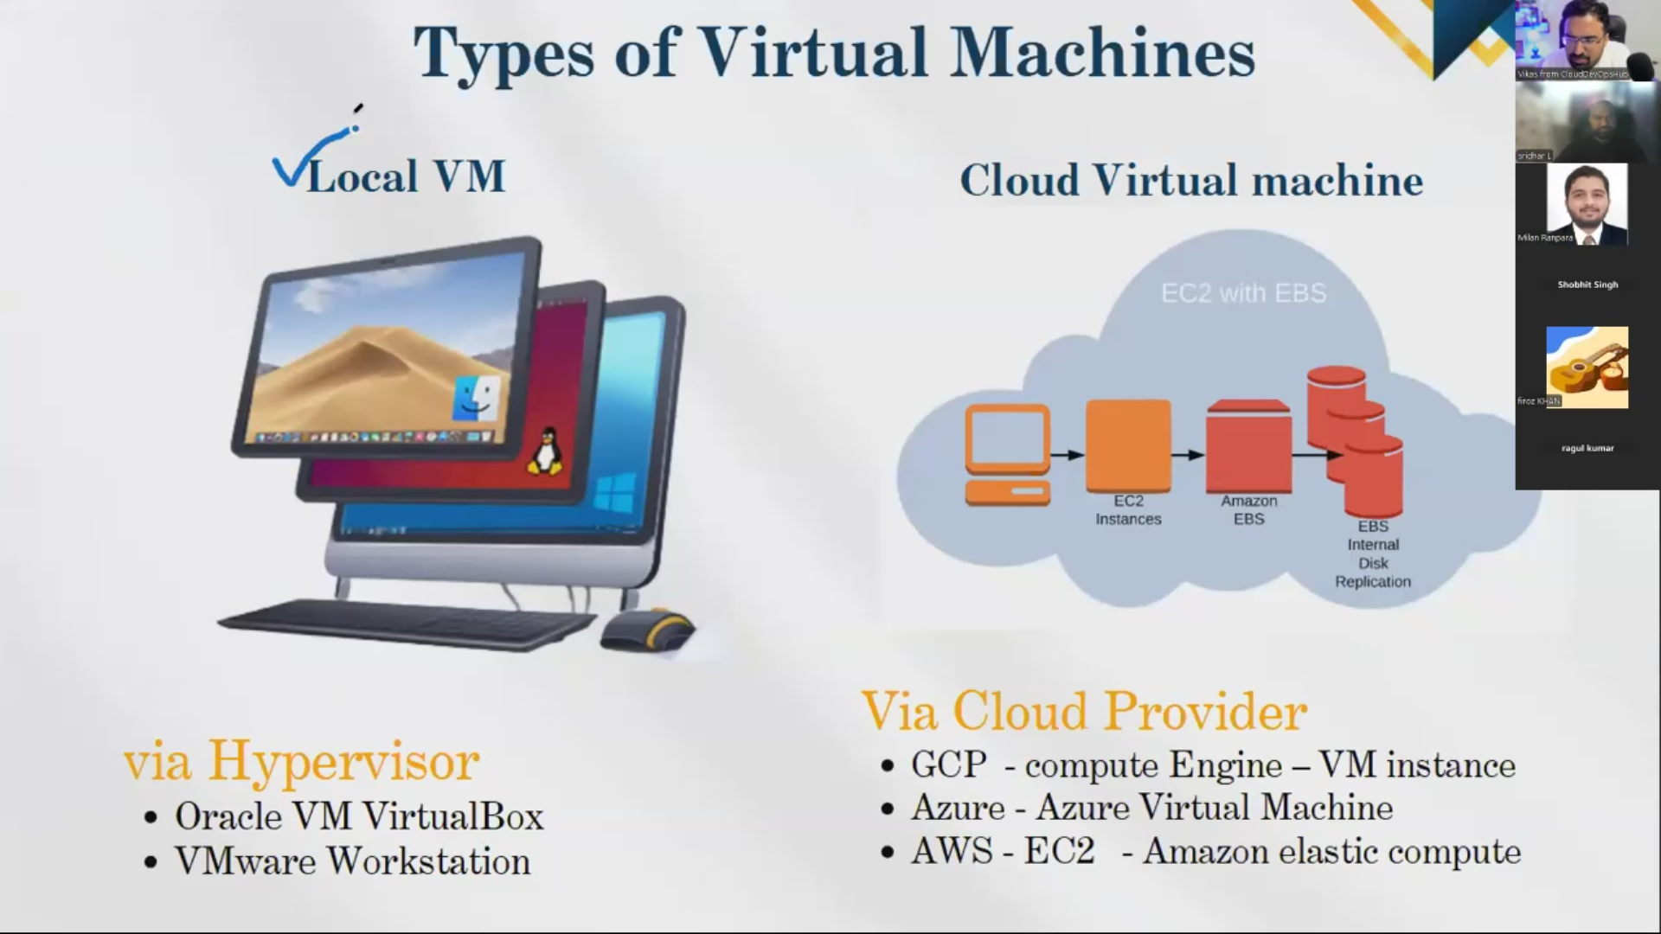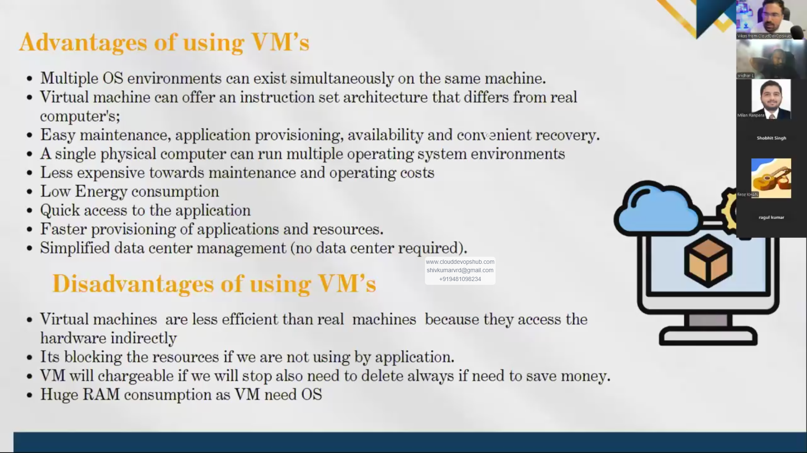

+ adv – can pick any number of machines to be created.

- Disadv – heavy, more size. Transportation is difficult. Takes more time to create.

Limitation of VM -> Hence docker.

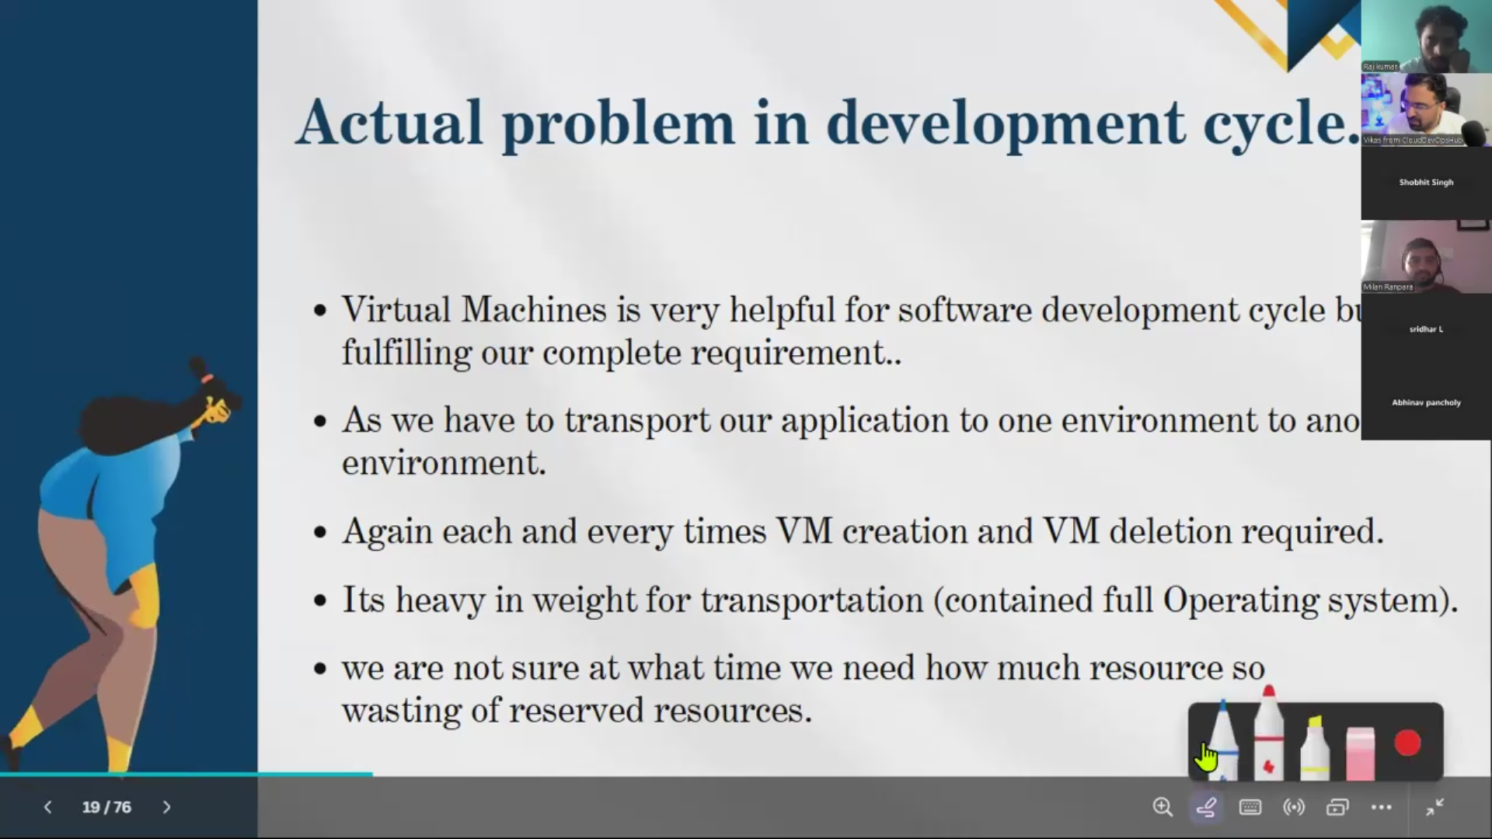

Dependencies:

Works only on heavy machine with 8GB RAM.

Virtualisation has to be enabled in computer.

Solution of VM is docker.

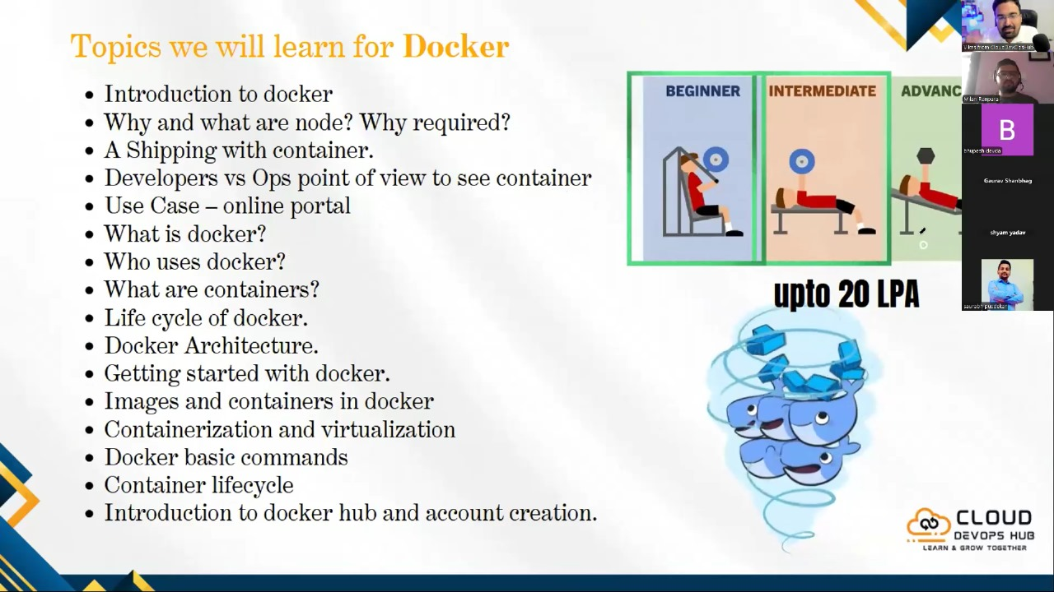

Node - When an app or software is installed in VM its called Node.

Why is node required? – If nodes are working, application softwares are available.

Shipping of container is possible with help of docker.

Use of docker? – It creates container, pack all binary dependency code, app config into image so it can be viewed in other platform. And is Lightweight.

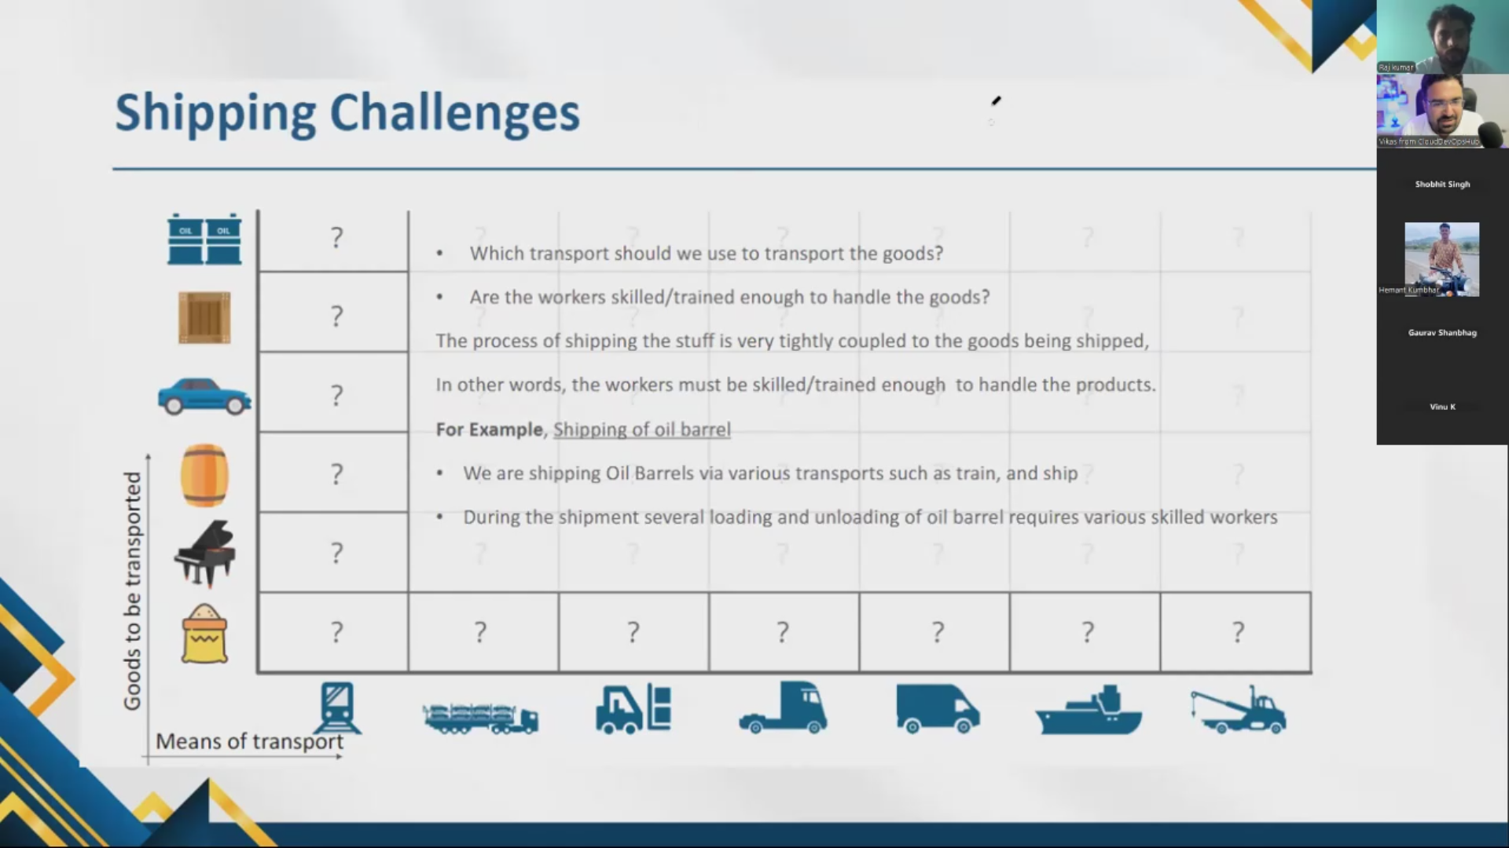

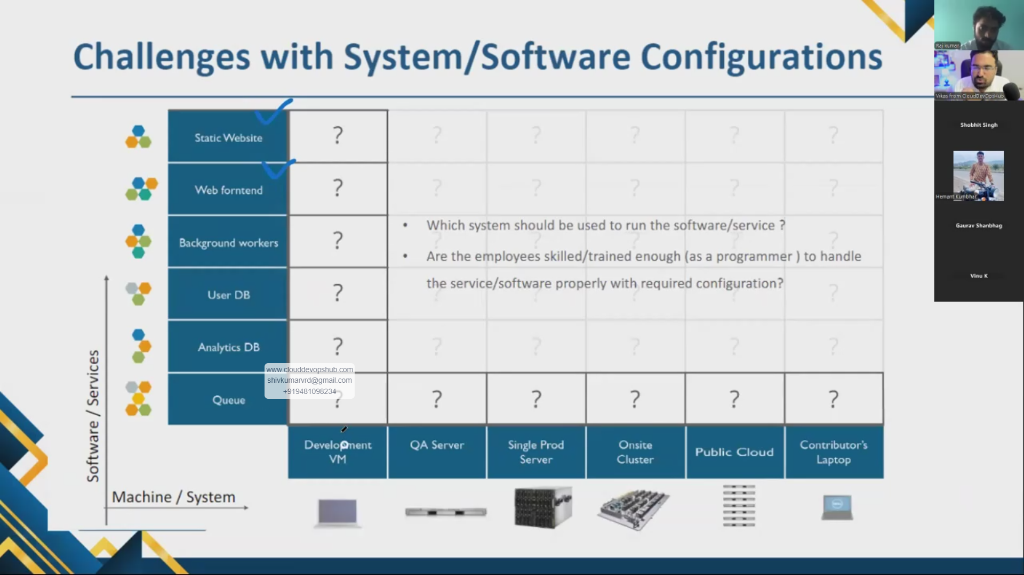

Put it in small small package and keep it in container. So security issues is sorted. So transportation of data is achievable. This is containerisation approach.

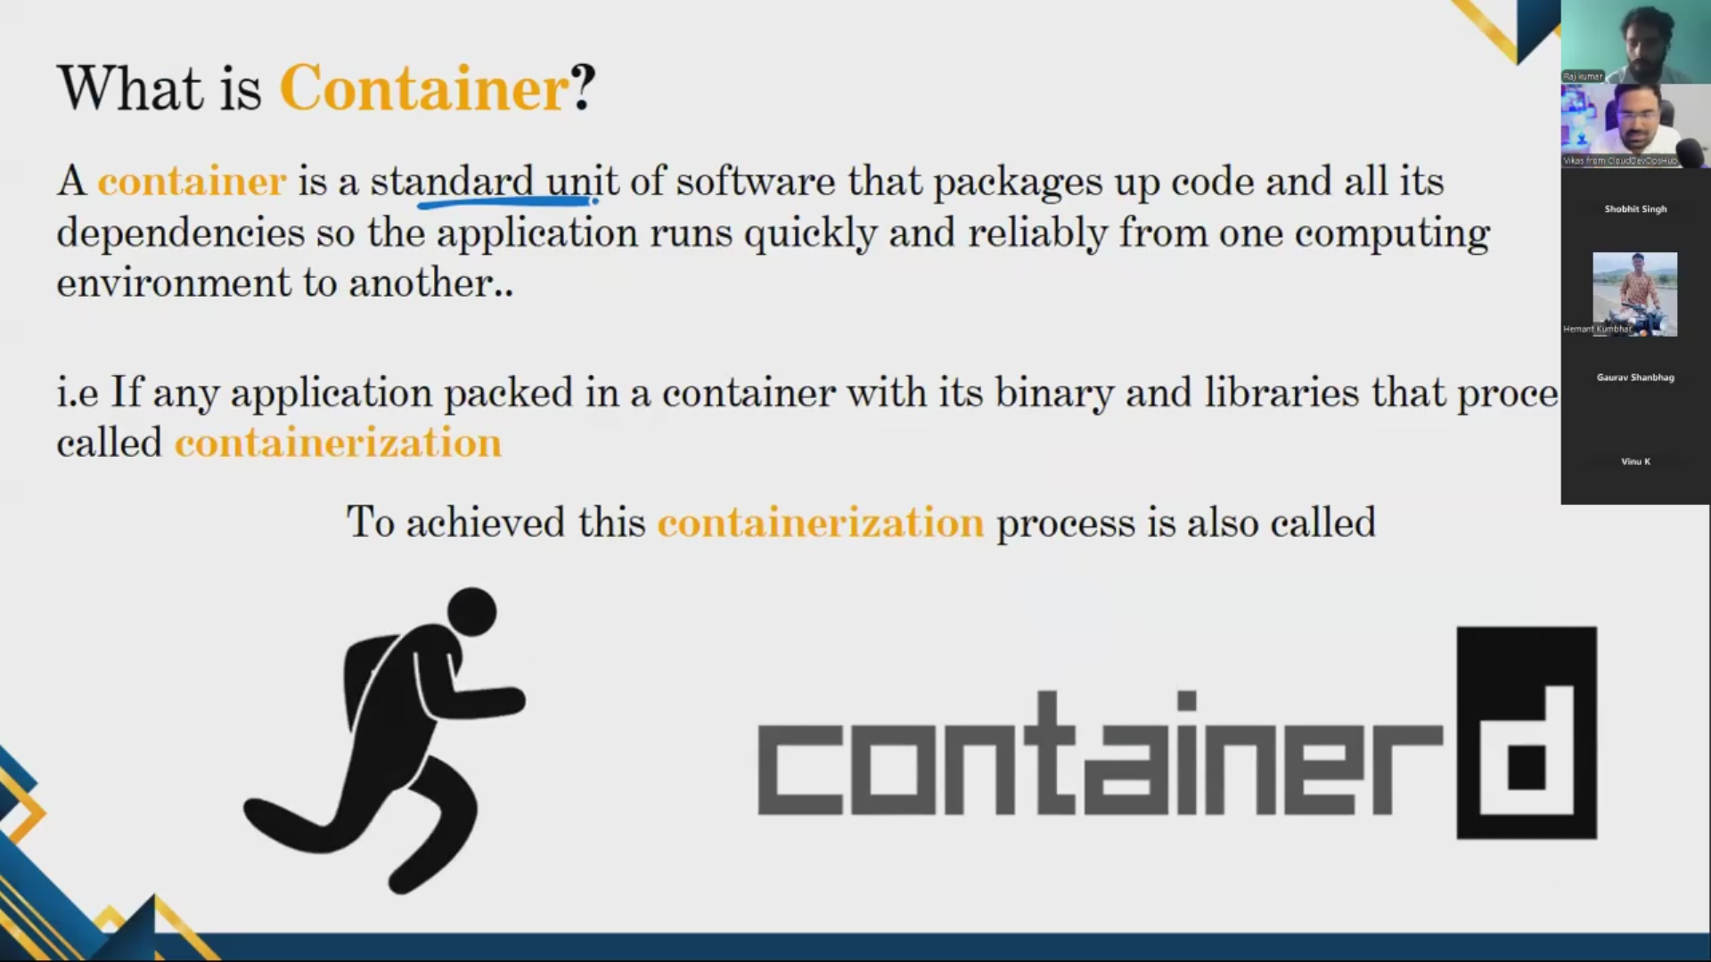

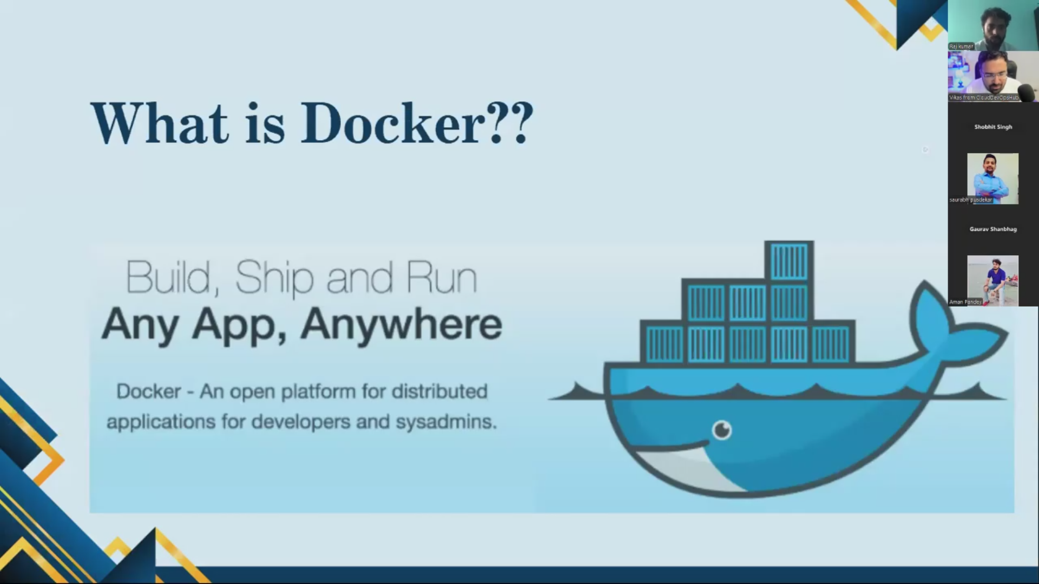 Why Docker? App working welling well in one environment (development env) might not work in another environment (ex: production env) due to dependencies like manual configuration.

Docker rules out all these manual config and packs everything in single img/single container and moves to new environment so dependency related issues is sorted and works well in all other environment.

Same application can be enables to run in Windows/ linux or MAC. How? Cause container has its own OS.

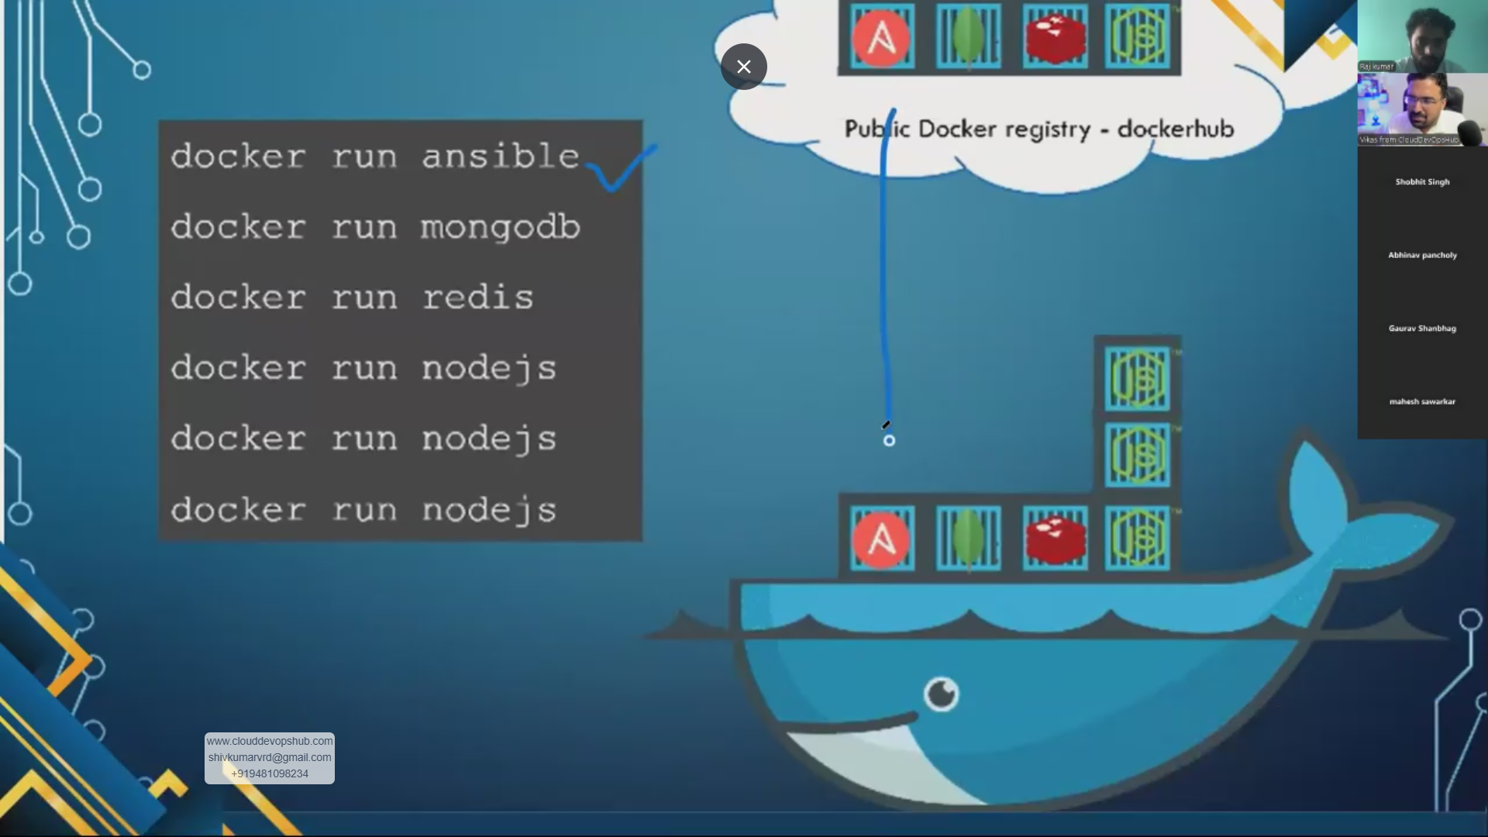

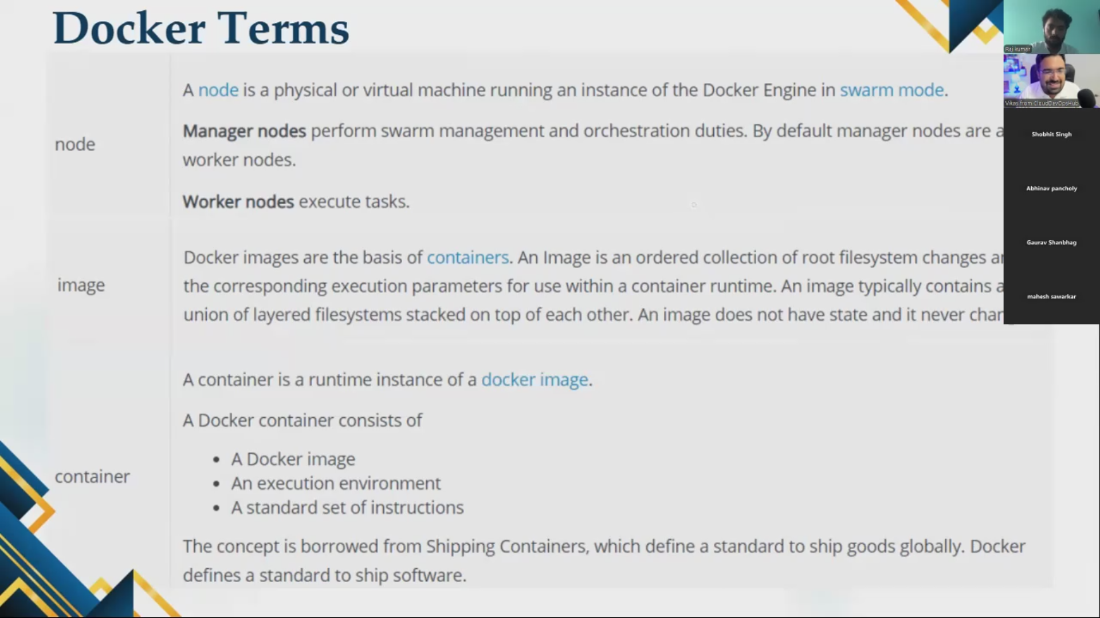

Node - When an app or software is installed in VM its called Node.

Image – template/config/blueprint how container looks like. It’s a static form of container.

Container – running image.

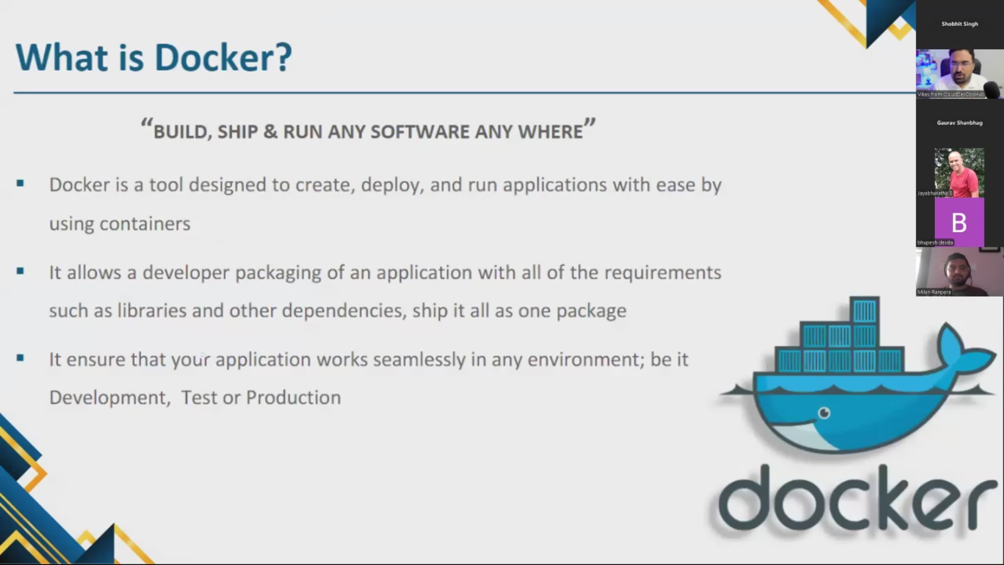

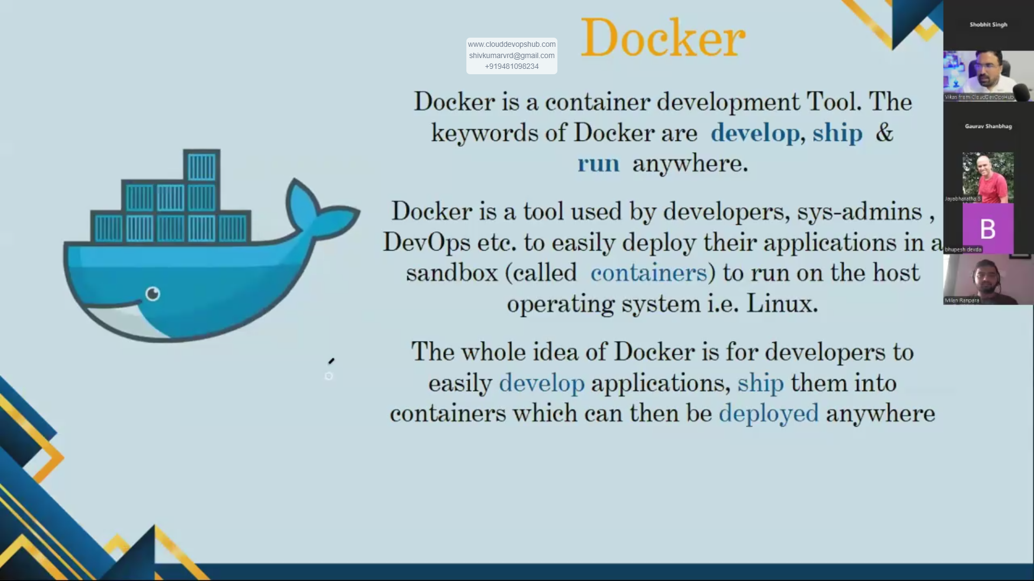

## DOCKER INSTALLATION – 3 APPROACH

### Docker in Linux machine (on Ubuntu)

### Docker for windows

### Docker playground

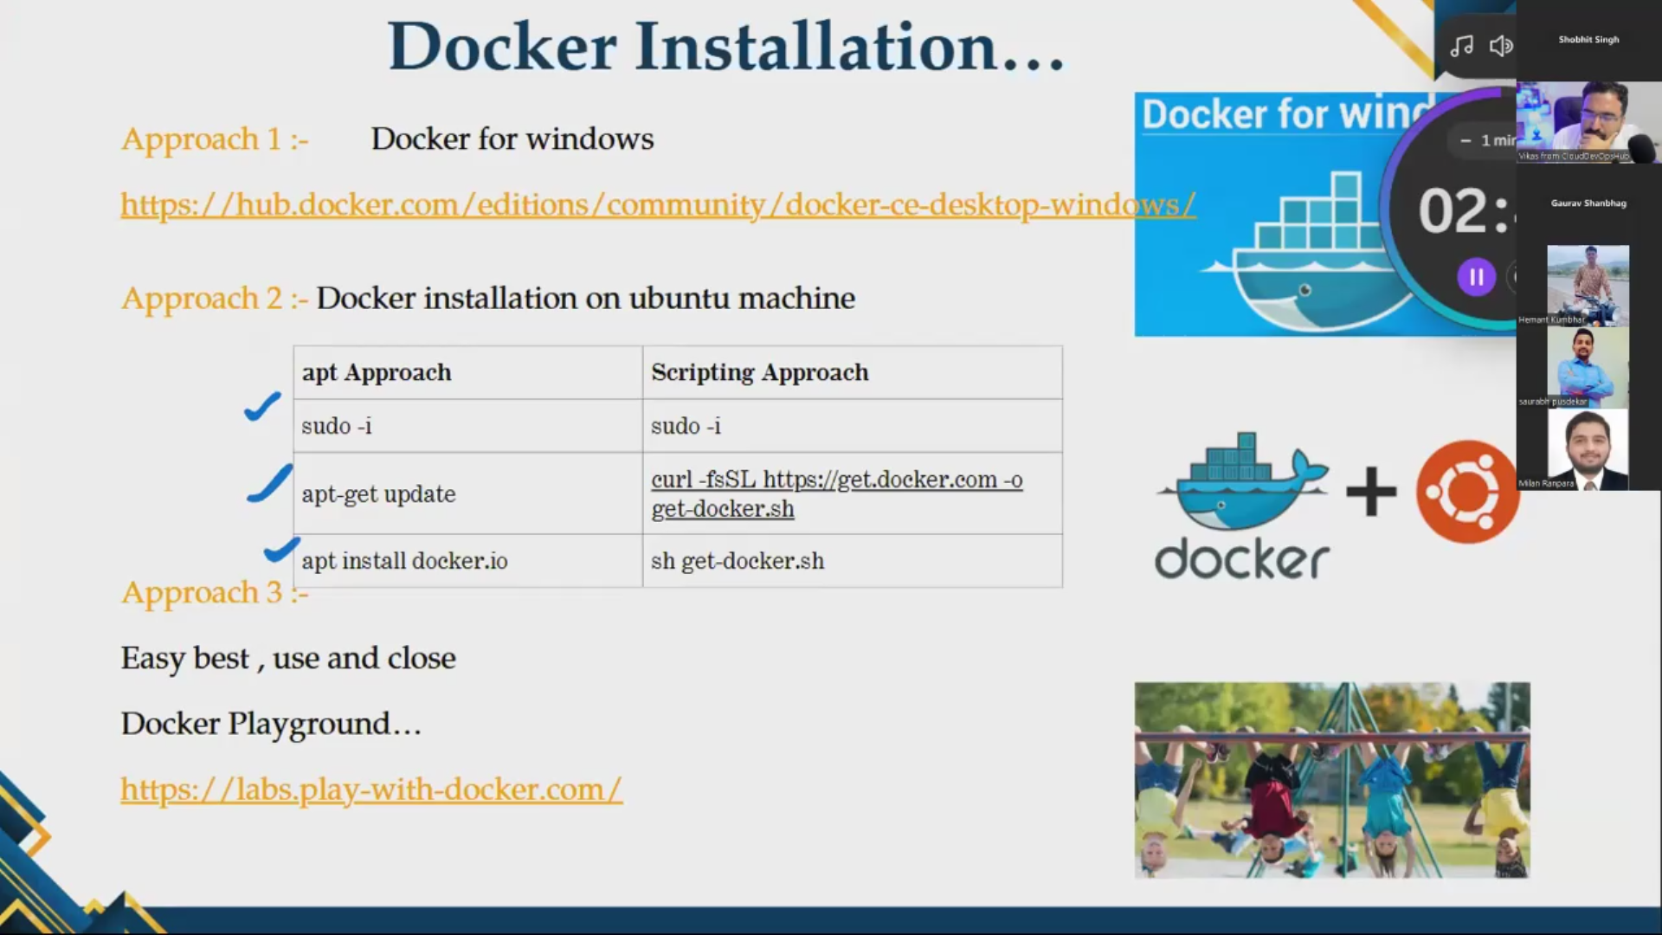

### DOCKER installation Approach 1: Docker in Linux machine (on Ubuntu)

#### 1.1 Docker in Linux machine (on Ubuntu) by apt approach

Practical:

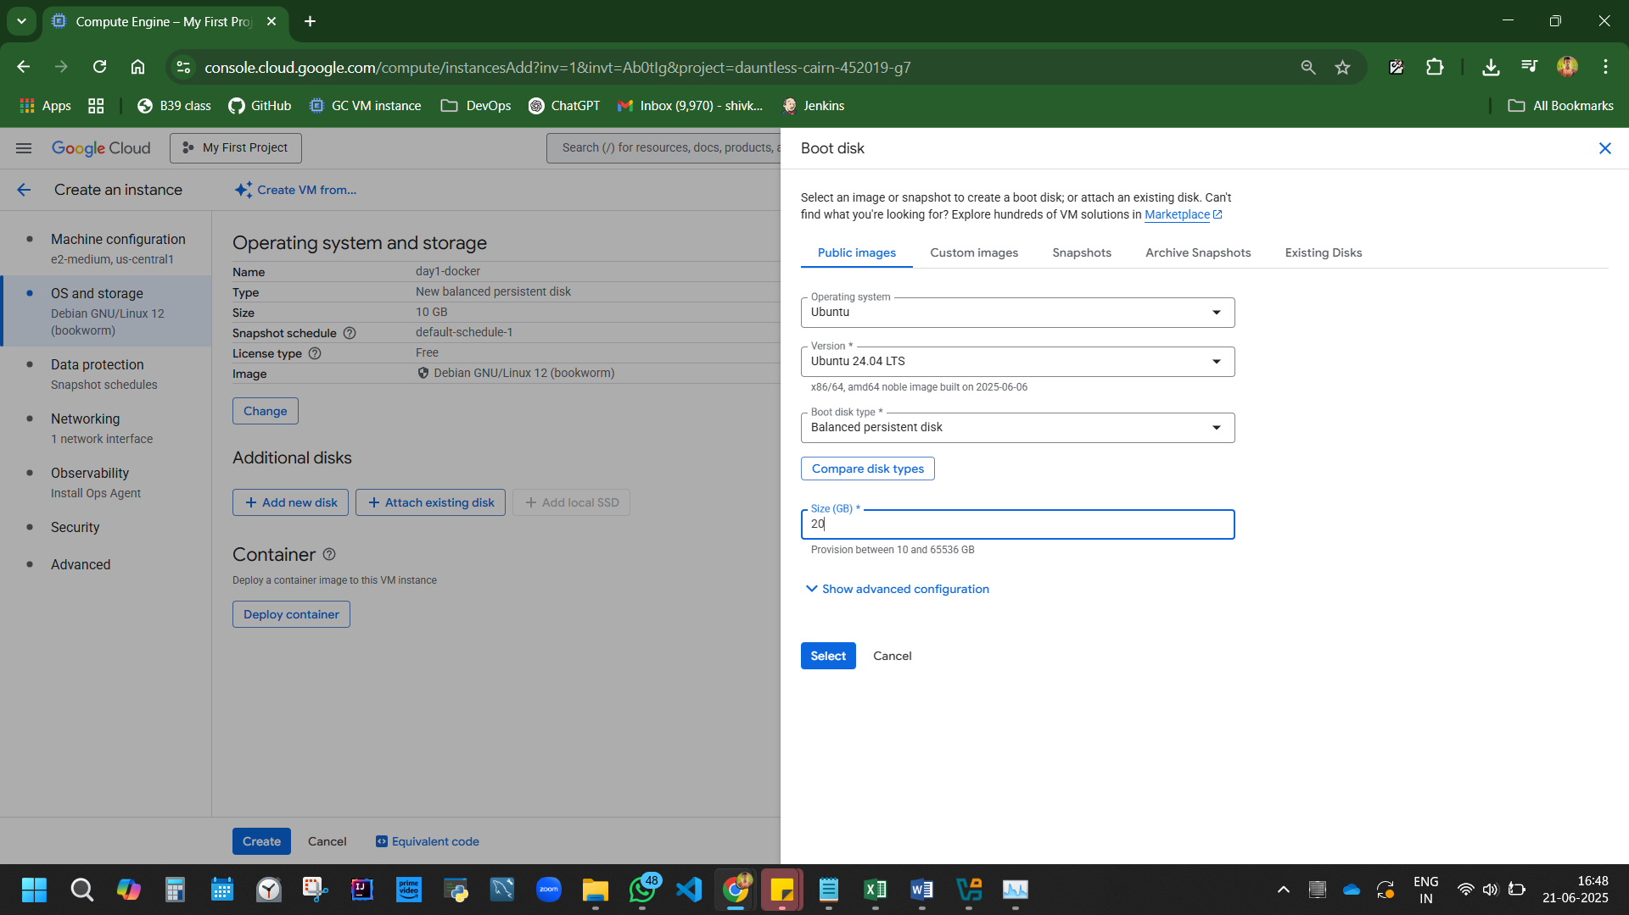

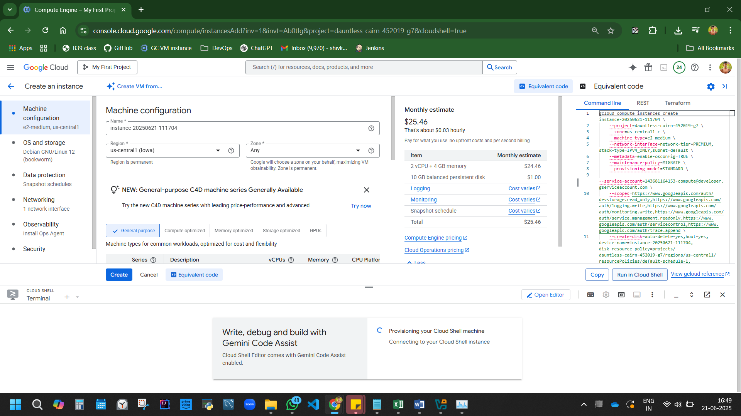

Copy and keep the code, so you don’t have to config and create instance eveytime to create VM.

How do you create VM? – have CLI, execute the code in shell.

Run in cloud shell>authorise>close terminal>back.

VM is created

Connect SSH

Code:

apt-get update

docker //type docker if you do not know command

apt install docker.io //use sudo as prefix if you are not root

sudo apt install docker.io

-y yes install.

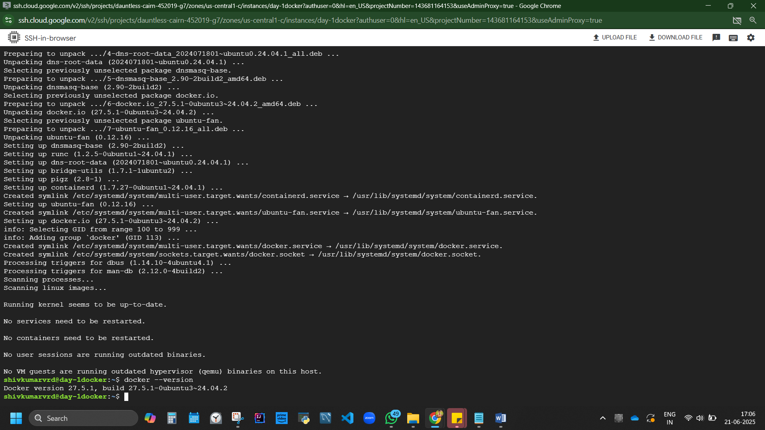

Figure 1 Docker installed

#### 1.2 Docker in Linux machine (on Ubuntu) by Scripting approach (preferred)



Create VM in Google cloud with Ubuntu LTS, 30gb, networking allow traffic.

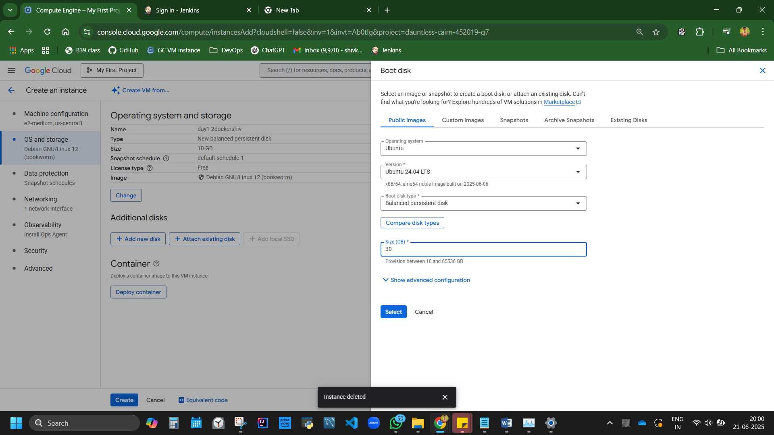

Connect SSH

Execute code:

curl -fsSL https://get.docker.com -o install-docker.sh

cat install-docker.sh

sh install-docker.sh

docker --version

Get script to install docker In any environment (Ubuntu, CentOS) <https://get.docker.com/>

Code from google explained:

# 1. download the script from the site

# $ curl -fsSL https://get.docker.com -o install-docker.sh

# 2. verify the script's content

# $ cat install-docker.sh

# 3. run the script with --dry-run to verify the steps it executes

# $ sh install-docker.sh --dry-run

# 4. run the script either as root, or using sudo to perform the installation.

# $ sudo sh install-docker.sh

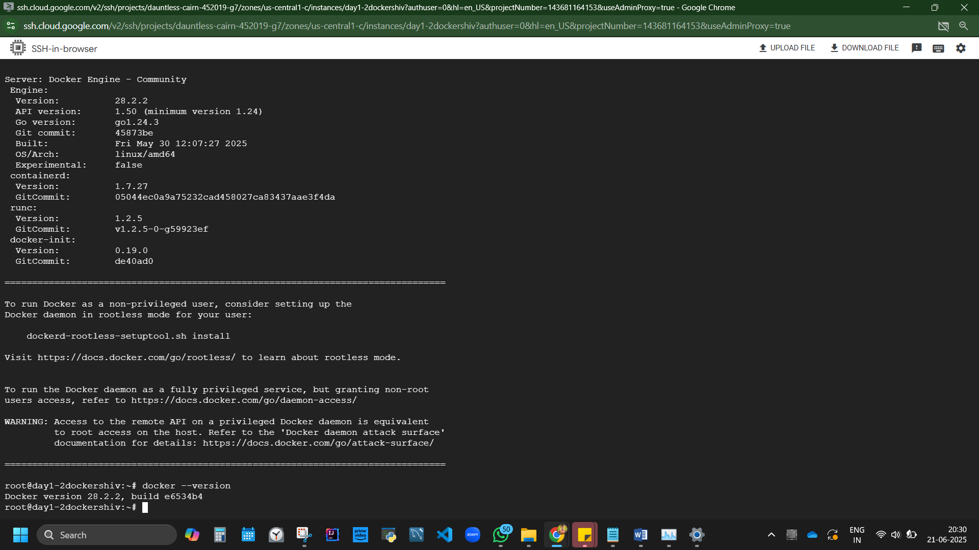

We get latest version.

Use case of Docker?

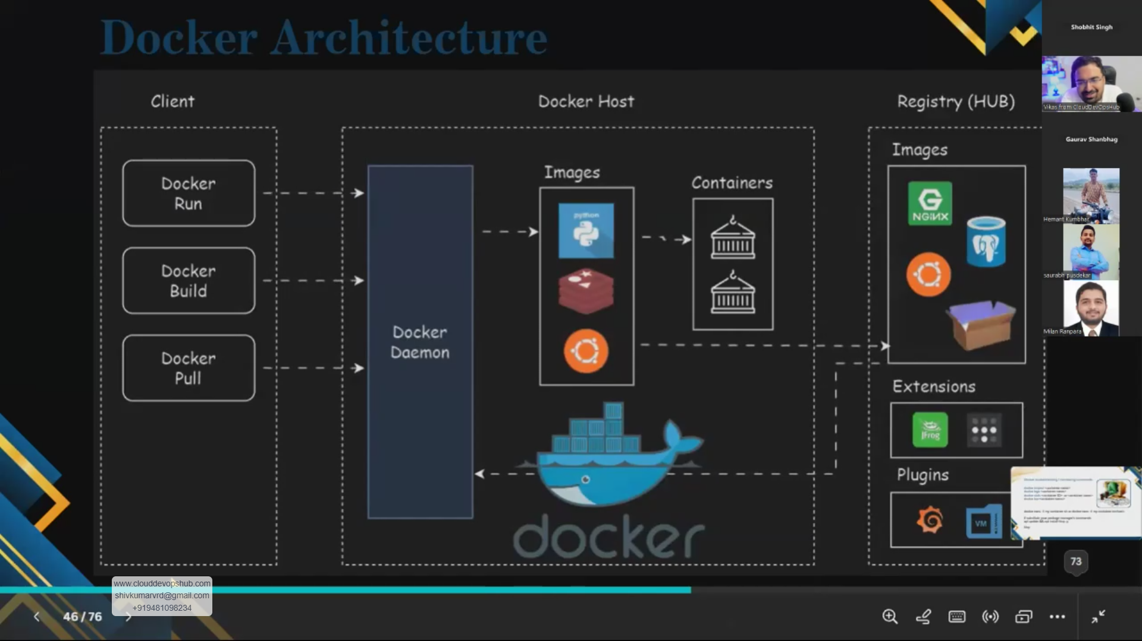

## Docker archietecture workflow explained

Client and docker = VM.

In VM, 1st terminal client side and host where docker daemon software is running.

We have 3 interface. Client interface, docker host, registry hub with img, ext, plugins.

Docker host convert cmd executed in client, based on the cmd (run, build, pull), it interacts with registry hub and perform activity.

When we run a docker pull command in termiinal, if goes to Docker daemon environment and checks for image, if it has image it pulls, if it doesn’t have img, it reaches to registry hub and check for image and pulls image from there and runs.

If we execute docker run, we need a container. Checks docker host for img if Y, gives image to to client with container output. If img is not there in docker host, it fetches it from reg hub and gets imag (container) from reg hub to client.

## Practical 1: Create 1st Container – Hello World

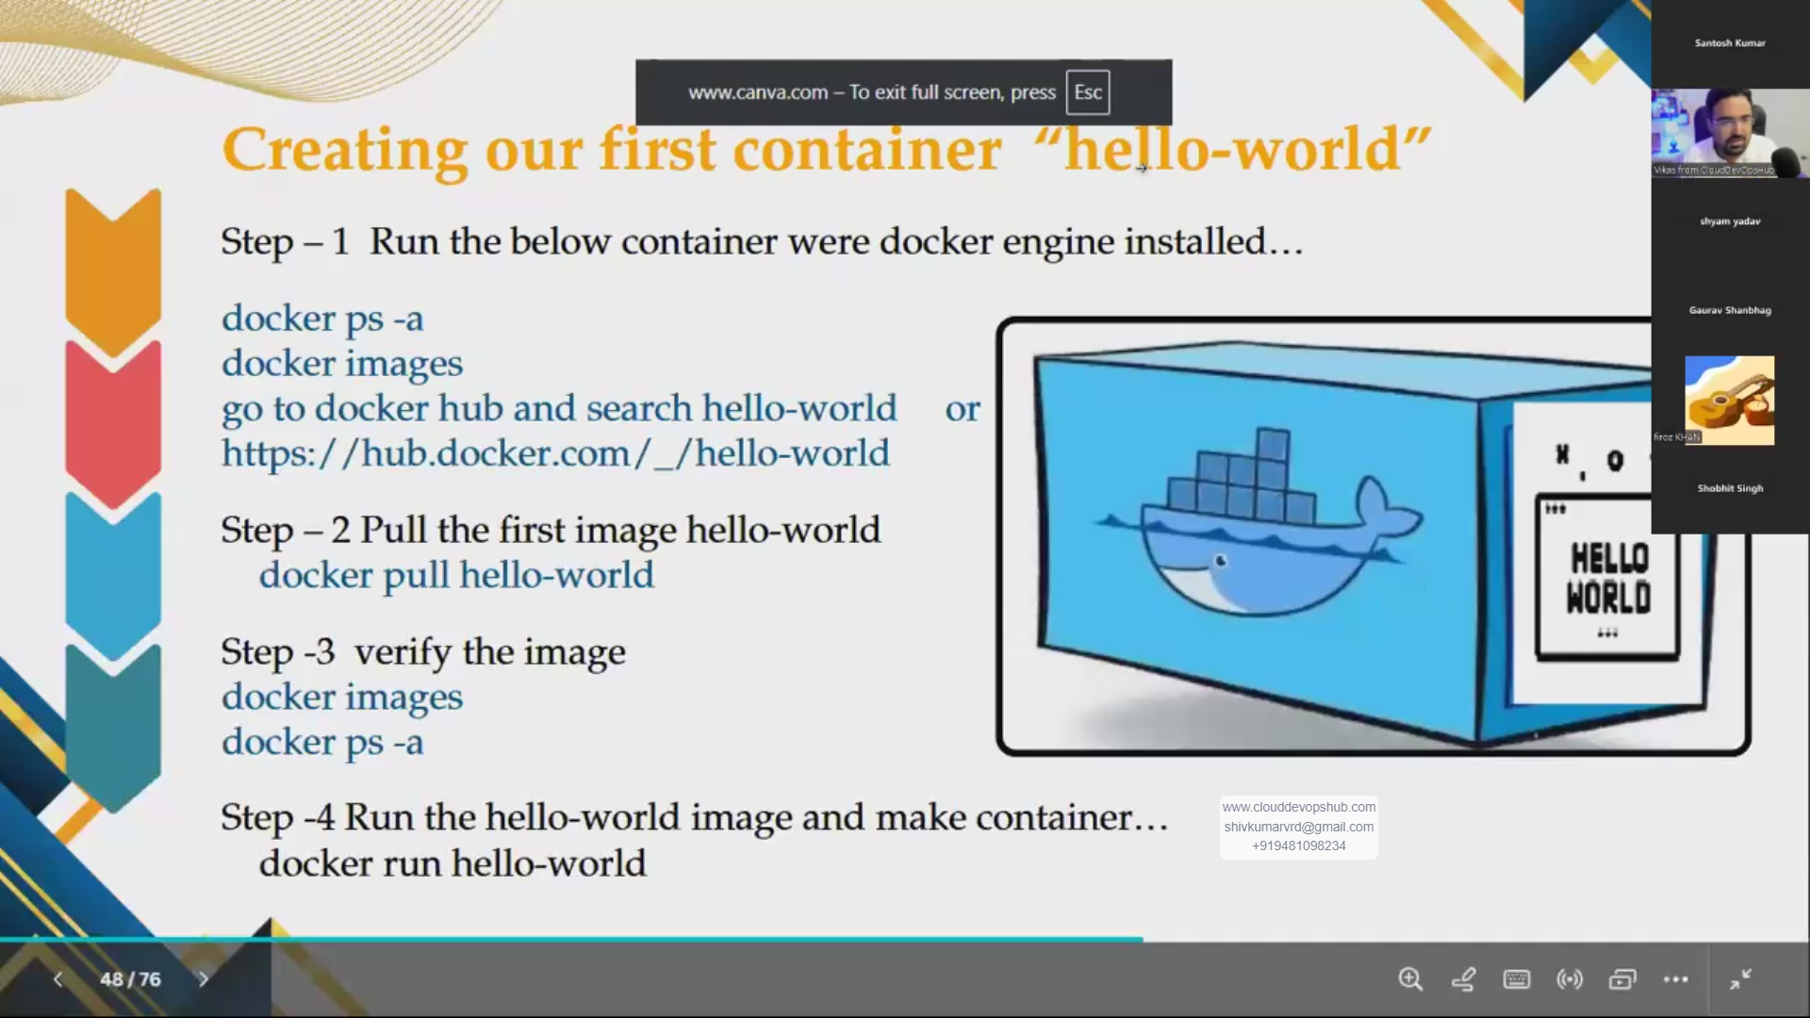

Code:

docker pull hello-world

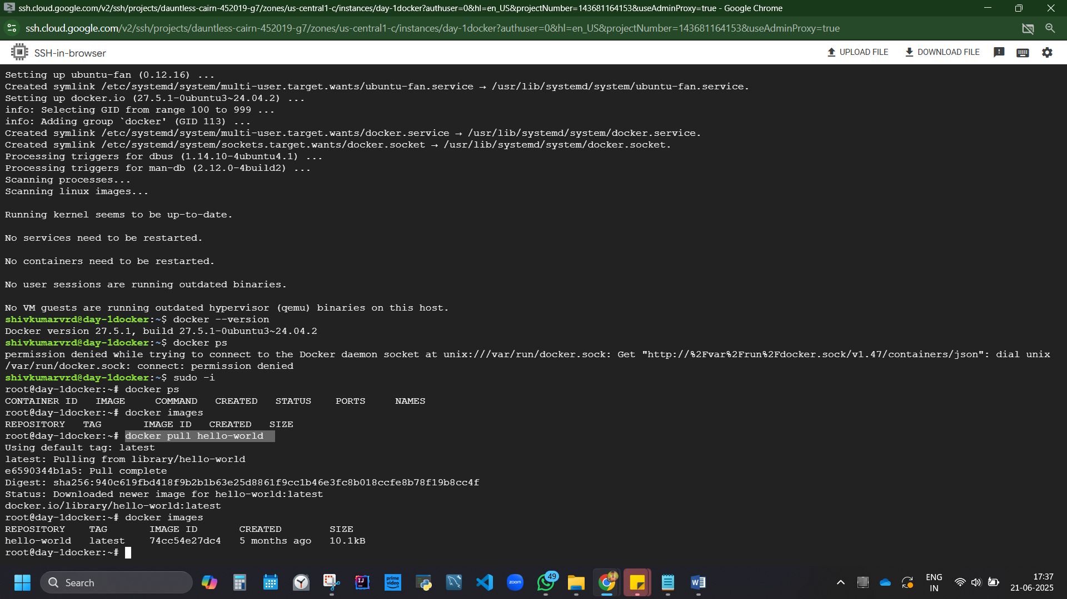

Figure 2 docker pull/download hello-world image

Docker run image:

docker run hello-world

docker ps – not seen, because container is created but not running. Gotto check in archieve

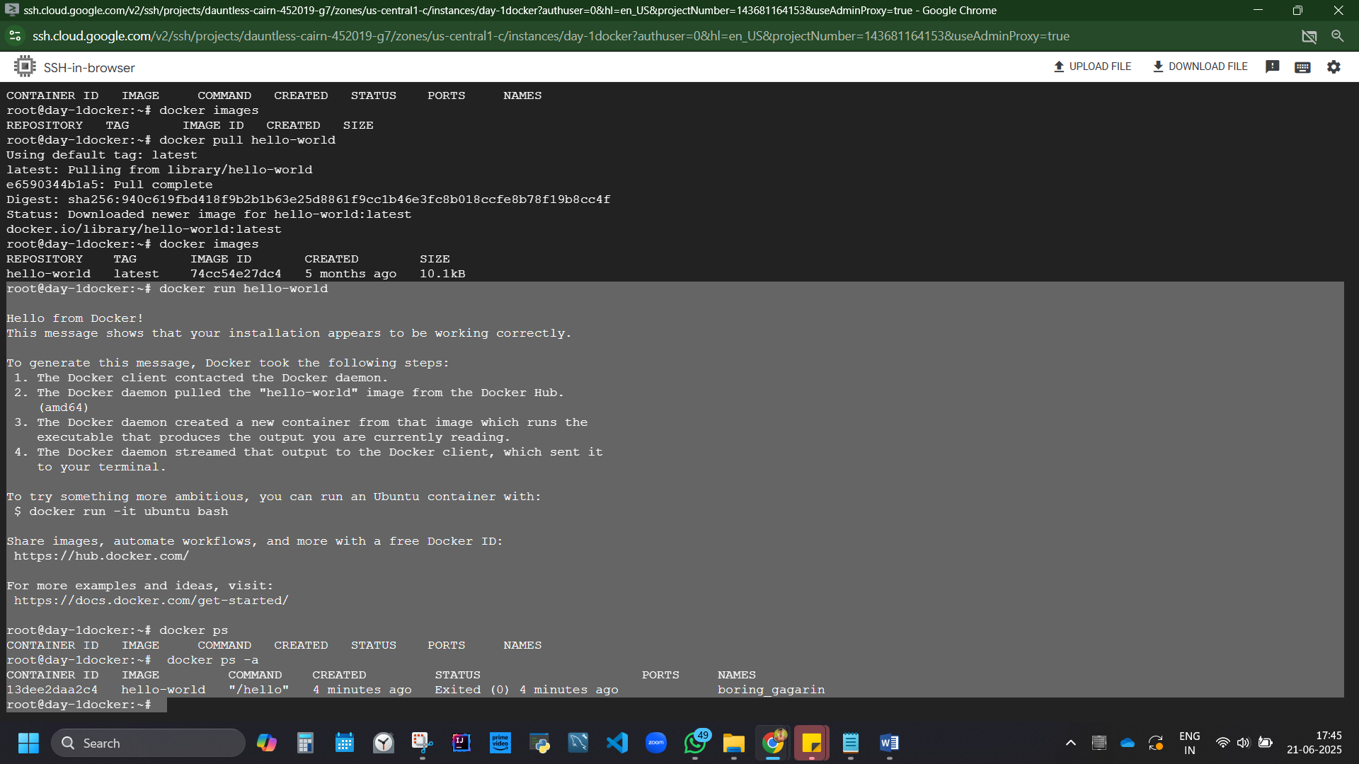

Understand the code:

docker ps //ps-current running process.

docker images //how many images are avialble?

docker pull //download image

docker run //gets container

docker run hello-world //runs image hello-world and becomes a container.

docker run <img name> -a //checks archieve

To generate this message, Docker took the following steps:

### Docker archietecture workflow explained in SSH code

1. The Docker client contacted the Docker daemon.

2. The Docker daemon pulled the "hello-world" image from the Docker Hub.

(amd64)

3. The Docker daemon created a new container from that image which runs the

executable that produces the output you are currently reading.

4. The Docker daemon streamed that output to the Docker client, which sent it

to your terminal.

## Practical 2 – Run Jenkin on docker container

docker run -it -d -p 8080:8080 jenkins/jenkins:latest

code explained:

it-interactive mode

-d detached, runs in backend

-p runs in 8080 port

SSH runs code:

Unable to find image 'jenkins/jenkins:latest' locally

So Docker daemon went to docker hub, downloading it, extracting, and fetching it to create a container.

To check – docker ps

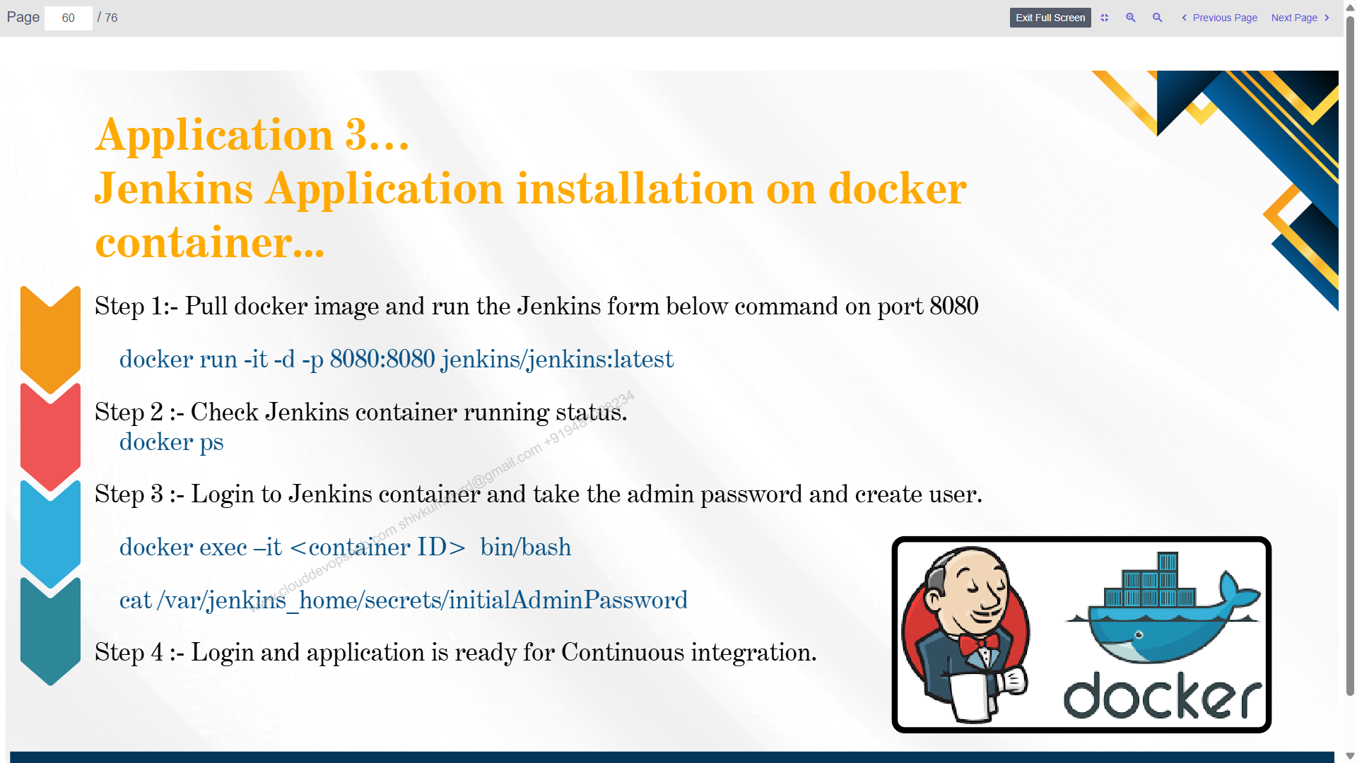

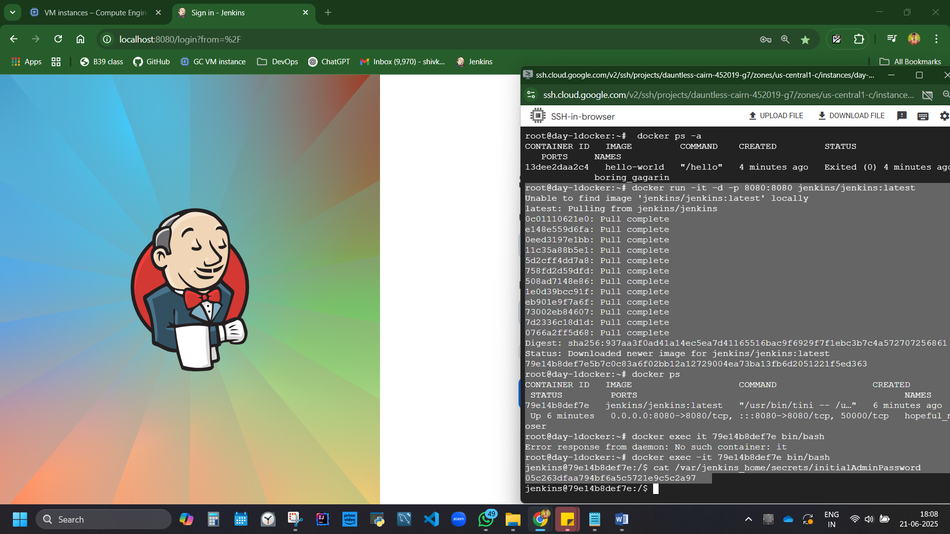

Unlock? 1st Go inside container

docker exec -it 79e14b8def7e bin/bash

the fetch password

cat /var/jenkins_home/secrets/initialAdminPassword

We are now using microservise based architecture for containerization for Kubernetes environment.

## Lets try creating a VM.

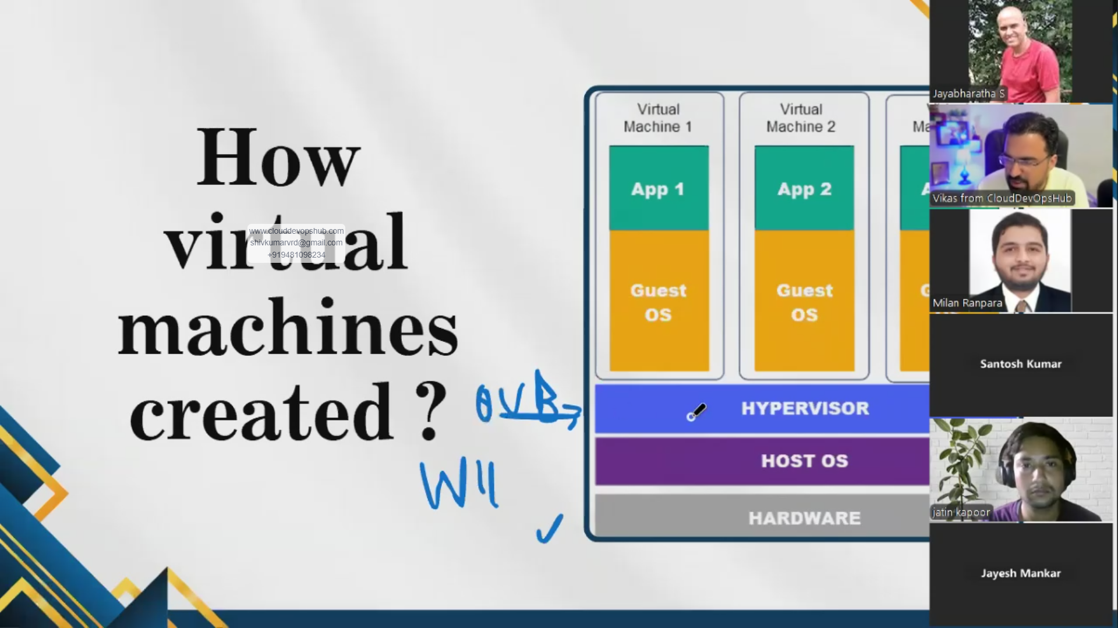

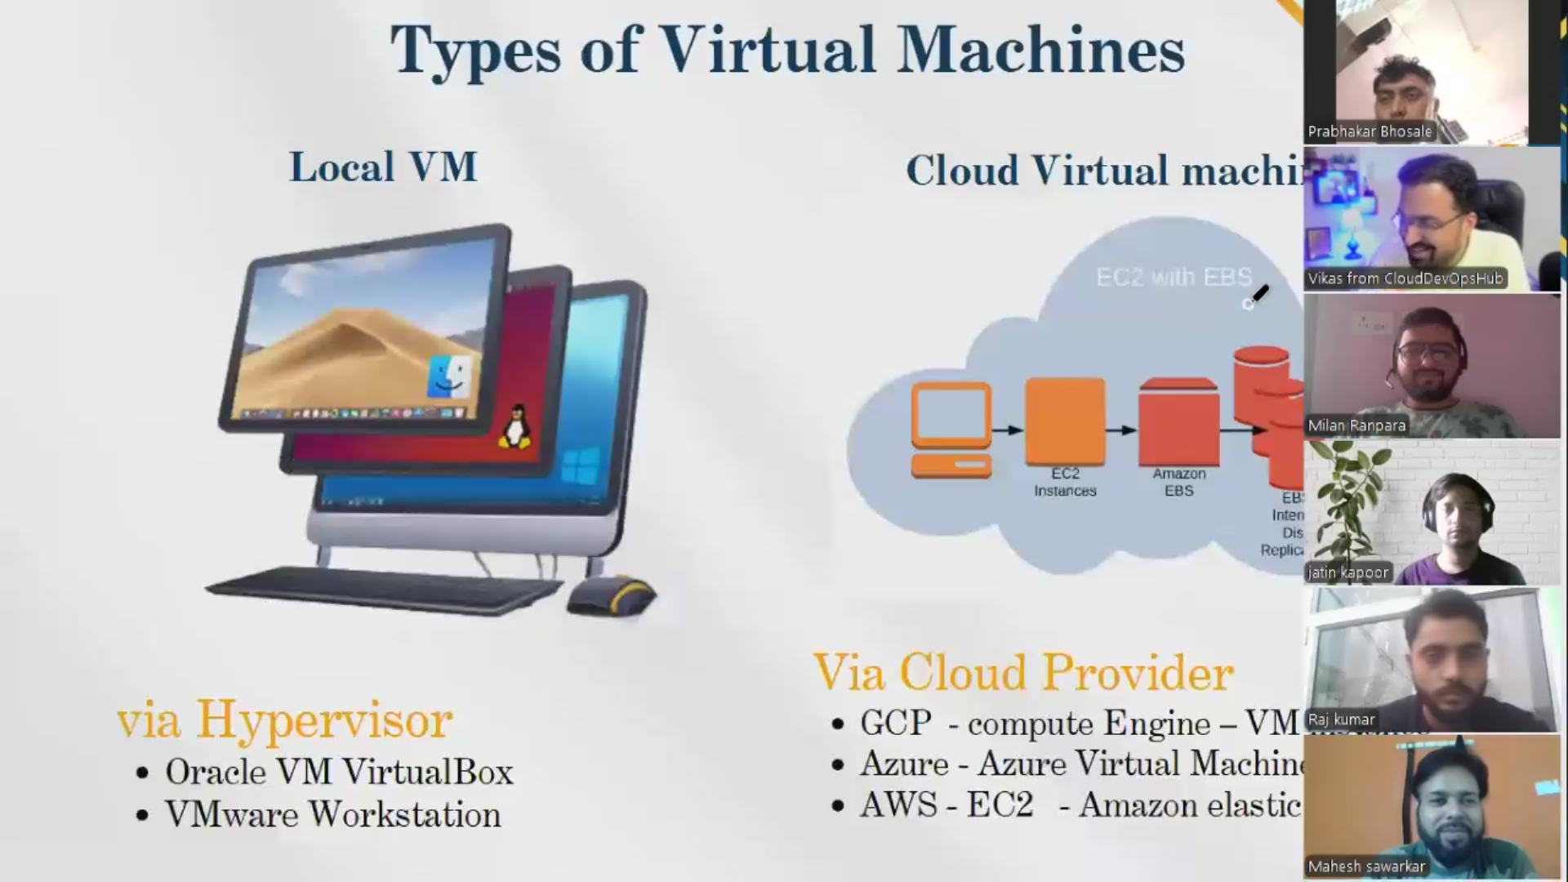

### Practical 3: Creating a virtual Machine via Hypervisor. Just to see its downside (Outadated approach)

<https://www.virtualbox.org/wiki/Downloads>

download

VirtualBox 7.1.10 platform packages

[**Windows hosts**](https://download.virtualbox.org/virtualbox/7.1.10/VirtualBox-7.1.10-169112-Win.exe)

Install.

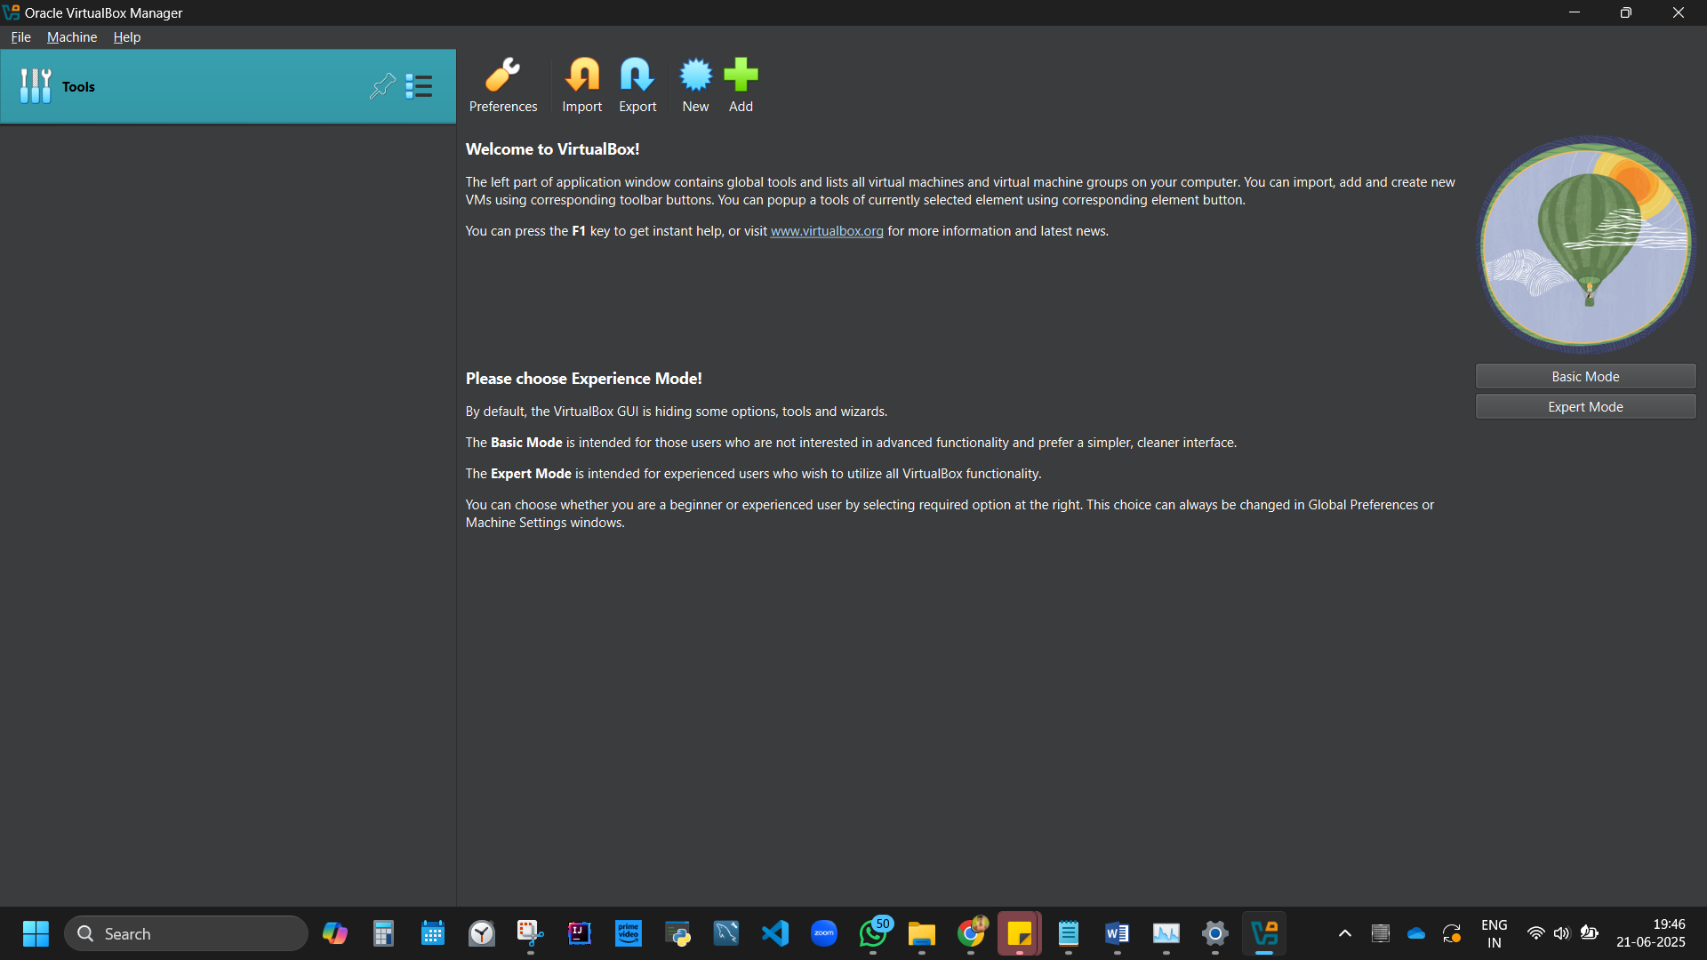

This is Hypervisor software.

We have

Hardware – RAM, ROM, CPU

Host OS – Windows 11,

Now we have Hypervisor – Oracle Virtual Box.

We now need a guest OS to create a VM – CentOS or Ubuntu

[www.osboxes.org/virtualbox-images/](http://www.osboxes.org/virtualbox-images/)

Download CentOS – 1.4GB workstation. Then Ubuntu.

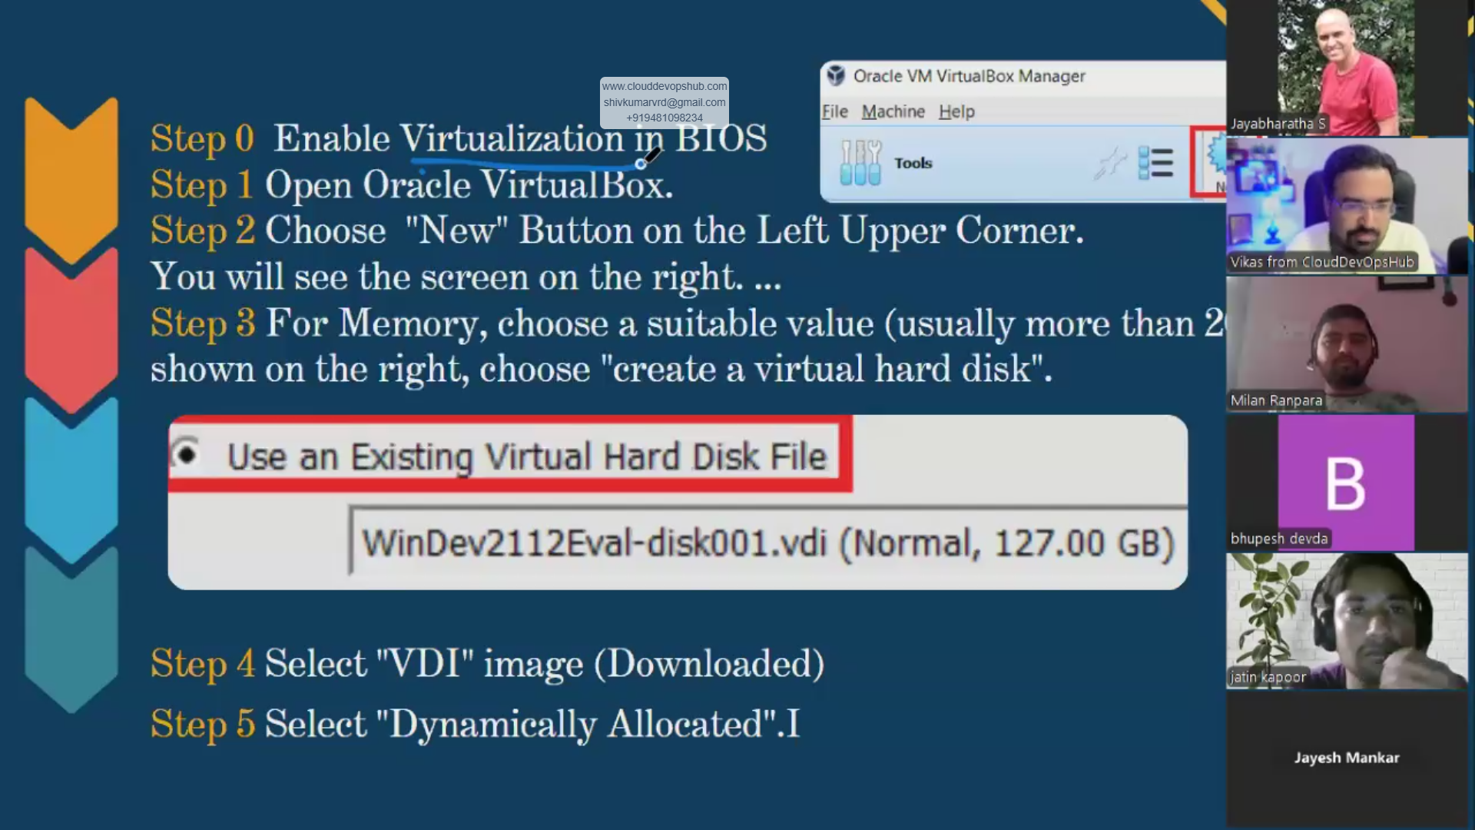

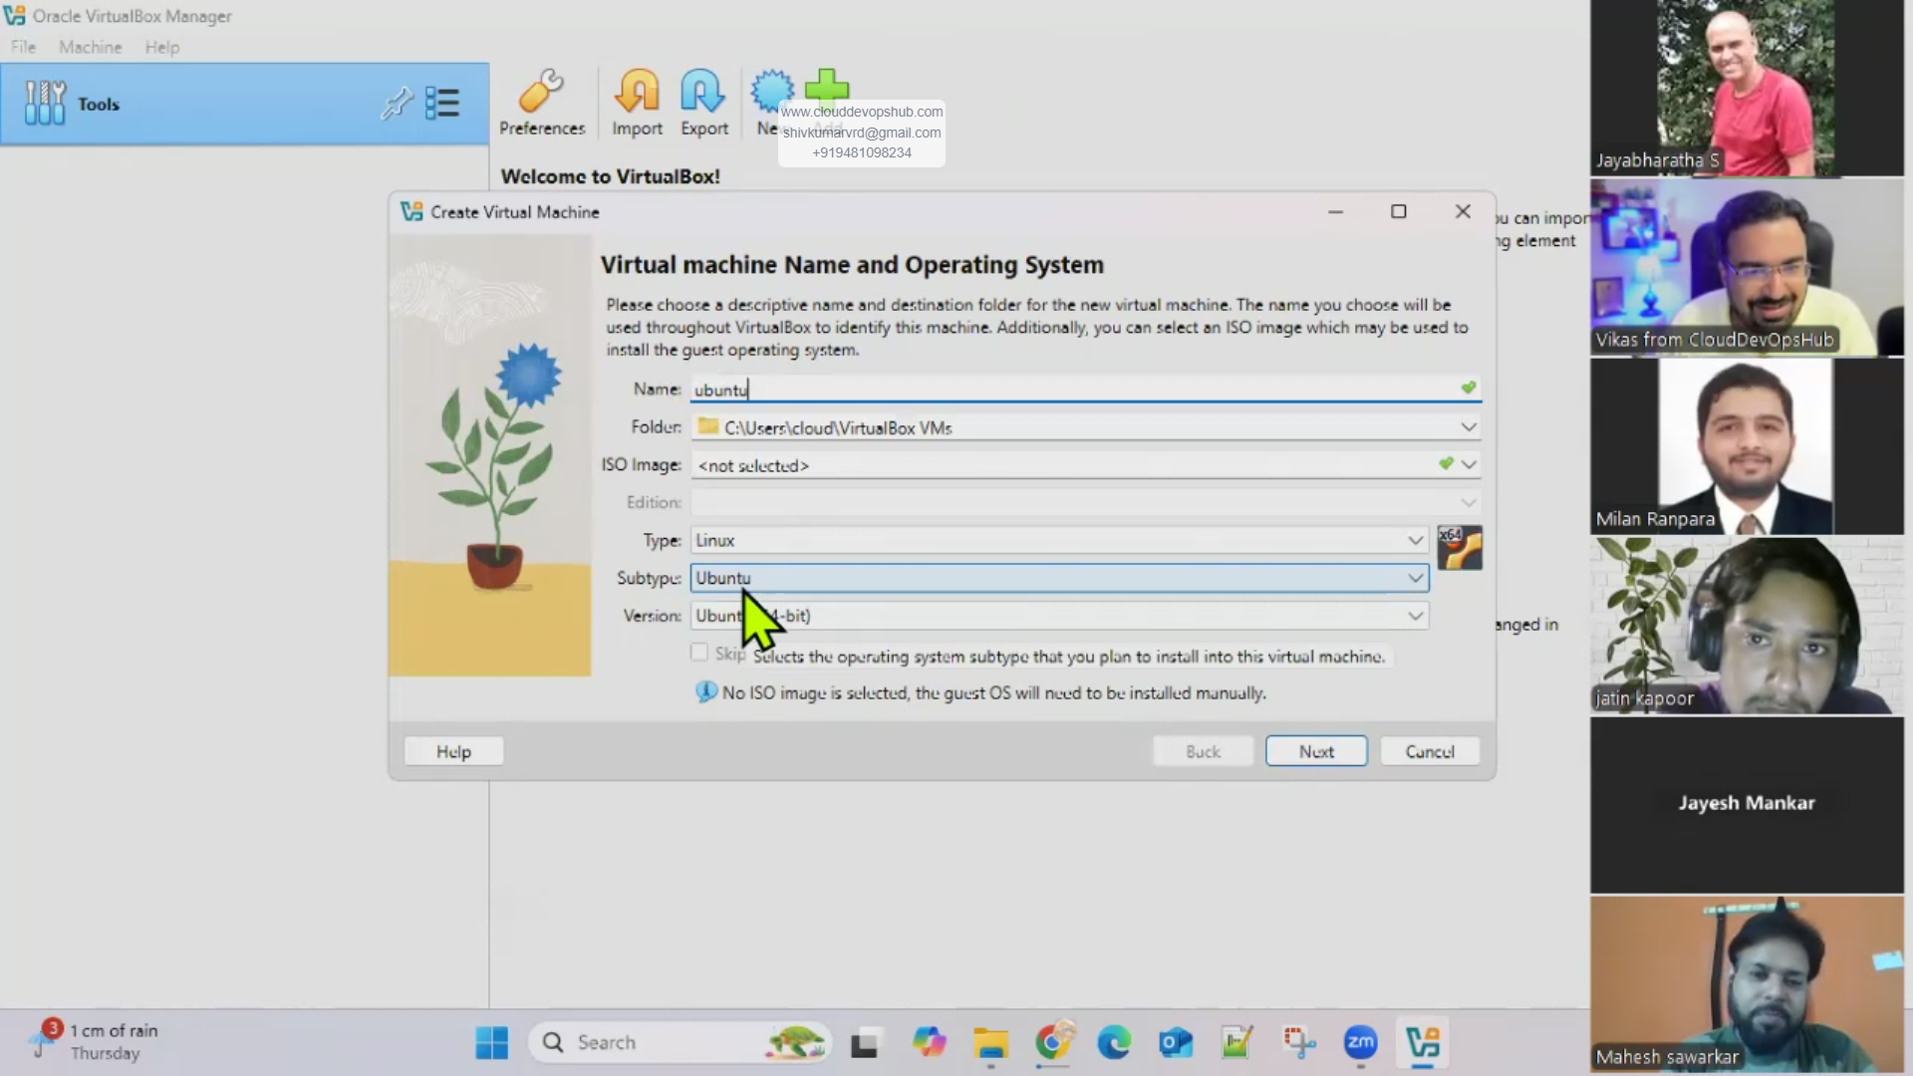 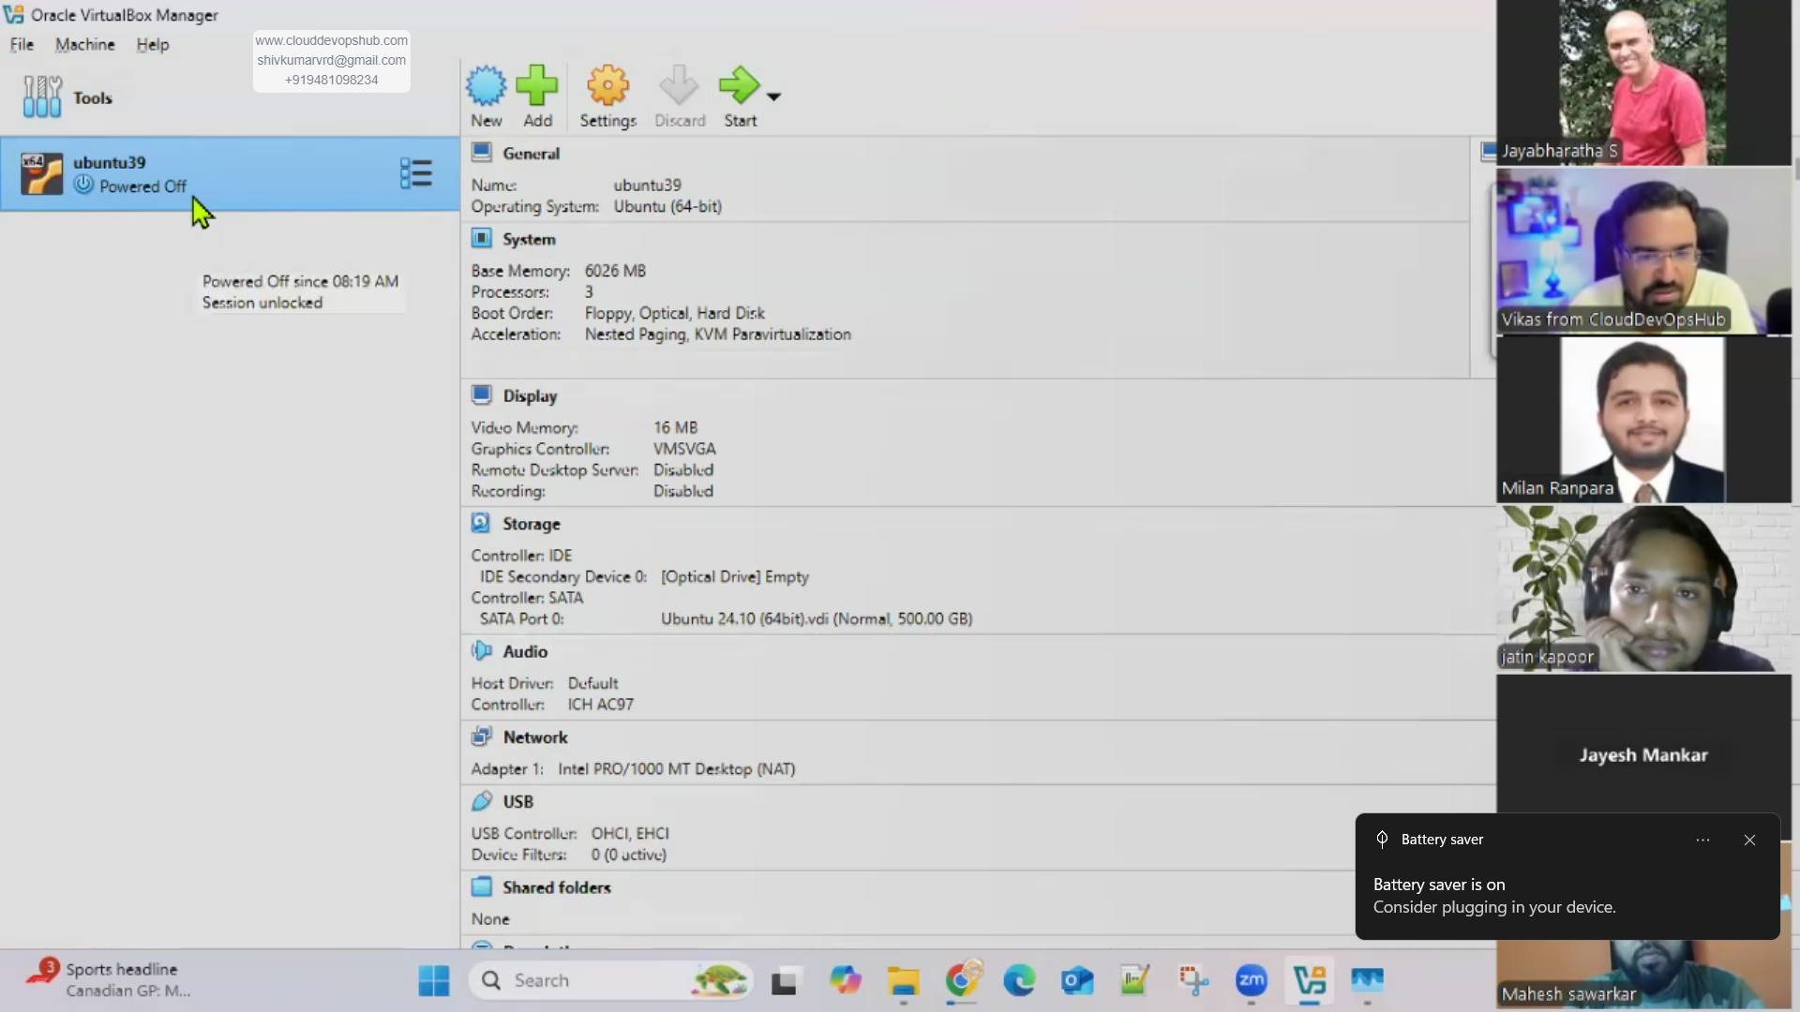

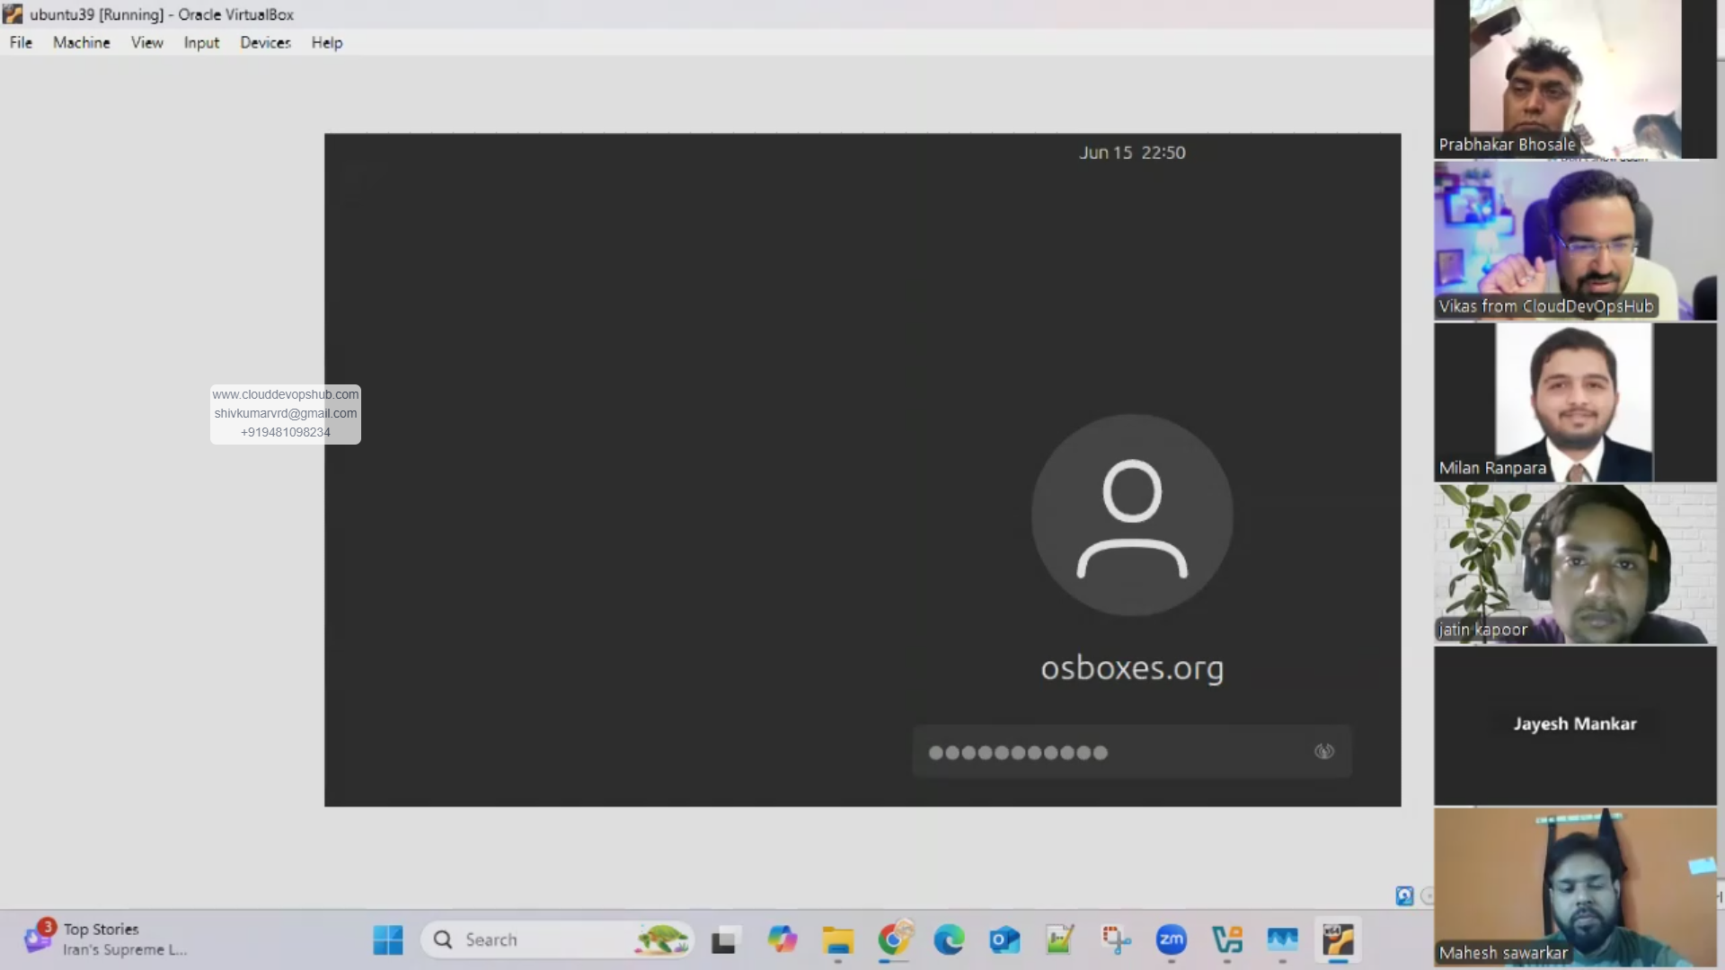

Figure 3 Virtual box, after loading ubuntu, it froze, hanged. Slow and outdated approach

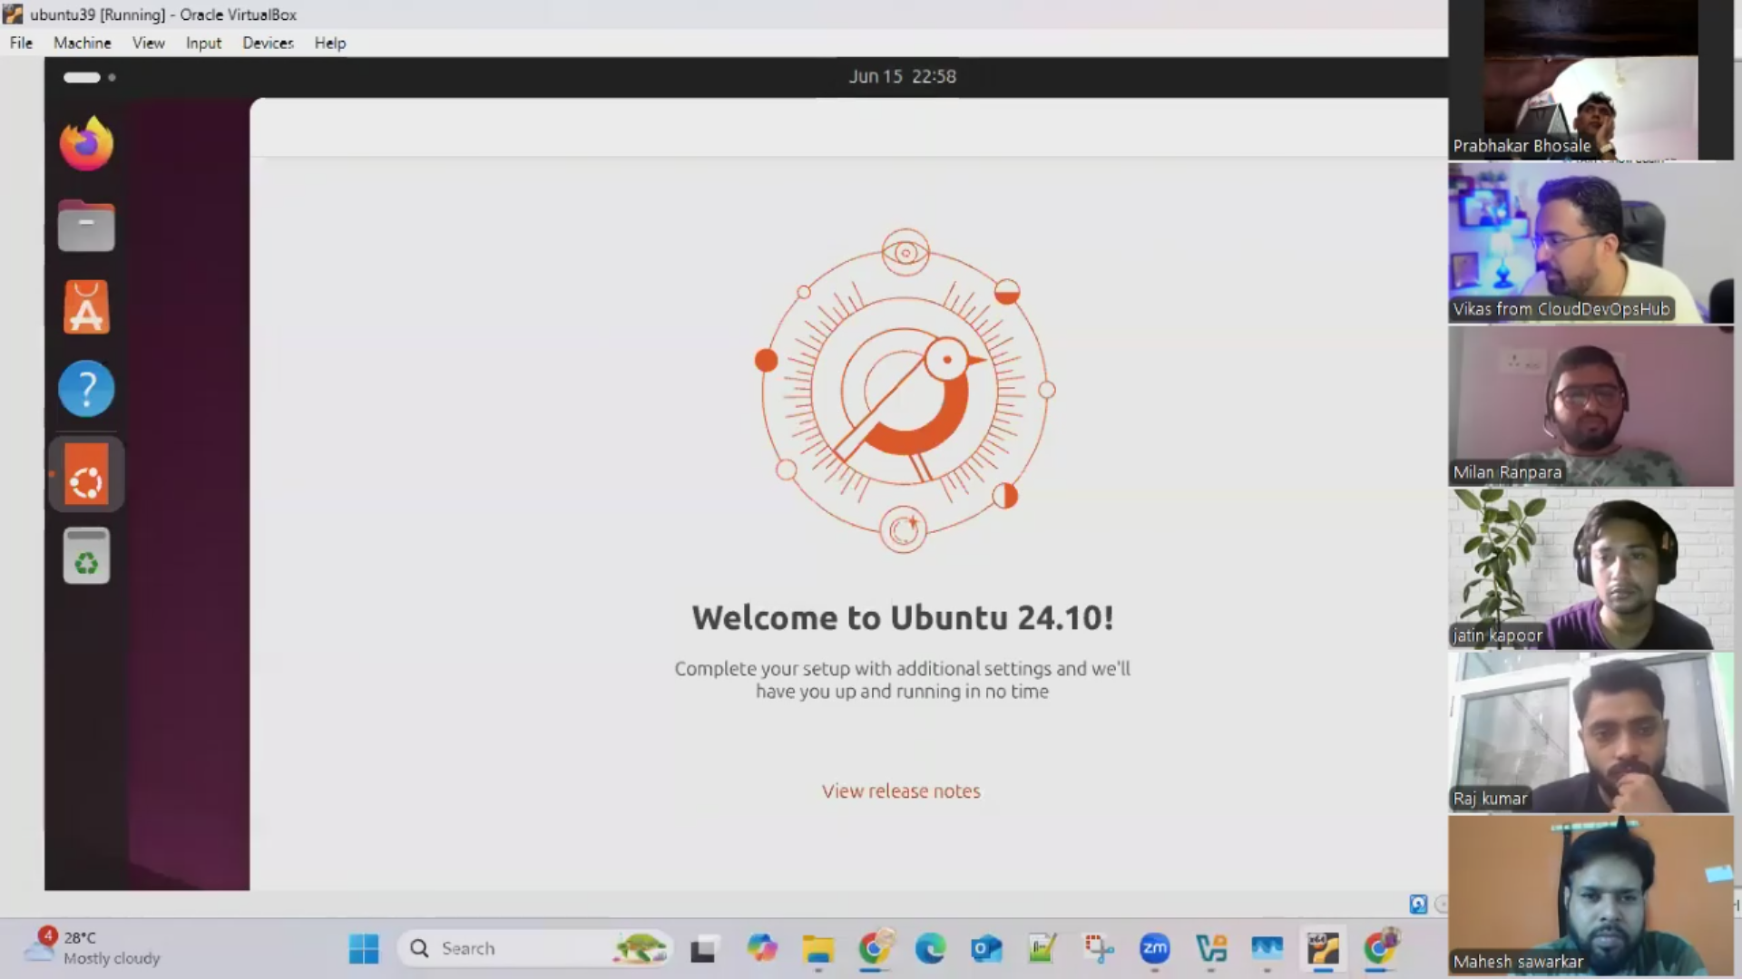

Takeaway: VM is slow and heavy 6.9gb was VM size . Needs more than 6gb ram to run. Heavy OS file size.

Hence docker came into picture. To fix OS step in Virtual machine.

Creating a virtual Machine via Cloud provider is the best approach

## Practical 4: Create 2nd Container – Ubuntu

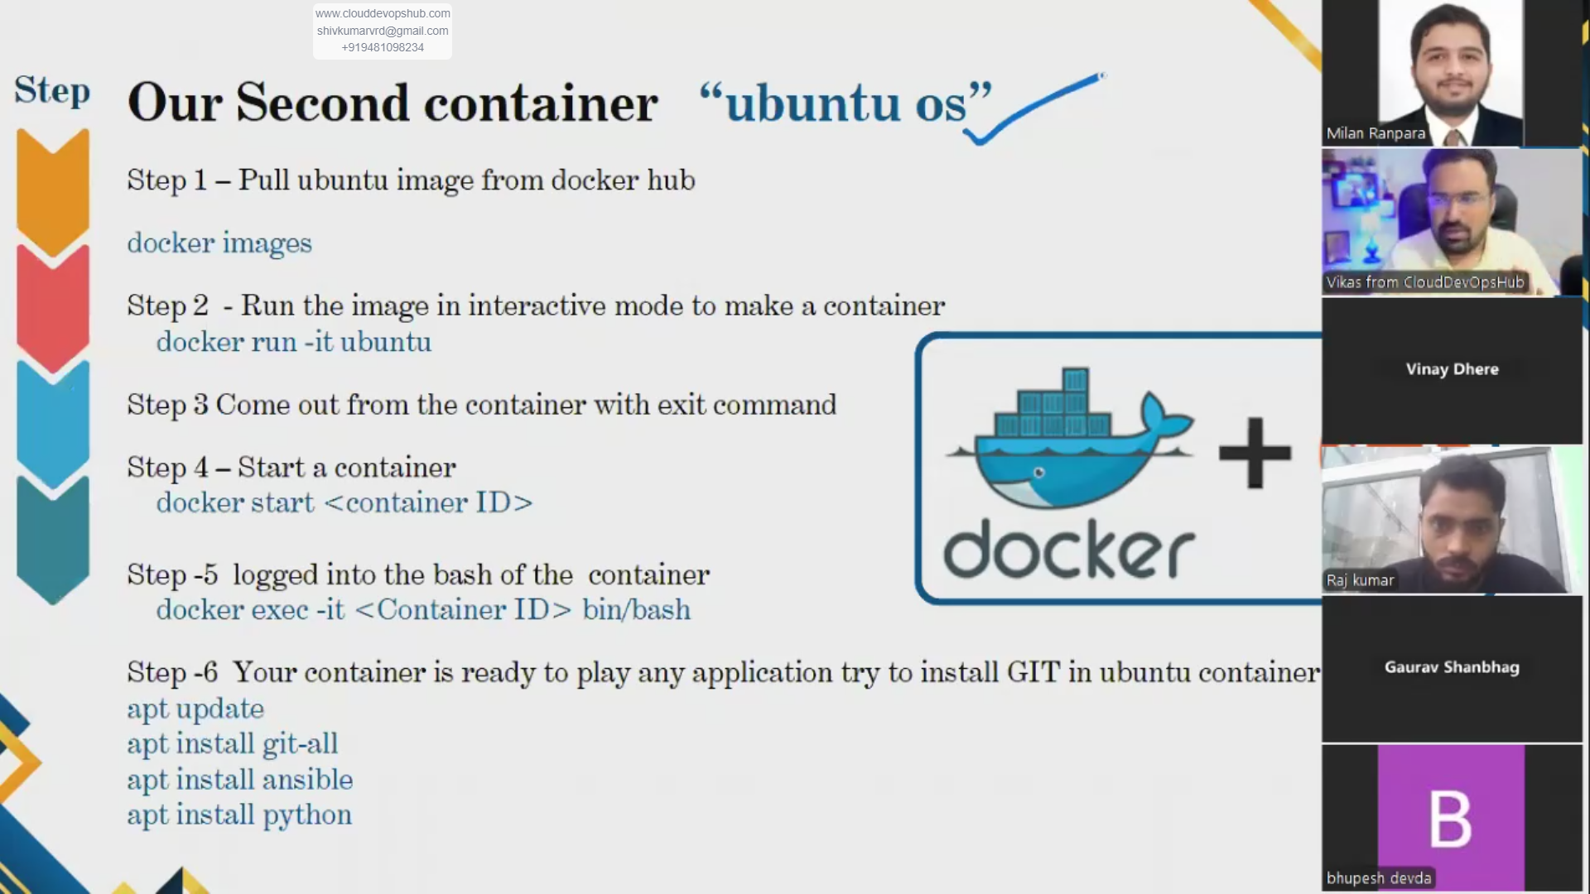

docker run -it ubuntu //installs ubuntu

Note: -it gets you inside container

From root@day1-2dockershiv:~# docker run -it ubuntu

We go to root@f66966874240:/#

Extra: you can install any package/application/software.

apt-get update //container packagers are getting updated.

apt install python3 // python as well

apt install git //installs git

apt install ansible

exit //to come out of container

docker images //can view size as well

root@f66966874240:/# exit

exit

root@day1-2dockershiv:~# docker ps

CONTAINER ID IMAGE COMMAND CREATED STATUS PORTS NAMES

root@day1-2dockershiv:~# docker ps -a

CONTAINER ID IMAGE COMMAND CREATED STATUS PORTS NAMES

f66966874240 ubuntu "/bin/bash" 16 minutes ago Exited (0) About a minute ago distracted_lehmann

root@day1-2dockershiv:~#

docker ps //shows no container

docker ps -a //shows archieve, but in exit mode. Why? To save memory. It’s a feature.

How to go inside a container which you have exited? –

Code: docker start <container_id>

Wrong code: docker exec -it //we will go inside running container. Here its not running. So not possible.

docker ps

docker exec -it f66966874240 /bin/bash //gets you back to a running container.

From

root@day1-2dockershiv: to

root@f66966874240:/# ^C

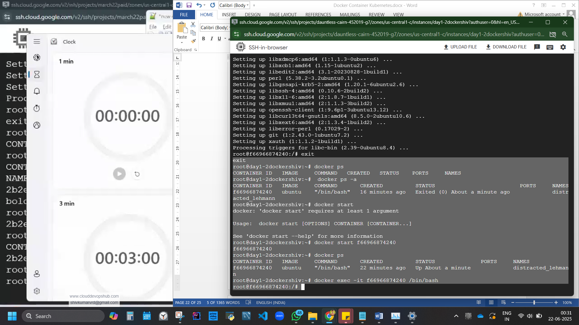

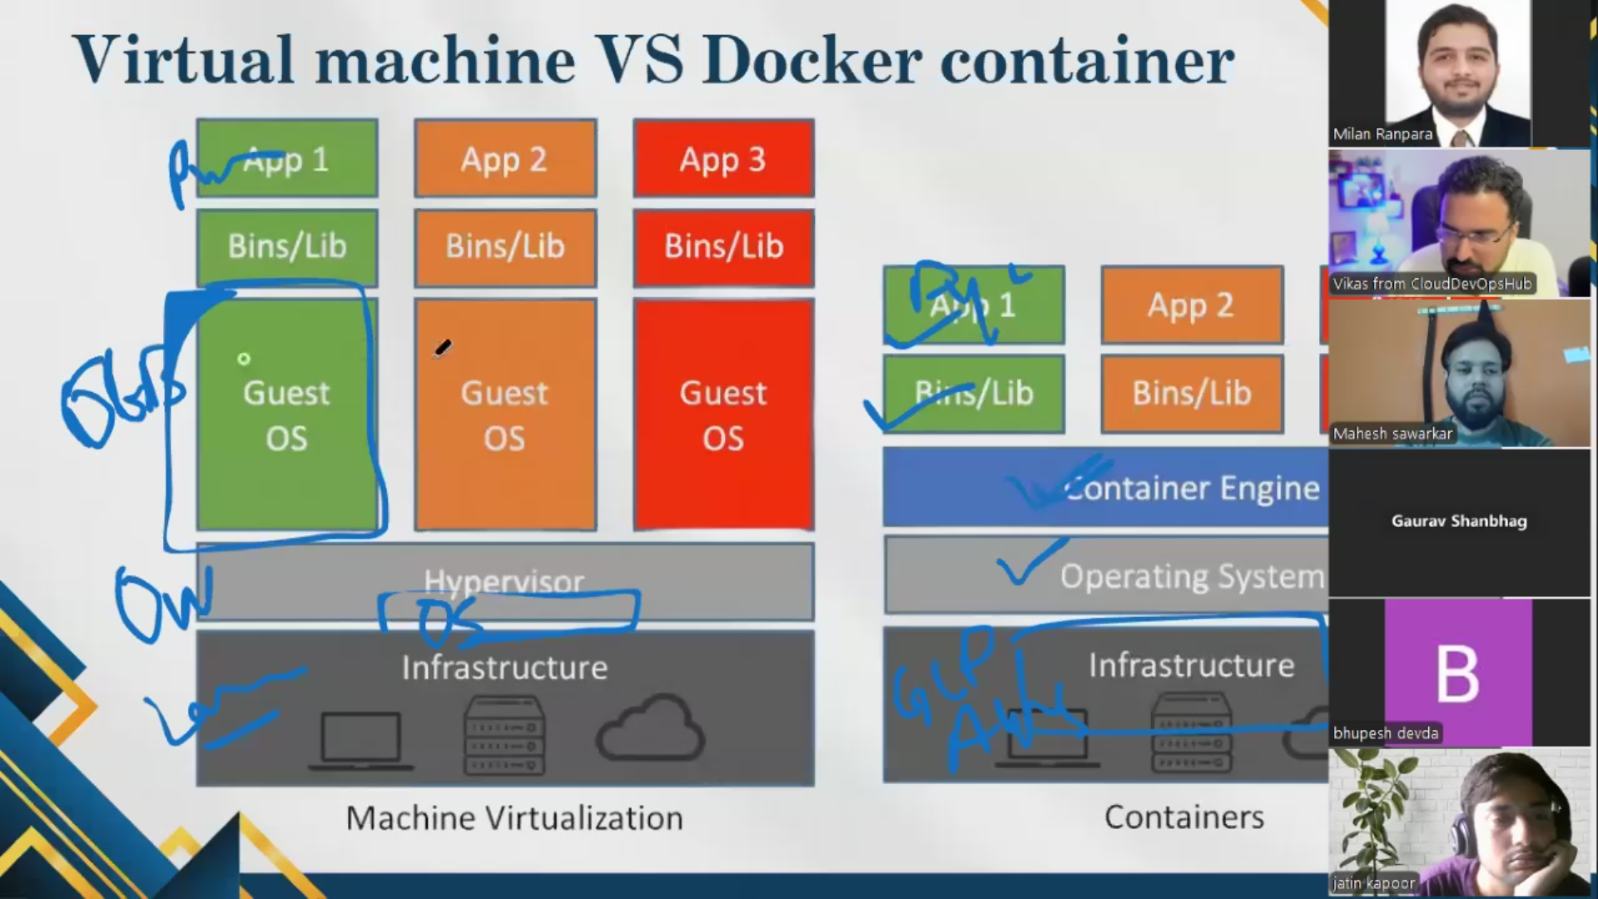

#### Docker is popular vs VM with respect to size.

Ubuntu download file is 2.17gb, after installing in windows its 7gb. But here in container, ubuntu size is just 78.1mb ~90 times reduction is size. Hence docker is popular vs VM.

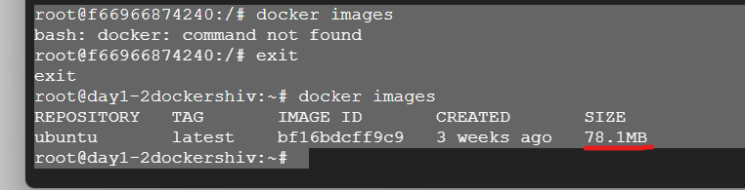

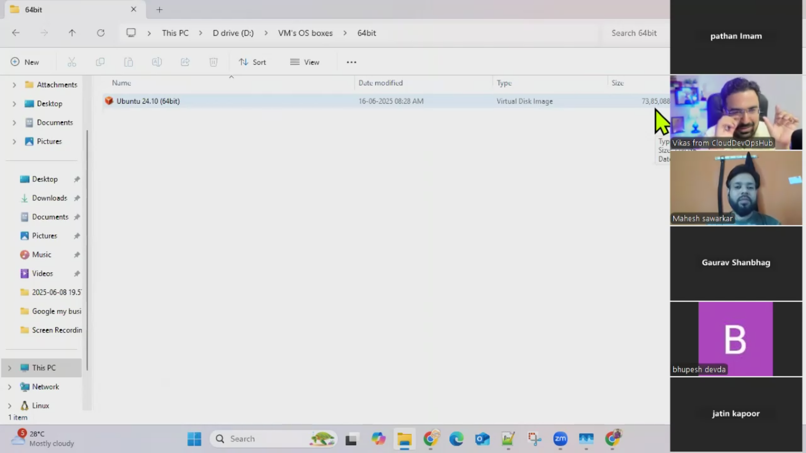

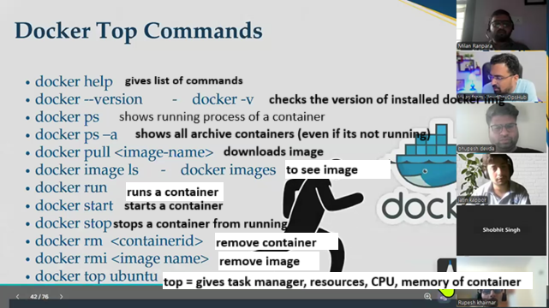

Day 10 of DevOps, Day 2 at Docker

## NGINX

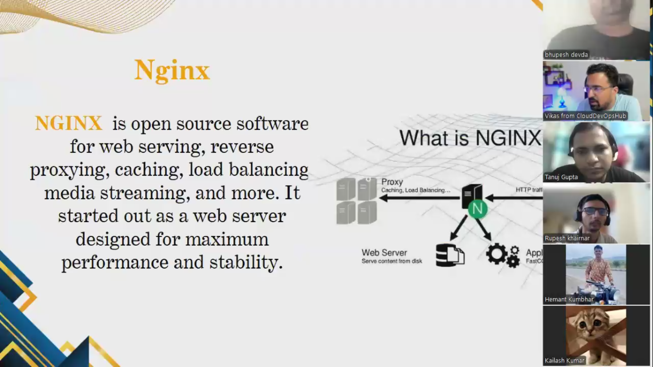

### Practical. Application 1: Pull and run nginx application with docker.

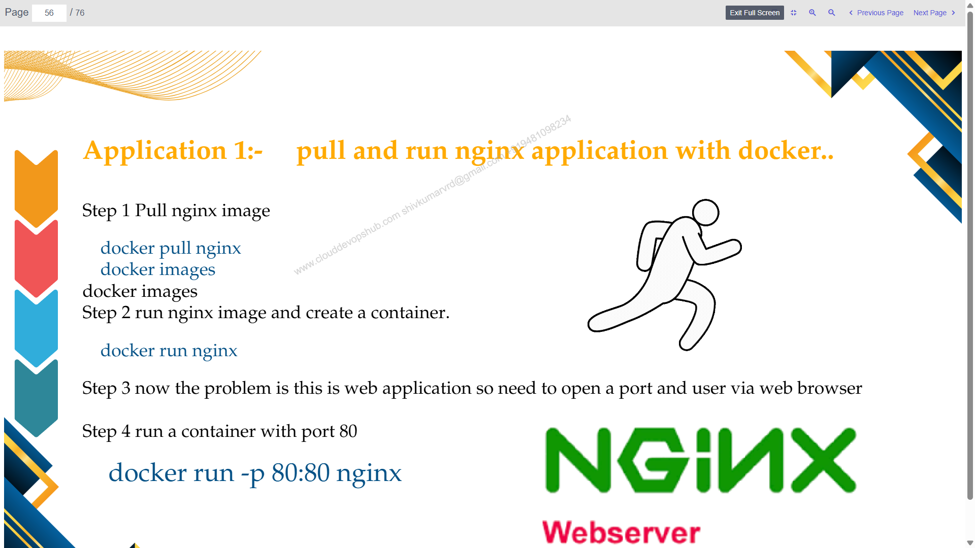

IM instance, conenct SSH, authorise.

Code:

sudo –i

apt-get update

docker

apt install docker.io

**docker pull ngnix**

docker images

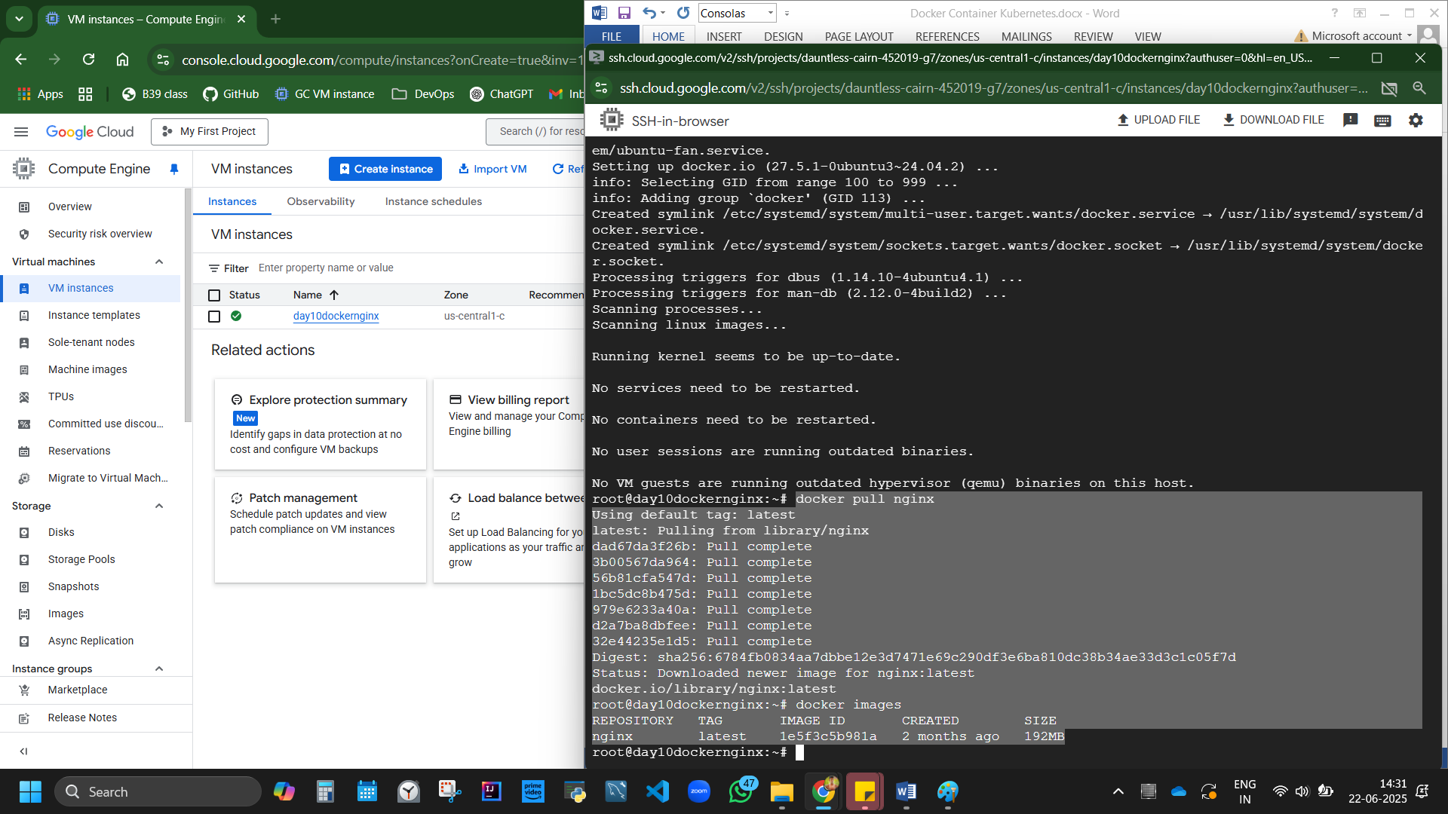

Figure 4 ngnix is 192mb

### Practical. Application 2: Create a webserver – nginx application with docker

Complete codes:

sudo –i

docker stop docker-nginx 2>/dev/null // Stop & remove existing container if any

docker rm docker-nginx 2>/dev/null // Stop & remove existing container if any

apt-get update

apt-get install docker.io –y // Install Docker (if not already installed)

docker –version

mkdir -p ~/docker-nginx/html // **Create project folder and HTML file**

cd ~/docker-nginx/html

vi index.html // Open index.html in vi editor

copy paste html code, save by :wq and enter

docker run --name docker-nginx -p 80:80 -d -v ~/docker-nginx/html:/usr/share/nginx/html nginx

//Run Docker with volume and port mapping

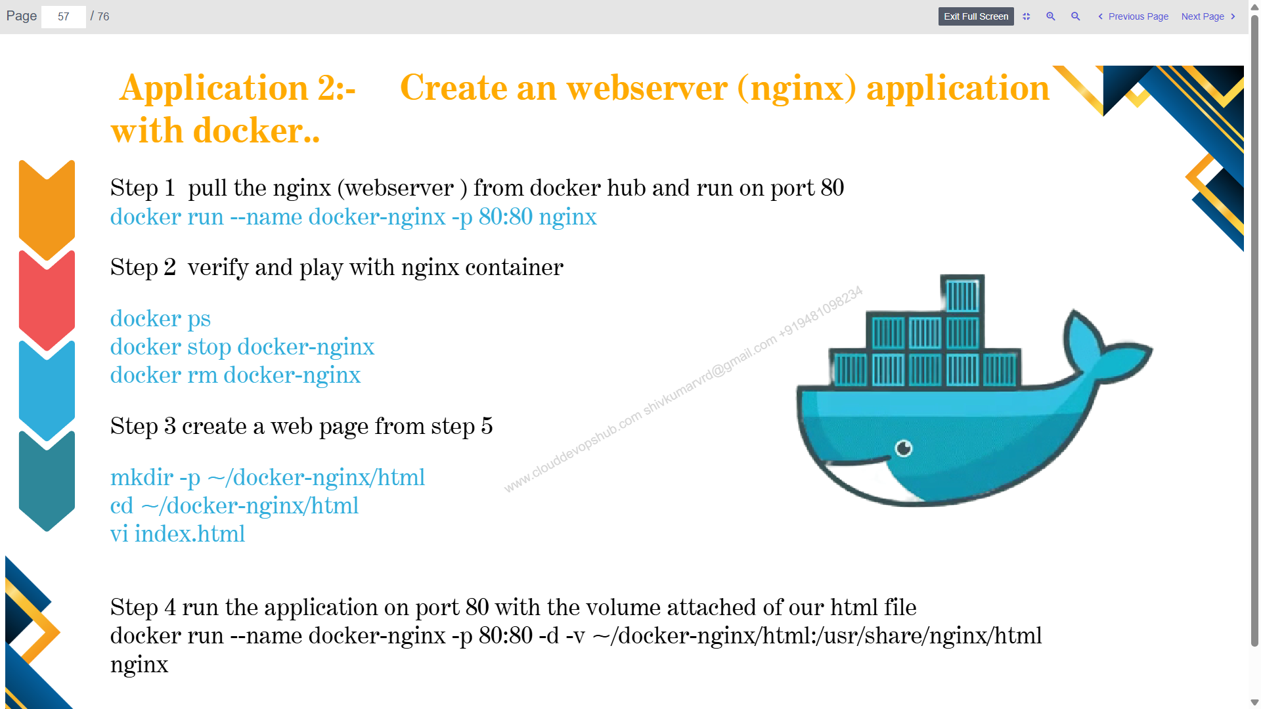

IM instance, conenct SSH, authorise.

Code:

sudo –i

apt-get update

docker

apt install docker.io

-y

docker --version

Step 1. Pull nginx from docker hub and run on port 80 [NOT REQURIED]

docker run --name docker-nginx –p 80:80 nginx

Code breakdown explanation:

--name docker-nginx: names the container name docker-nginx

-p 80:80: binds/maps host port 80 with container port 80. 1st is VM host port, 2nd is container port.

nginx: the image you're running is ngnix

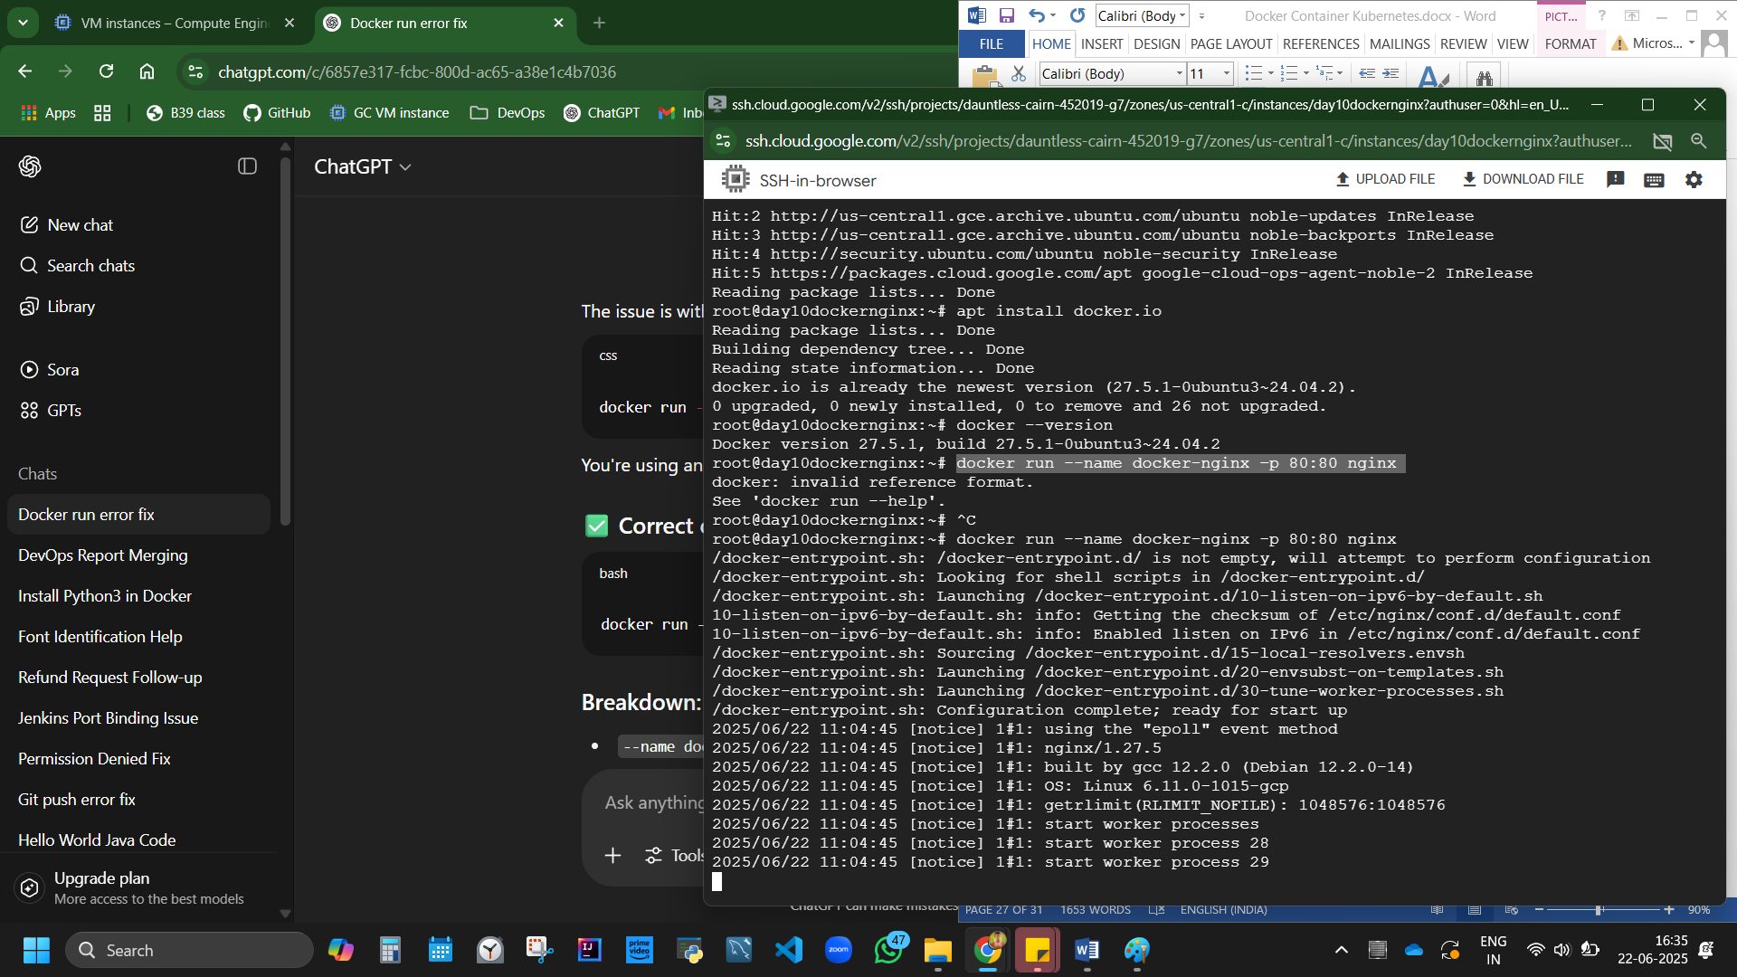

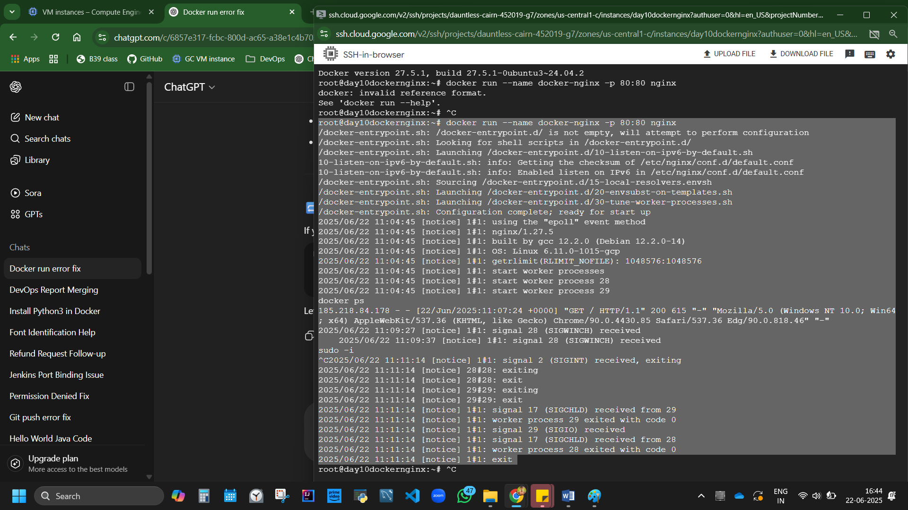

Figure 5 This shows that the NGINX container was initialized and the web server started without errors.

Step 2. Verify and play with code.

docker ps

docker stop docker-nginx

docker rm docker-nginx

Step 3: Create Directory with mkdir command.

mkdir -p ~/docker-ngnix/html //creating a directory

cd ~/docker-ngnix/html //go inside container/directory

vi index.html //creating vi html file/directory

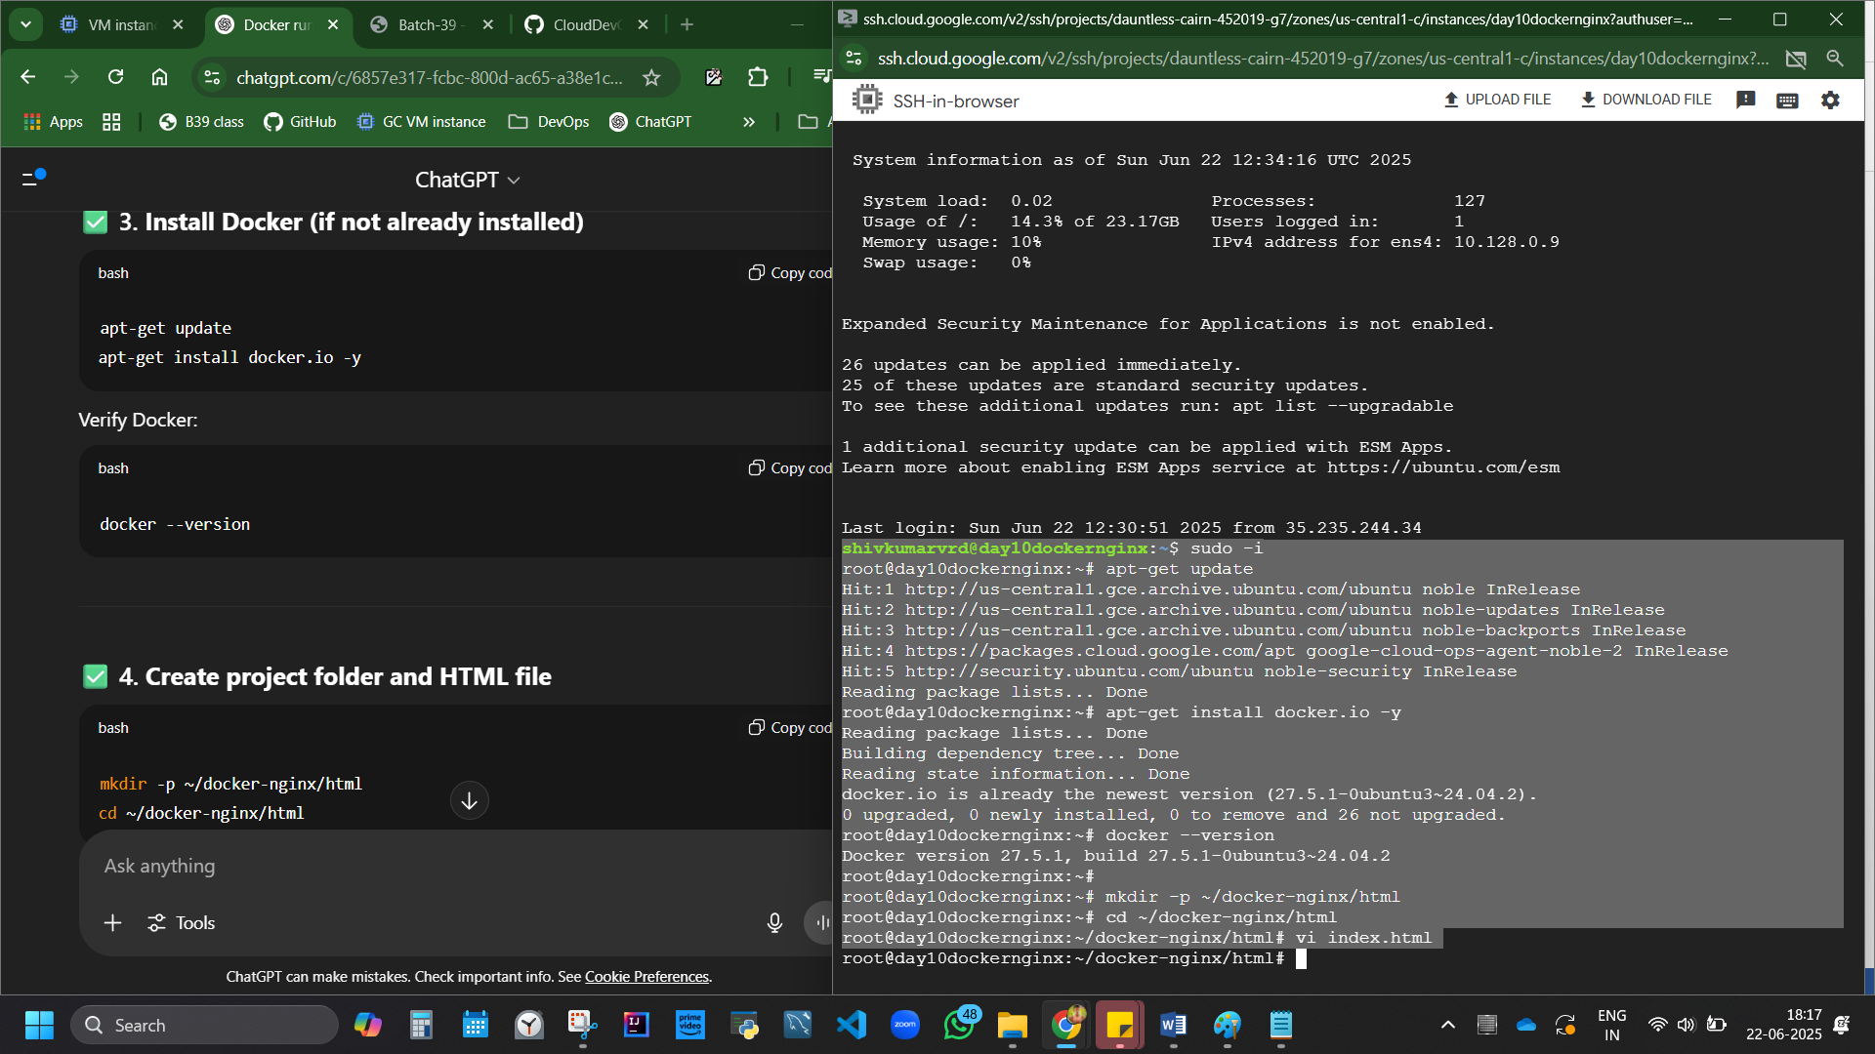

Directory created with mkdir command.

Step3 cont.: Take a simple html code,

ggdG to clear.

i to insert.

Copy paste the html code. and save (:wq)

<!DOCTYPE html>

<html>

<head>

<link href="https://maxcdn.bootstrapcdn.com/bootstrap/3.3.5/css/bootstrap.min.css"

rel="stylesheet"

integrity="sha256-MfvZlkHCEqatNoGiOXveE8FIwMzZg4W85qfrIFBfYc= sha512-dTfge/zgoMYpP7QbHy4gWMEGsbsdZeCXz7irItjcC3sPUFt0kuFbDz/ixG7ArTxmDjLXDmezHubeNikyKGVyQ=="

crossorigin="anonymous">

<title>Docker Nginx Tutorial</title>

</head>

<body>

<div class="container">

<h1>Heyy, Welcome to DevOps Learning of Batch39 with Shiv and Vikash. Jahnavi learning from Abhishek's youtube classes</h1>

<p>This nginx webservise page is brought to you by Docker. We started studying from June 13th and hoping to finish it by July end.</p>

</div>

</body>

</html>

Press esc, type :wq to save, enter.

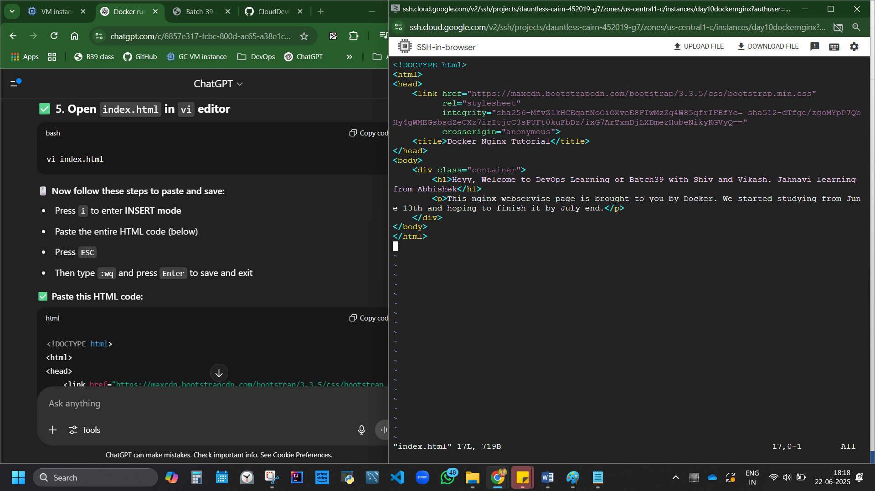

Figure 6 ggdG to clear existing code, i, paste

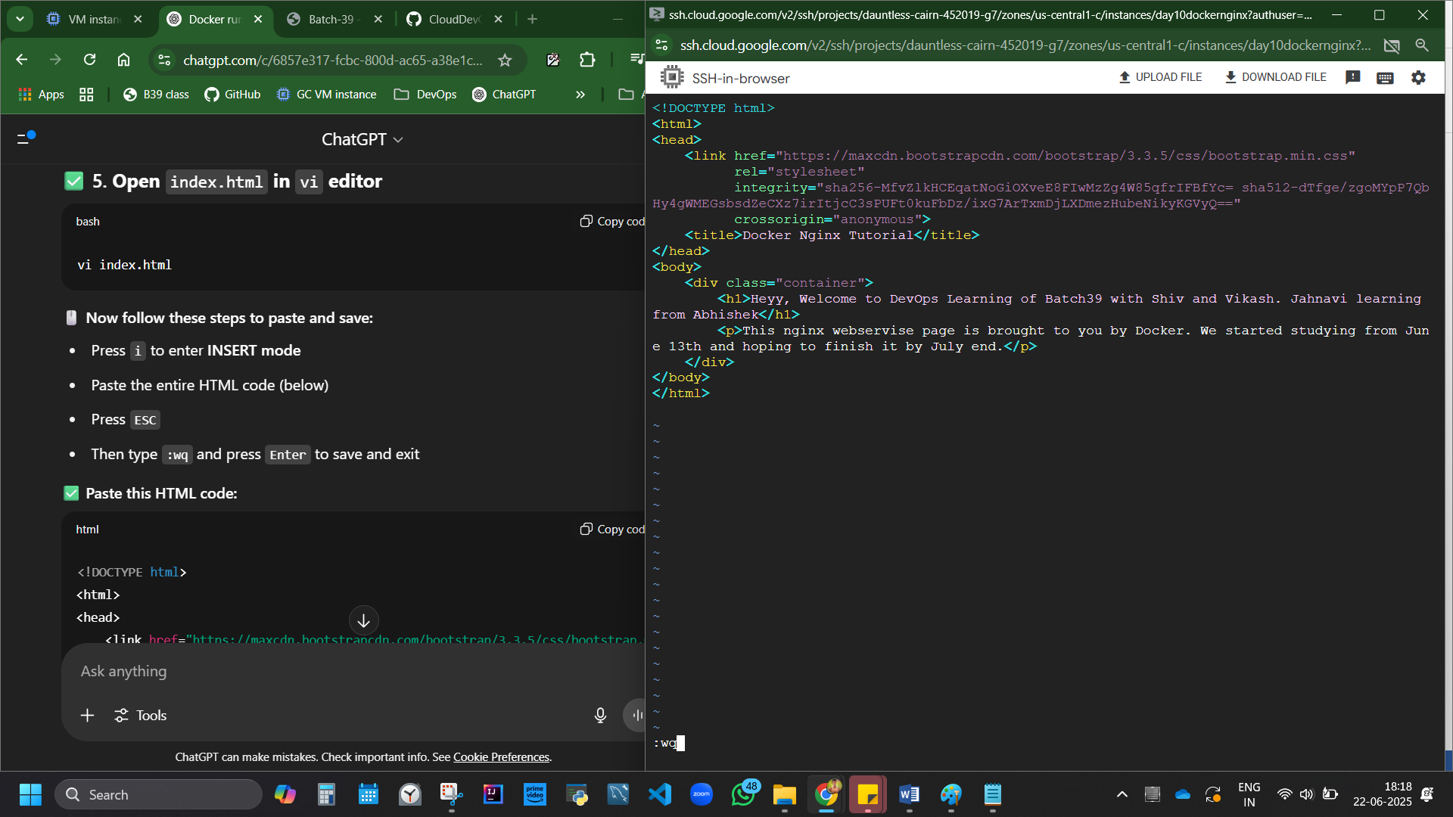

Figure 7 esc :wq enter save

Step 4: Run the application on port 80 with volume attached of our simple html file.

docker run --name docker-nginx -p 80:80 -d -v ~/docker-nginx/html:/usr/share/nginx/html nginx

This will: Start the nginx container, Map your HTML to nginx default path and Expose port 80 publicly

Code breakdown explained

docker run **Runs** nginx image with name docker ngin

--name docker-nginx Runs nginx image with name **docker nginx**

-p 80:80 docker nginx to run on port number 80. Mapping of VM:docker container.

-d runs container in detached mode. All things happen in background

-v ~/docker-nginx/html**:/usr/share/nginx/html** v indicates volume.

Volume of Virtual machine VM is mapped with container volume

nginx Runs nginx image

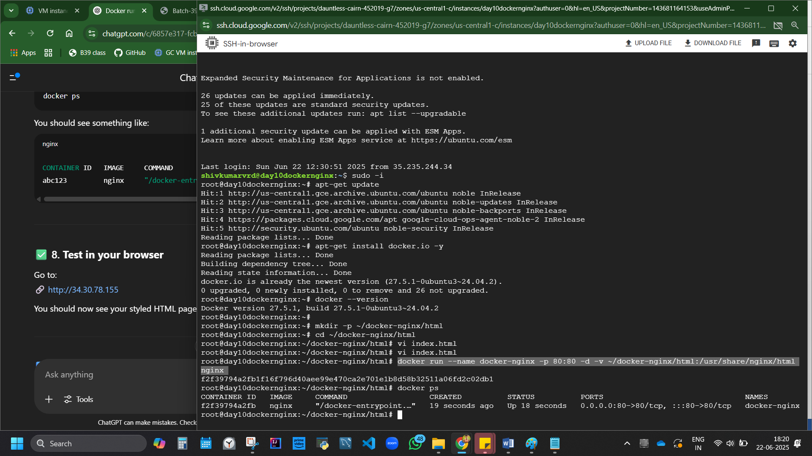Copy paste Exter IP in website it works - <http://34.30.78.155>

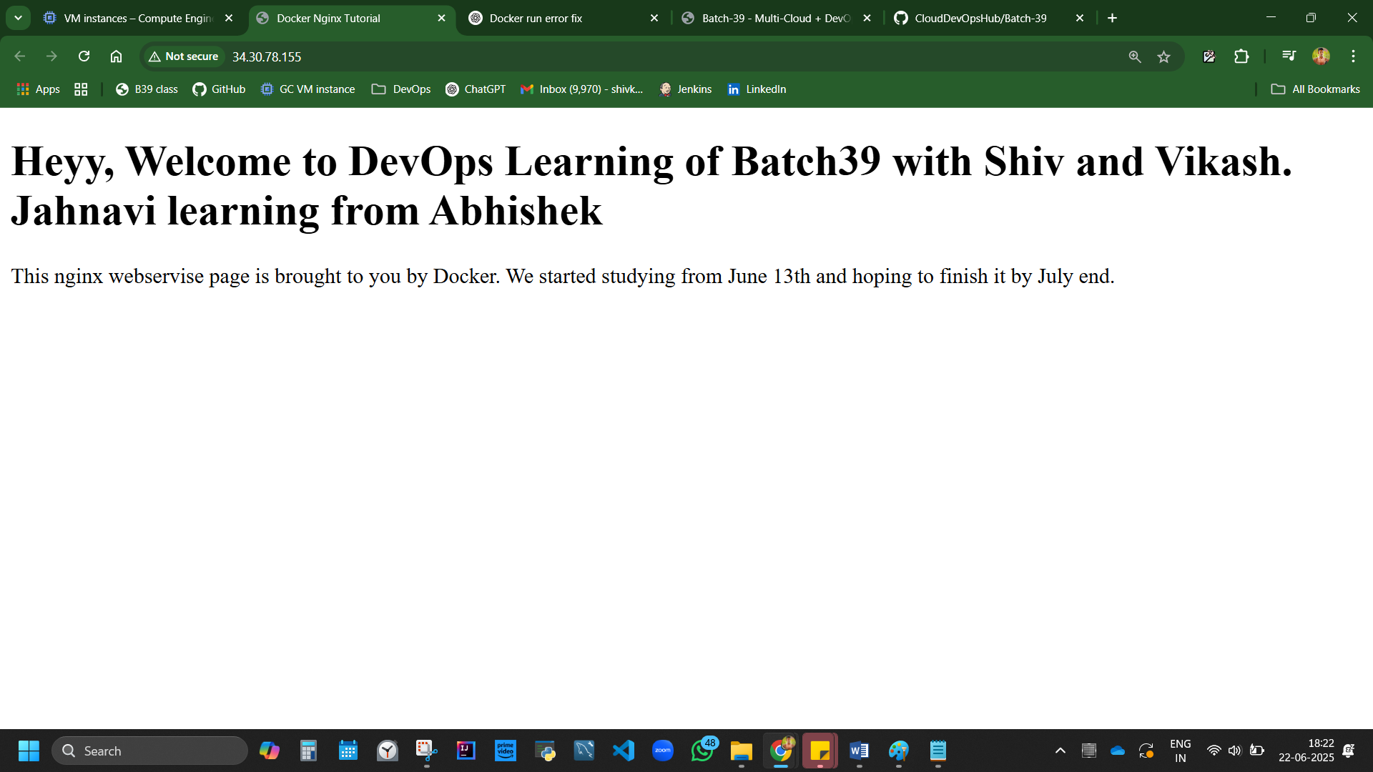

Tips: If the VM Rebooted or Container Was Stopped, To **start it again**:

docker start docker-nginx

Then to Confirm it's running again.: docker ps

#### To add any other code, Example lets add google home page code.

Obtain google html code: Go to googl, right click, view page source, copy HTMP code.

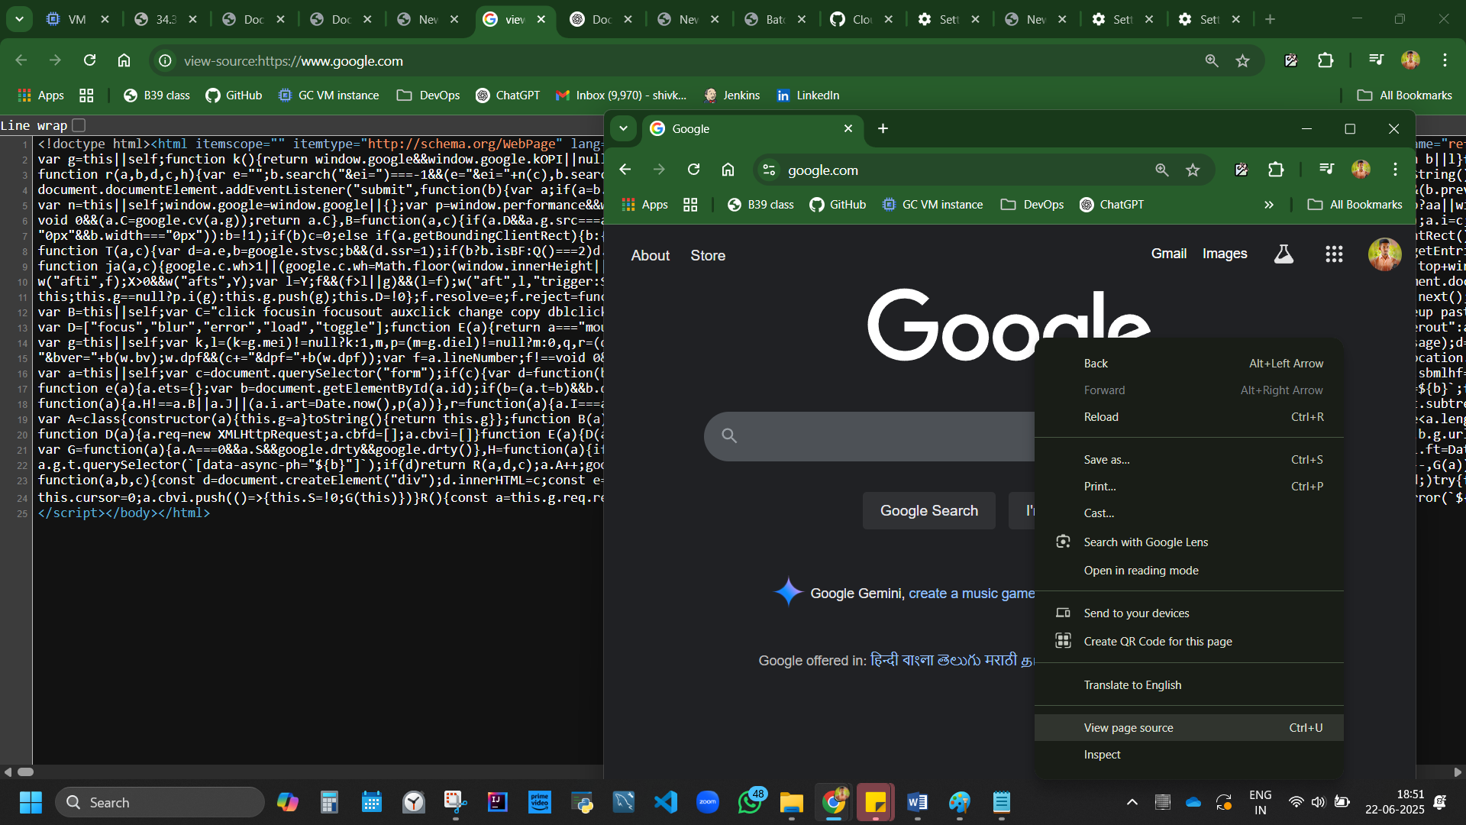

vi index.html

delete old code, ggdG, i enter, paste code, esc, :wq to save, enter

refresh or open the same ext IP.

Error, casue the code id huge.

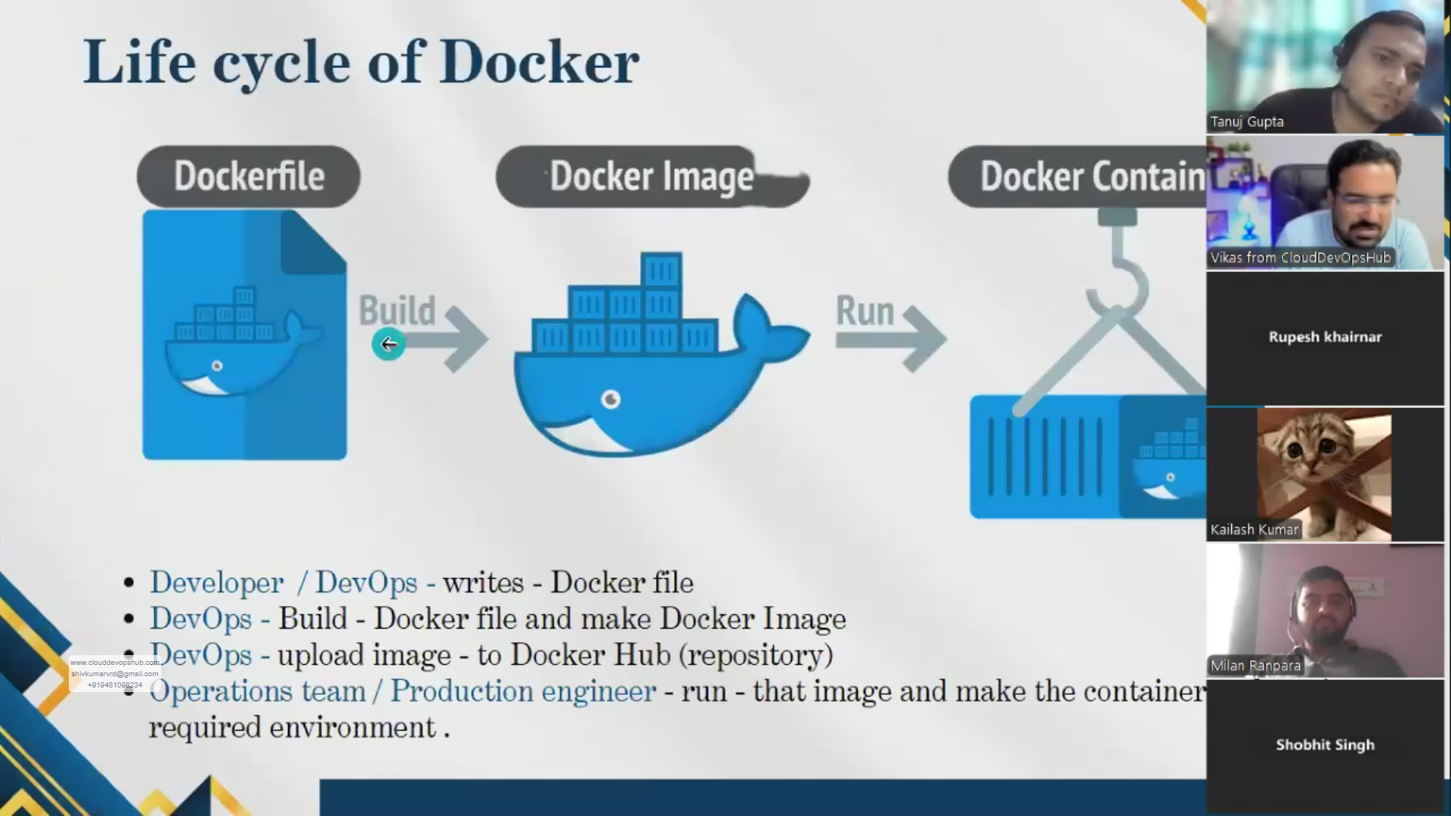

When devops engg pulls and image is not present in docker hub, a dockerfile needs to be created.

Its developers job 70%. But if they donno, devops engg has to do.

## DOCKER FILE

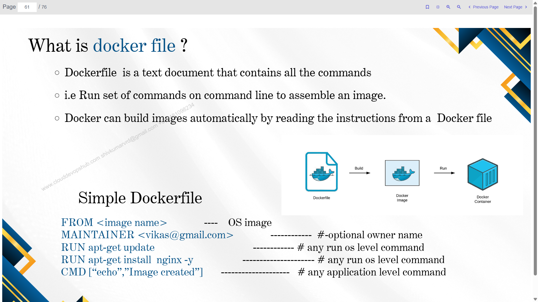

### Create Docker file

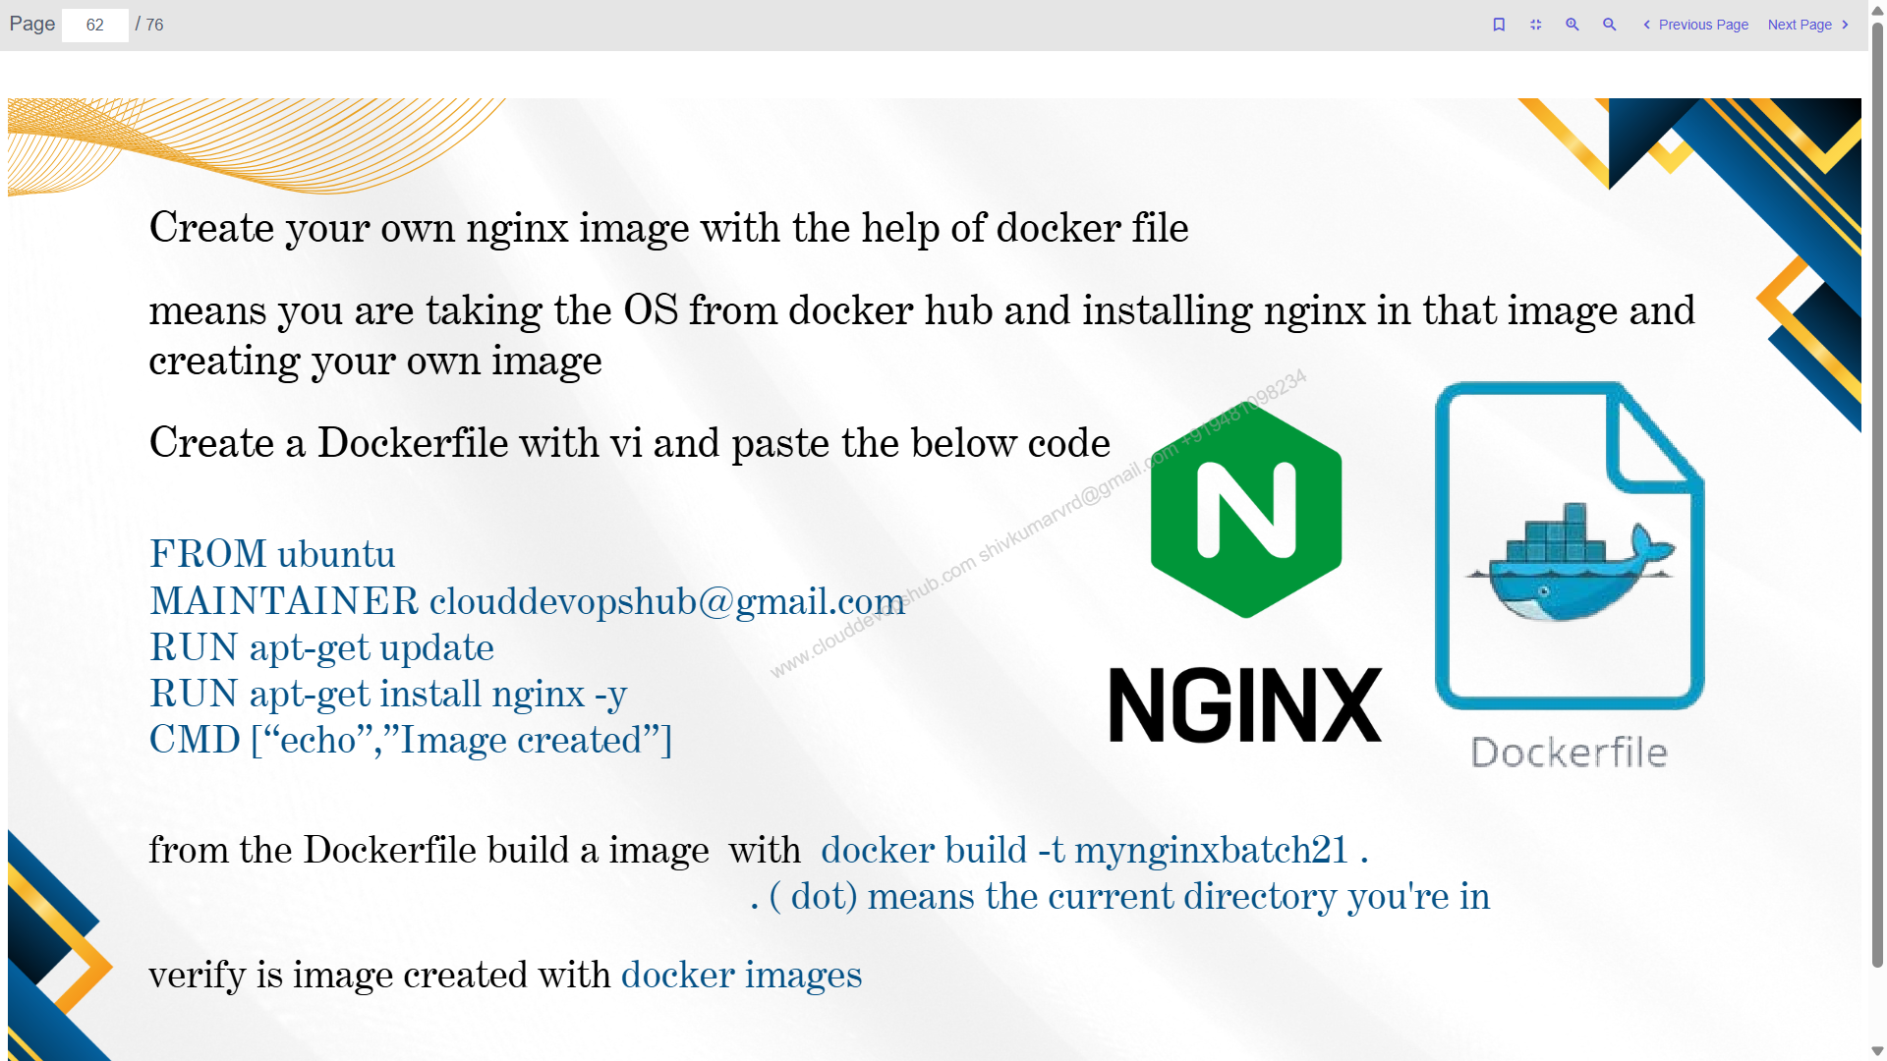

vi Dockerfile

copy paste the below code, like we did for html file. Save

cat Dockerfile

FROM ubuntu

MAINTAINER shivkumarvrd@gmail.com

RUN apt-get update

RUN apt-get install nginx -y

CMD ["echo", "Image created"]

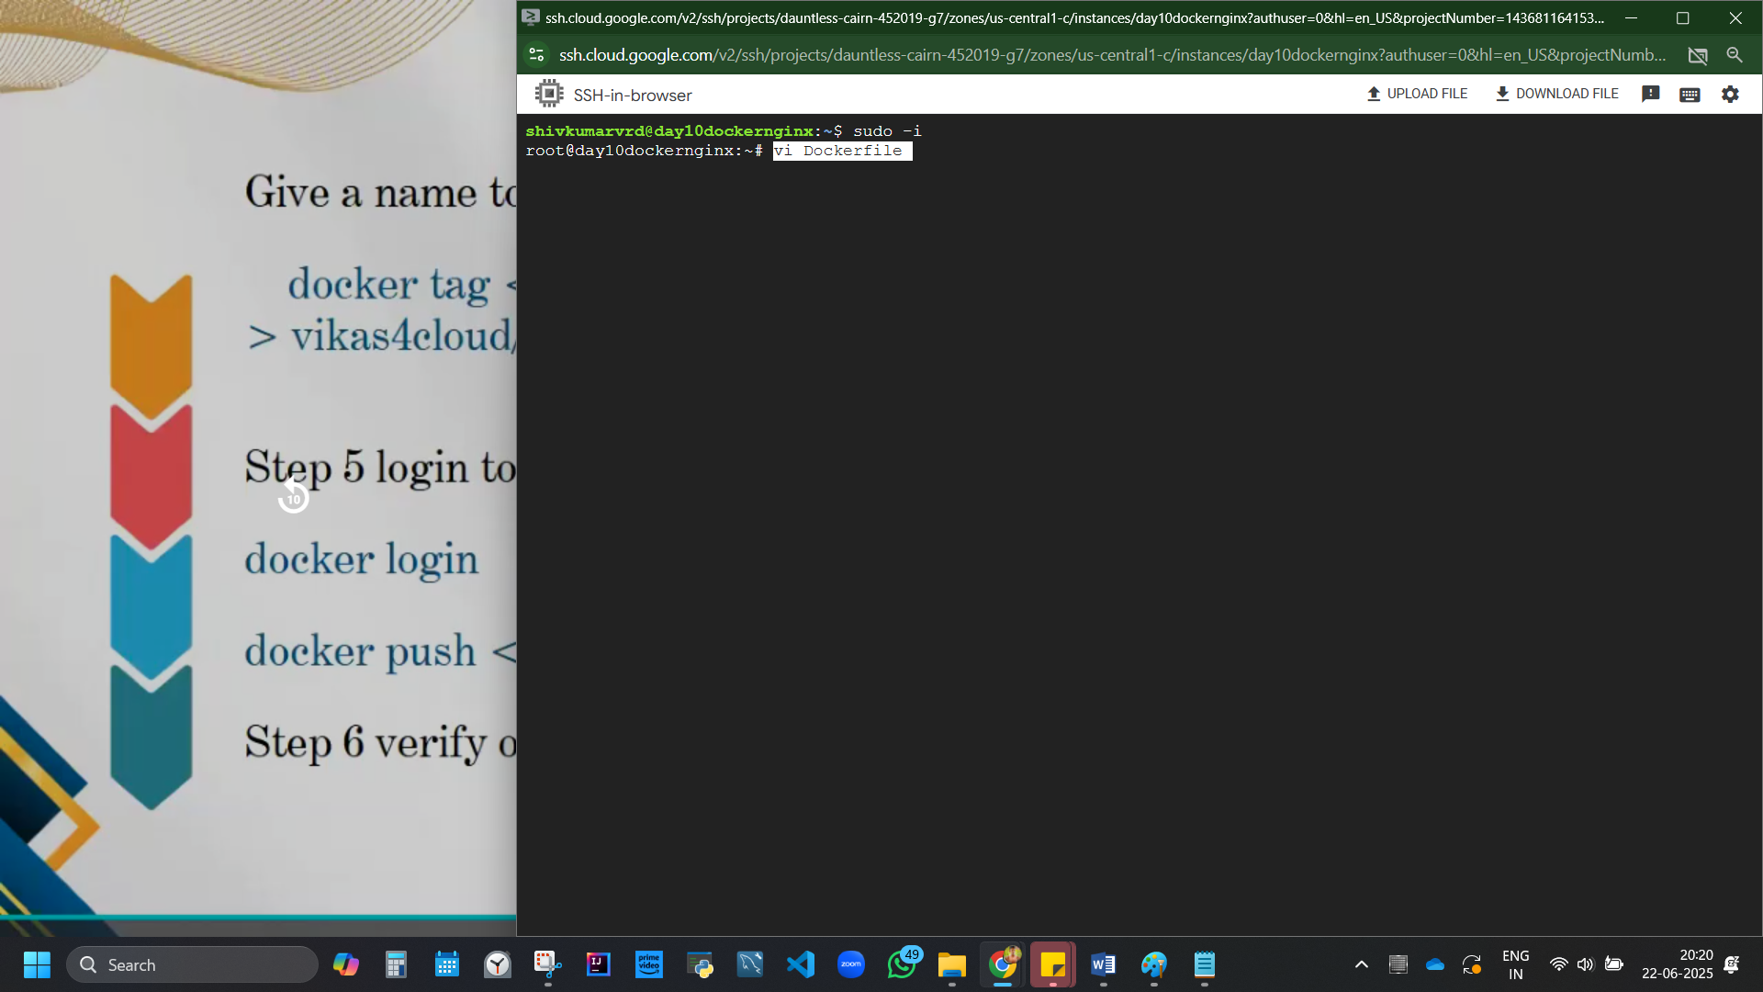

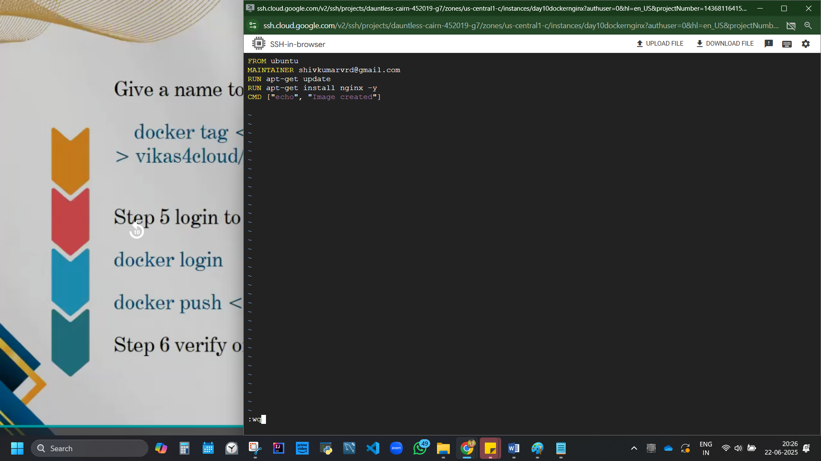

cat Dockerfile

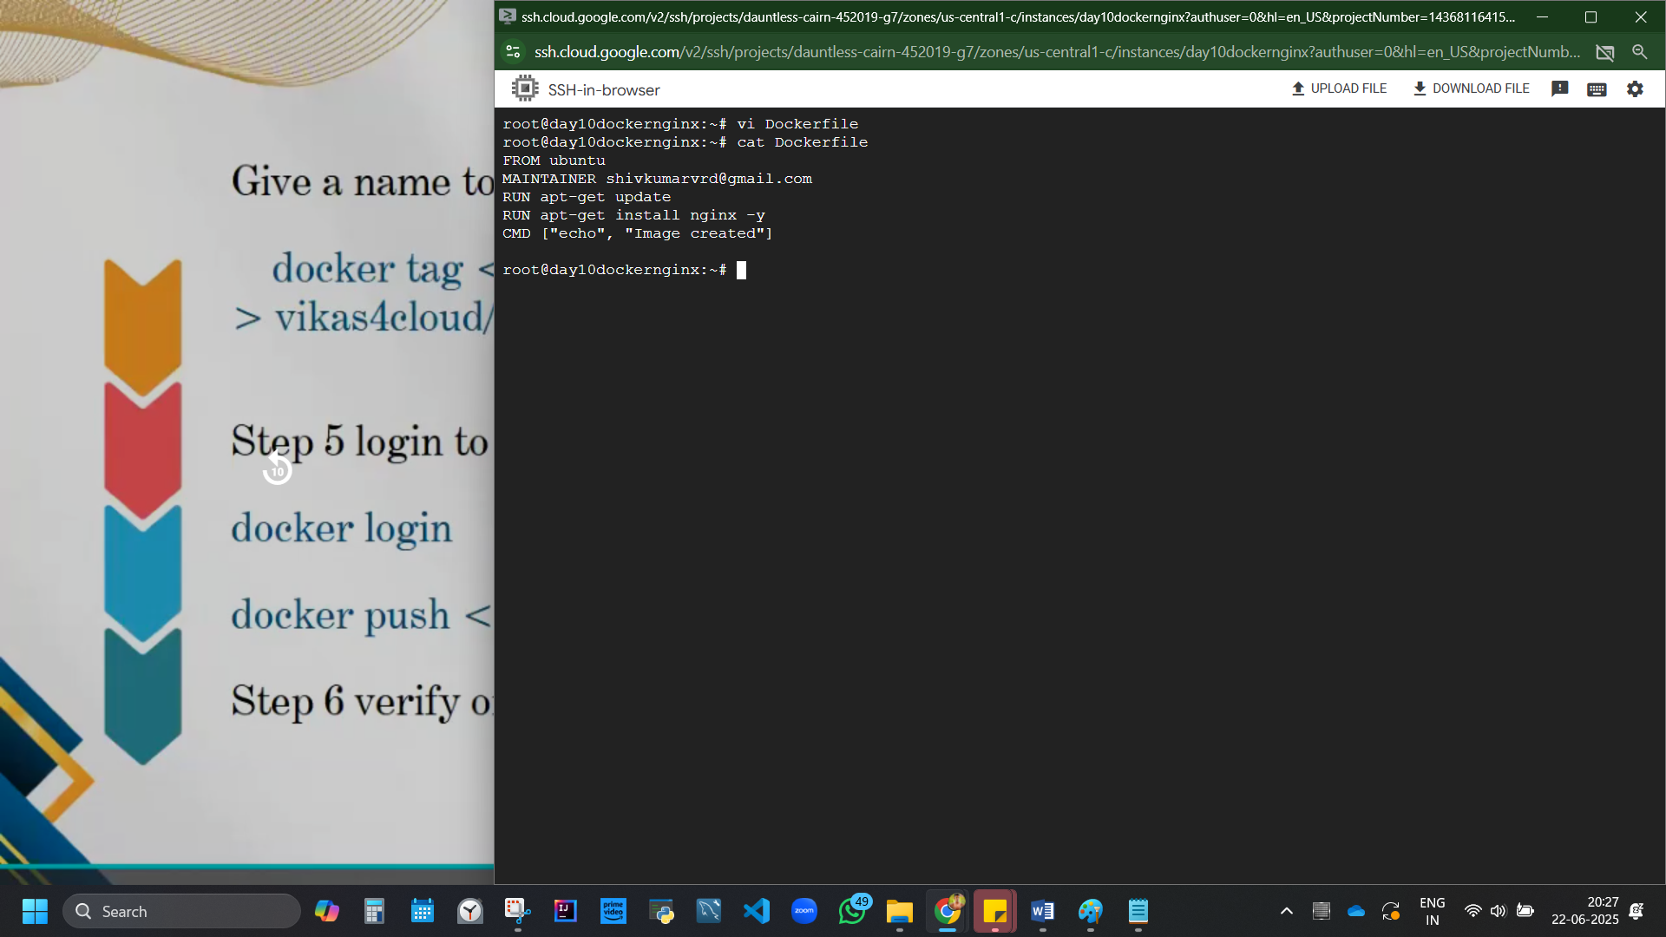

Figure 8 dockerfile created

### Now to create and build docker image

docker build -t shivfile .

The . (dot) indicates the current directory, which should contain the Dockerfile.

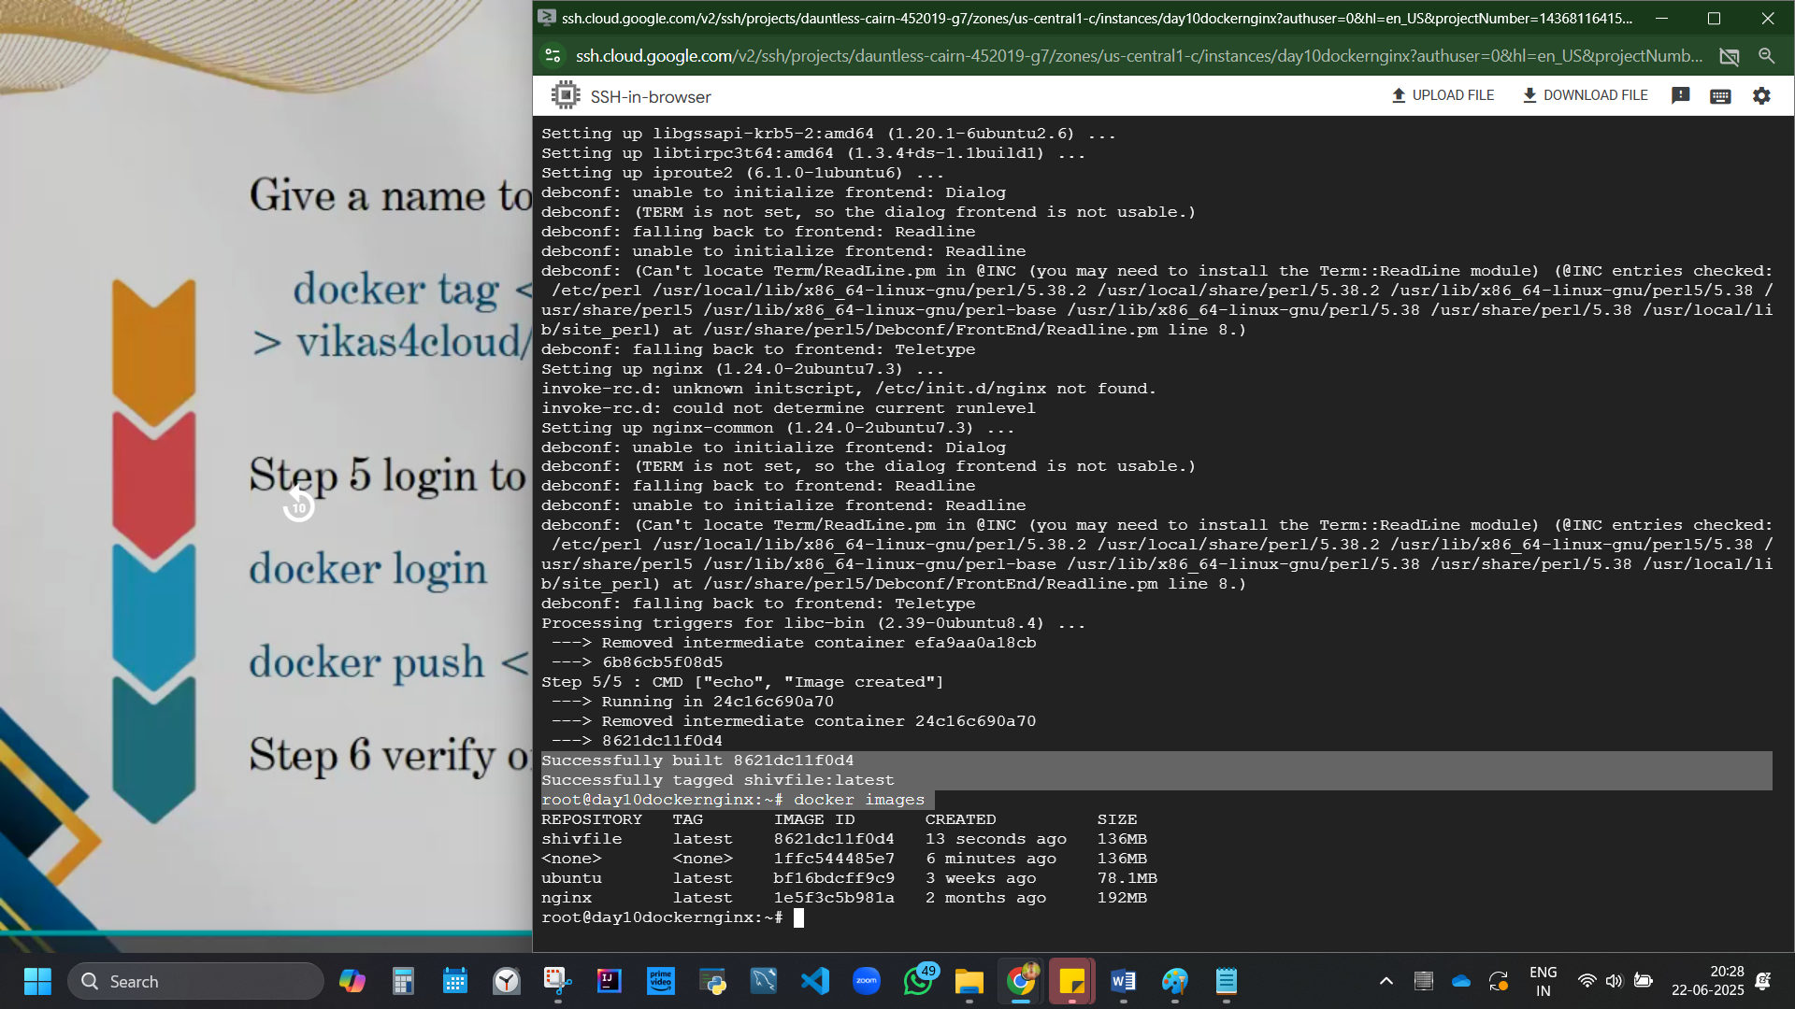

Figure 9 docker file is built. Image is created.

We downloaded ubuntu and shivfile. We have 3 images including, nginx. None cause dumb me coudnt get it at once so had to try multiple times

### docker login

docker login,

copy paste link in browser,

get code, from ssh, paste continue.

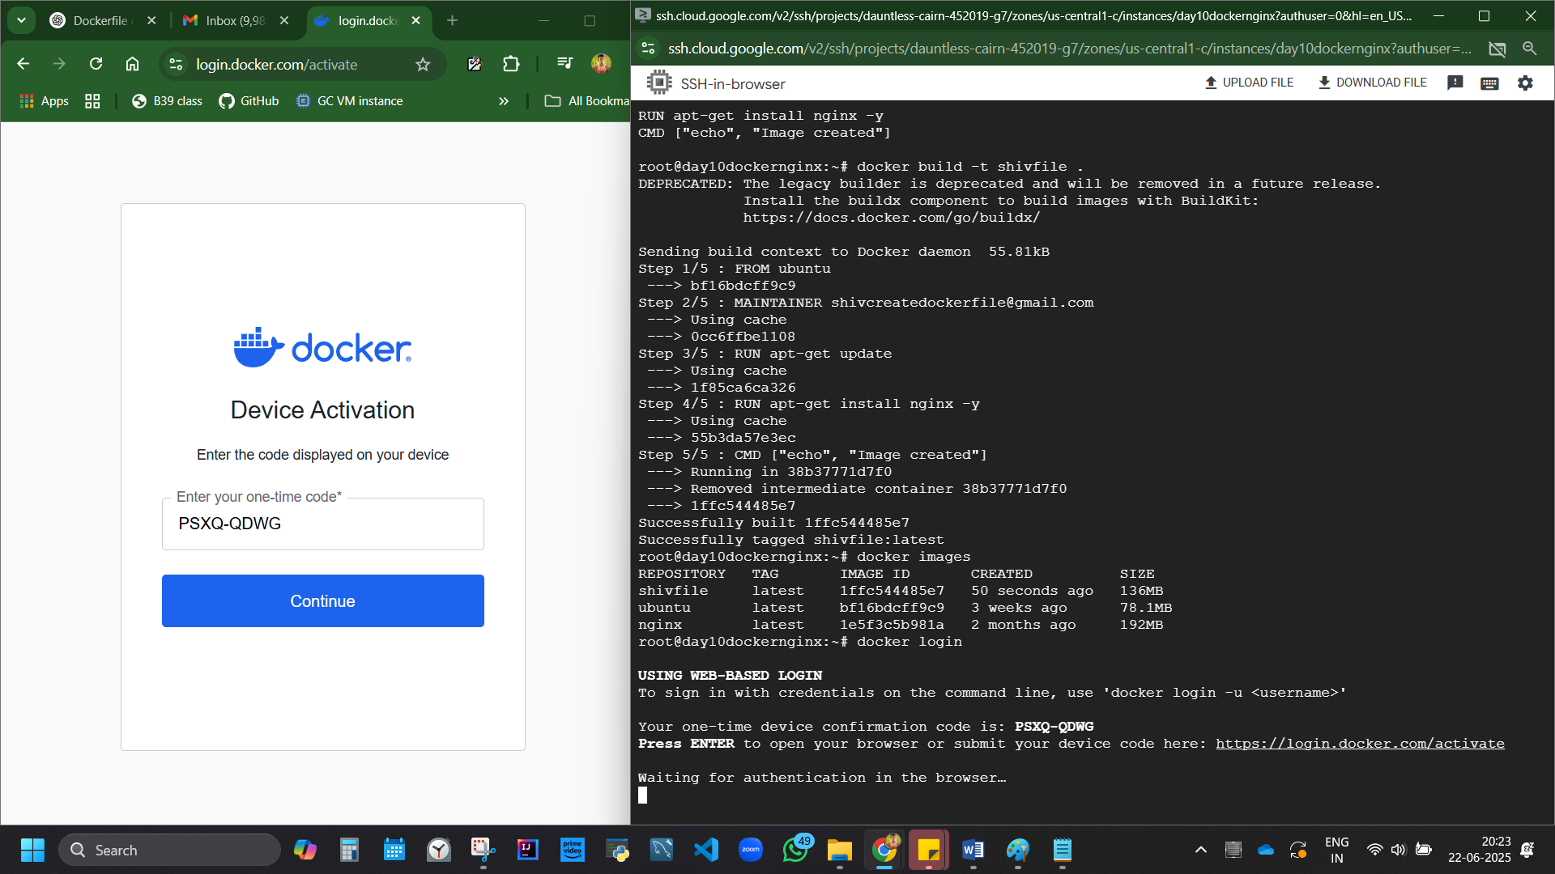

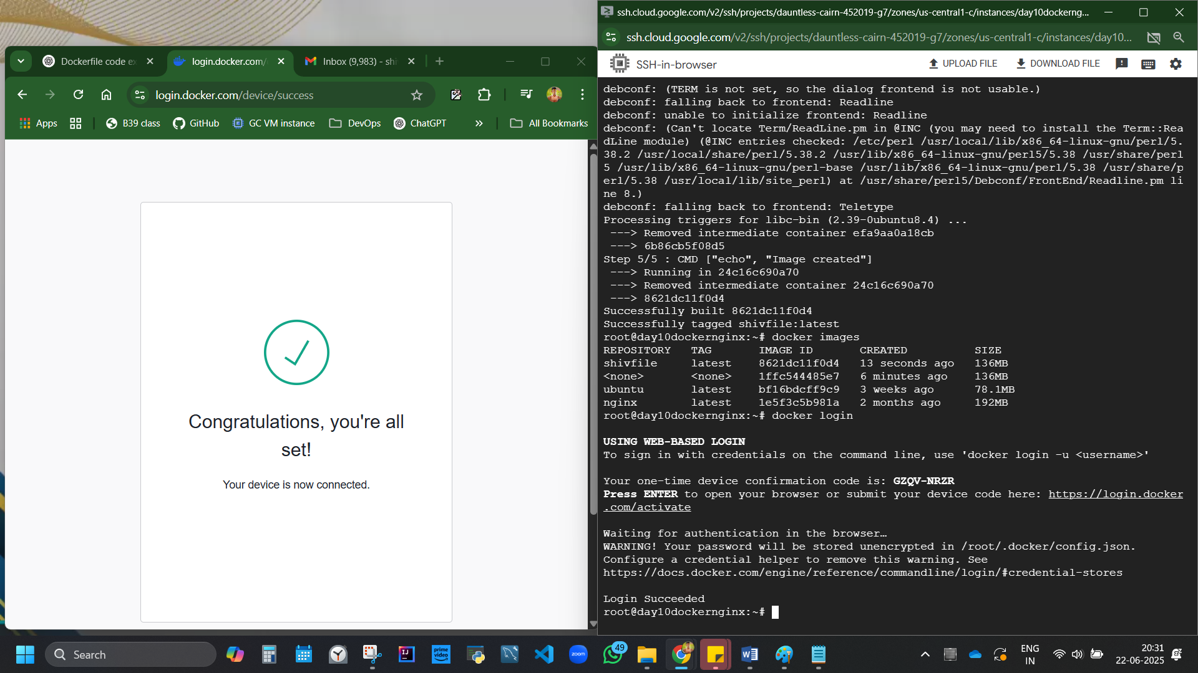

Figure 10 Finally logged in. had to login from gmail

## DOCKER PUSH

### Change/give a name to image

Check Username from docker hub Go to <https://hub.docker.com/repositories/shivk8431>

Code:

docker tag <image ID of our given repo name> <dockerhub username>/<repository image name>:latest

docker tag 8621dc11f0d4 shivk8431/shivfile:latest

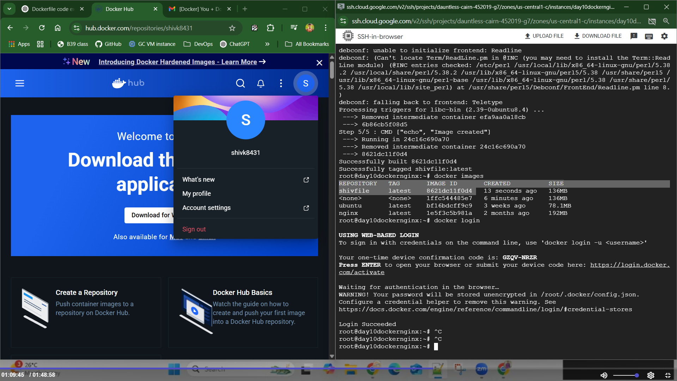

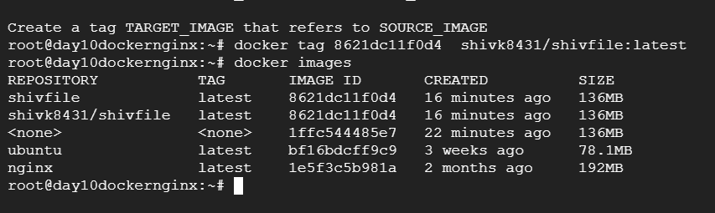

### Docker push

docker push <full repository name>

docker push shivk8431/shivfile

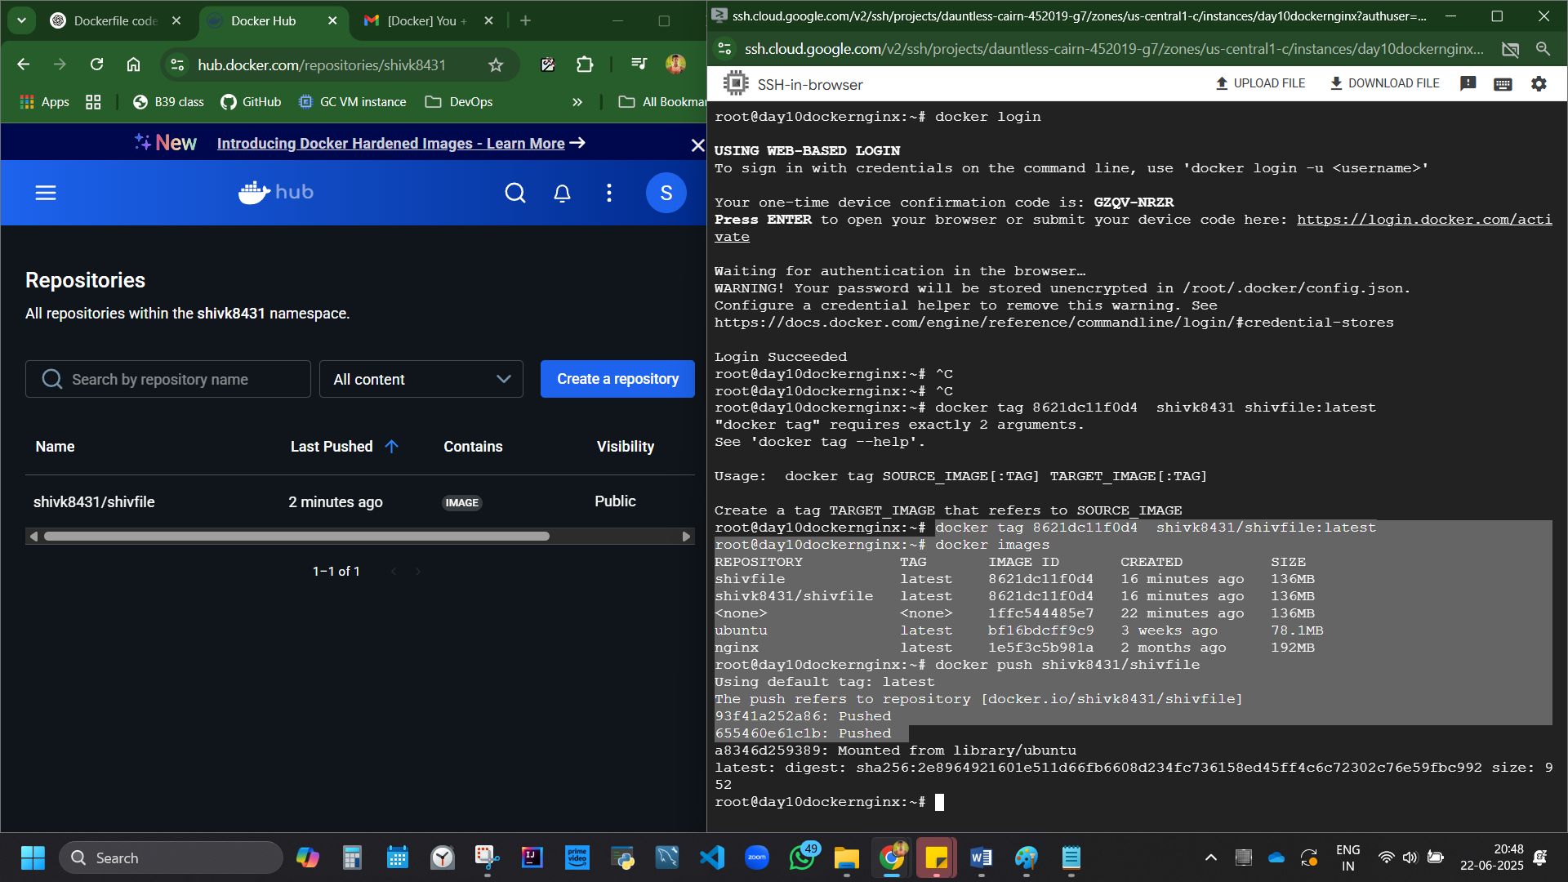

Figure 11 image pushed and docker hub repo updated.

## To Pull Docker

docker pull shivk8431/shivfile

<https://hub.docker.com/r/shivk8431/shivfile>

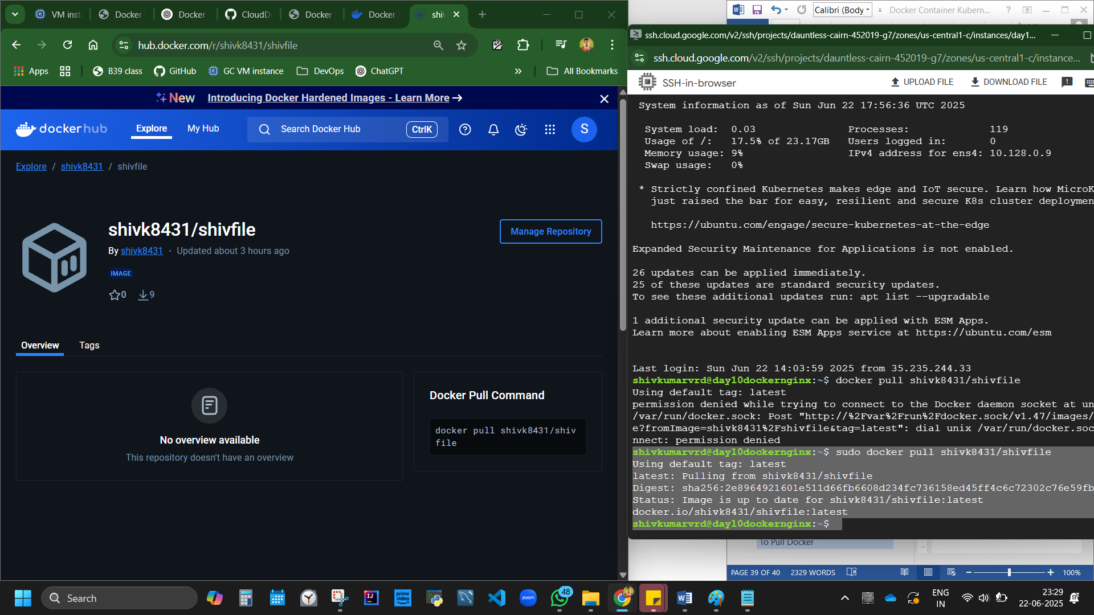

## More Docker codes (advanced level)

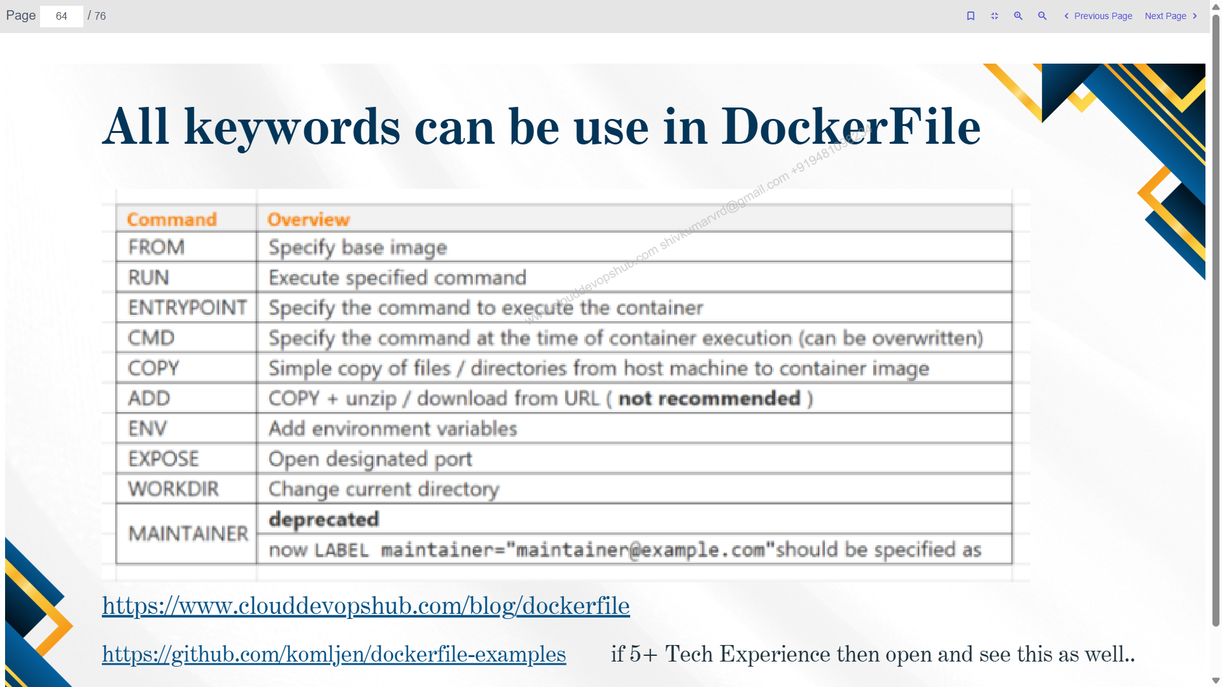

<https://www.clouddevopshub.com/blog/dockerfile>

<https://github.com/CloudDevOpsHub/Batch-39/blob/main/docker%20file%20day-3>

We created a container form image. Can we create an image from container?

Possible. From commit command.

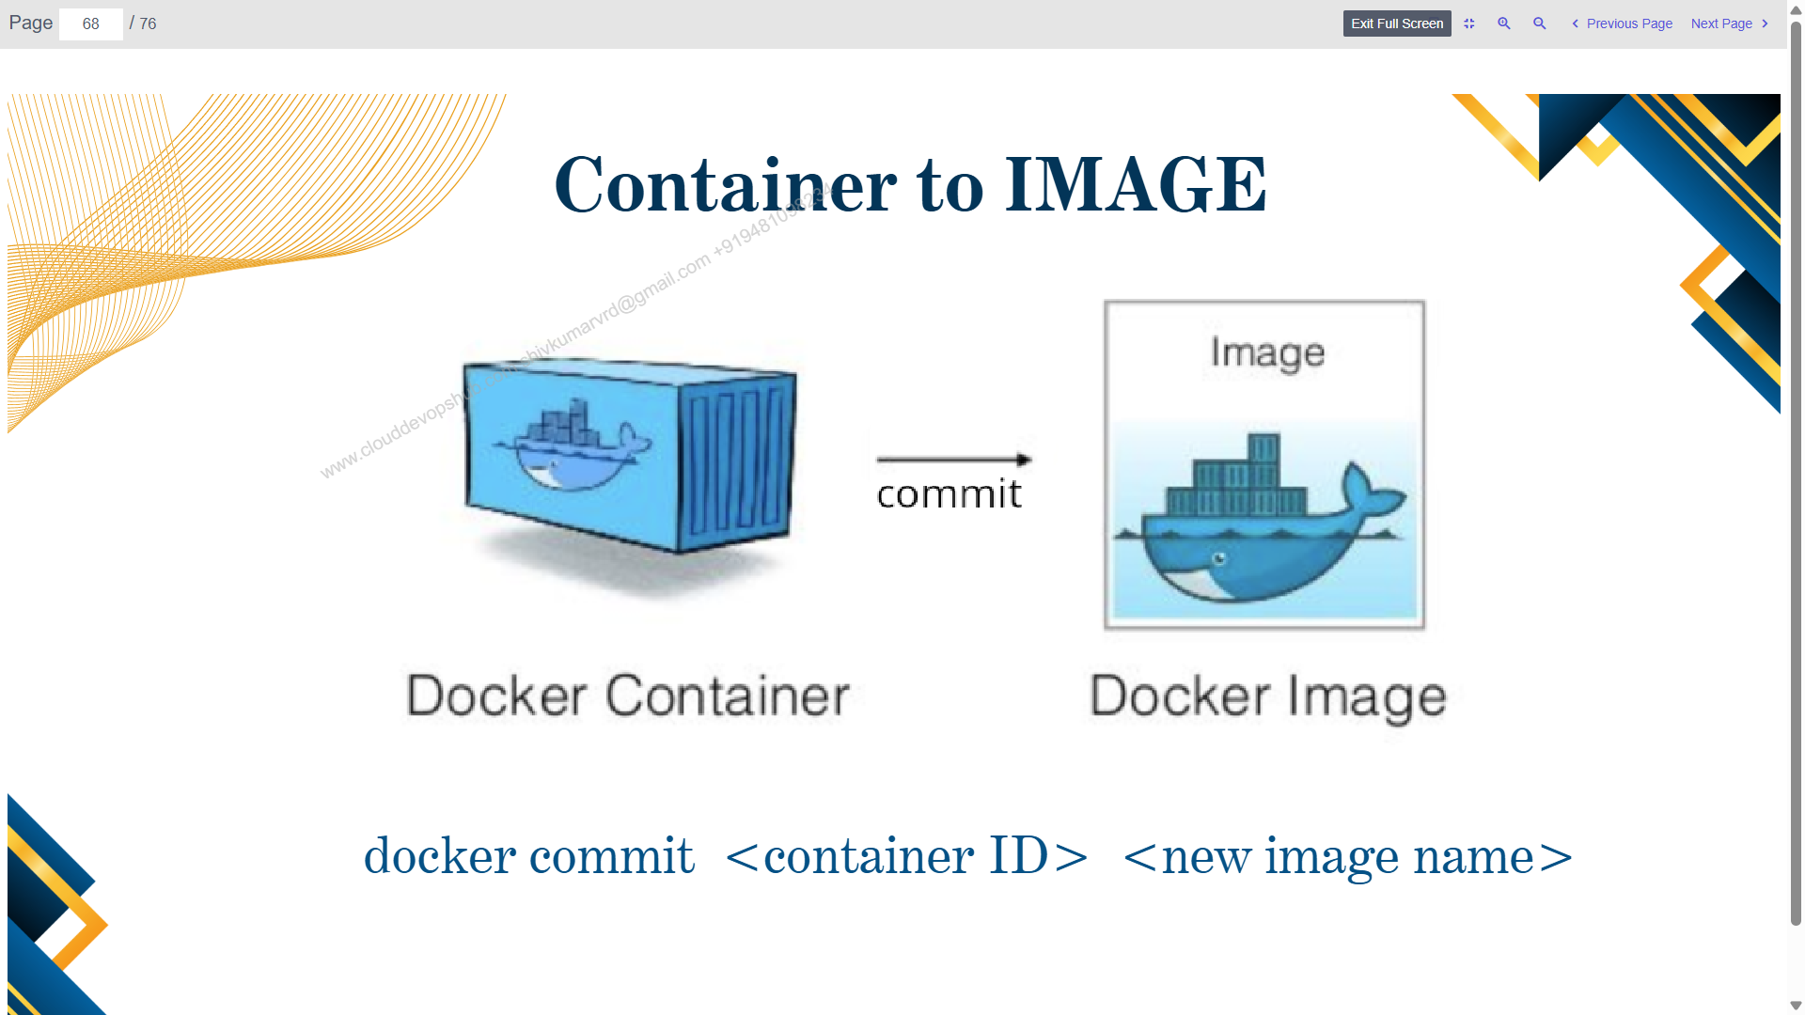

Create VM

sudo -i

apt-get update

apt install docker.io

docker run ubuntu

docker start <container id>

I have 1 container. Gotto create an image from it.

docker commit <container id> <new image name>

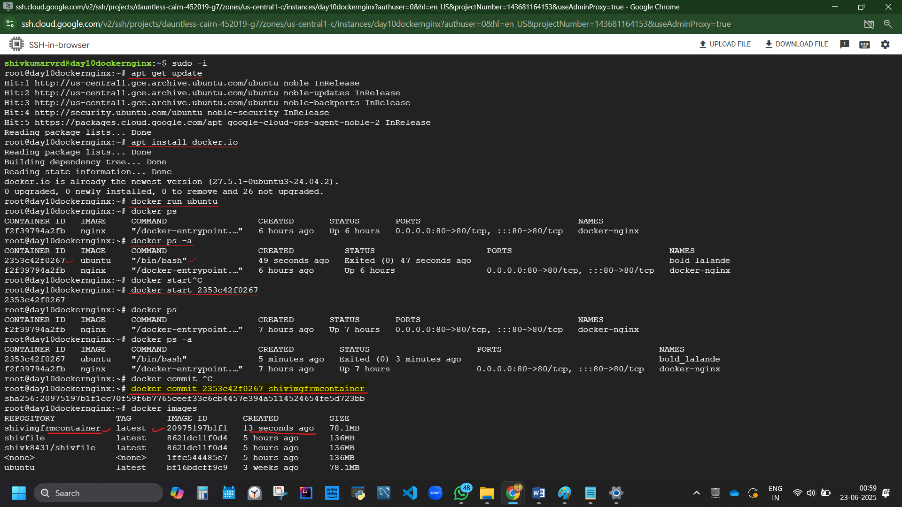

Used to take backup. When at final stage, if we want a backup of a container, we can create an image.

## Daily Operation activity of docker

### Save img using tar file.

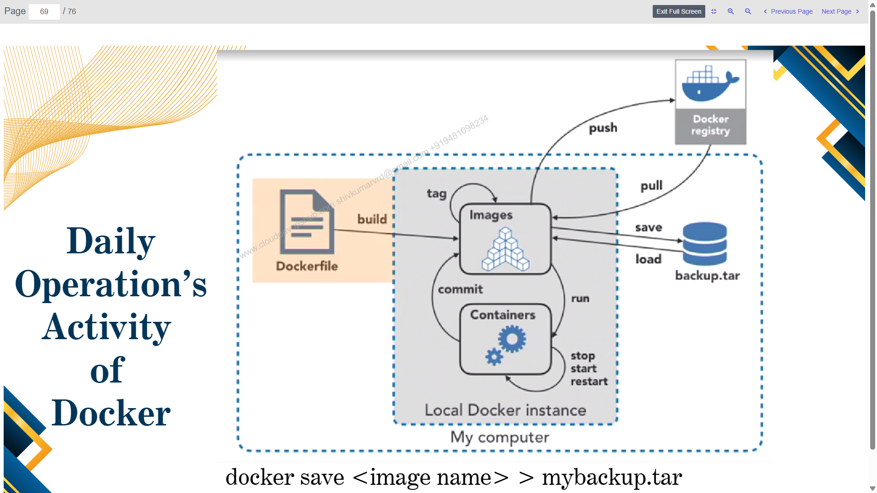

This is day to day activity of devops engg

Developer write docker file. with build cmd, img is created.

Created image, renamed with tagging.

Run cmd helps to create container from image file. Image can be start, stop and restarted.

Commit – gives image from container with new name.

Push – img goes to docker hub

Pull – img download from docker hub.

Backup.tar? to save images in backup.tar

docker save <img name> > mybackup.tar

docker save shivimgfrmcontainer > shivbackup.tar

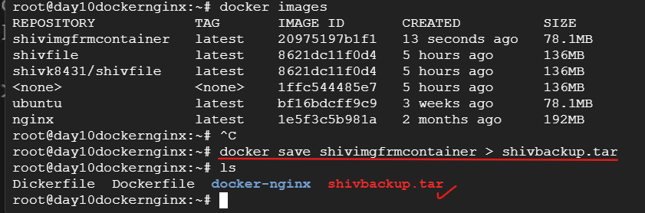

Restore?

docker load backupname.

### Docker workflow explained

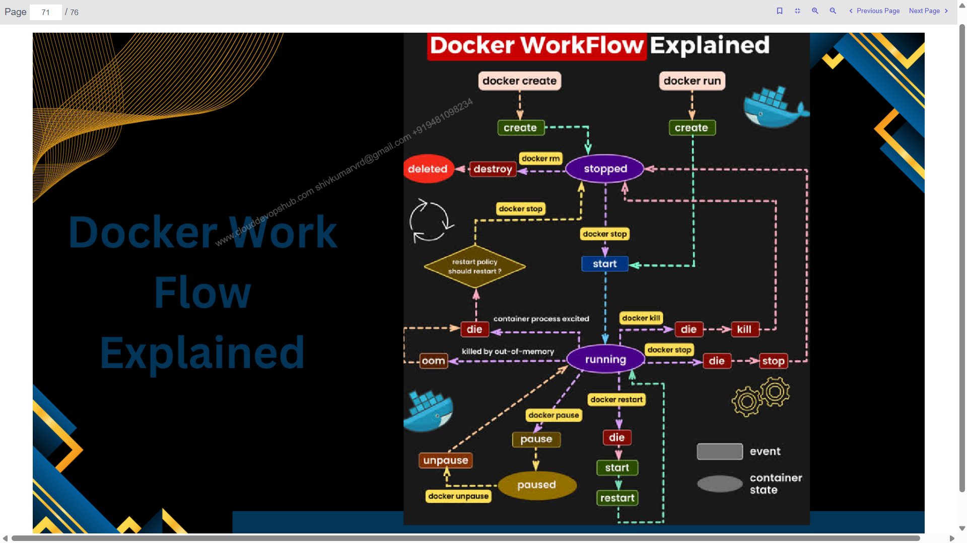

## Trouble shooting/Monitoring commands:

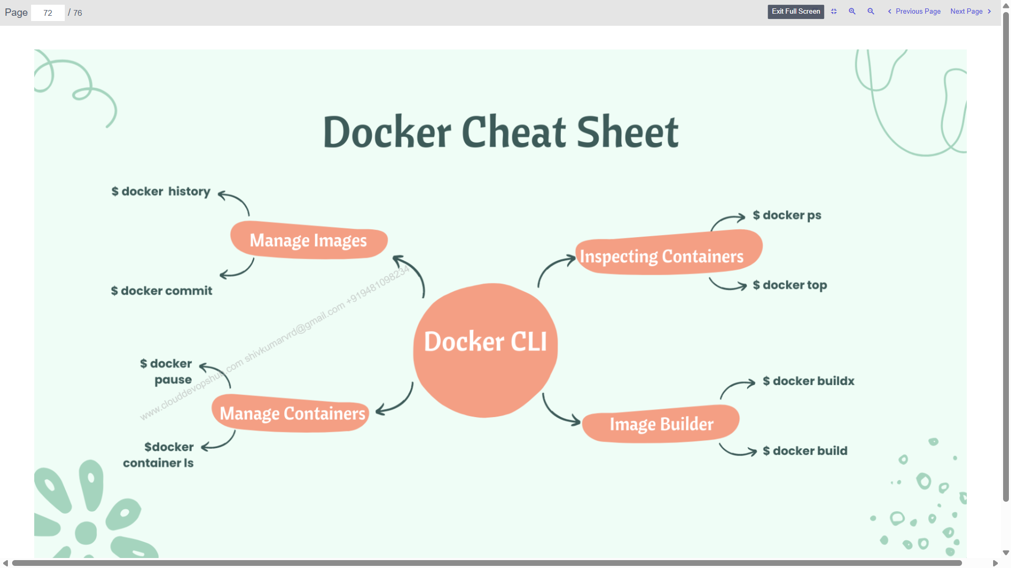

docker top <containerid> 🡪 we get internal IP. No option to purchase external IP in docker

docker inspect <containerid>

docker logs <container id>

docker stats <container id>

Cannot check logs of image

Container is a running applications. And application has logs. No sense in image log. Images are being build, and that can be logs of image.

docker exec -it <my container> sh or

docker exec -it <my container> bin/bash

apt update && apt install htop –y 🡪check external details

docker system df 🡪 checks disk utilisation

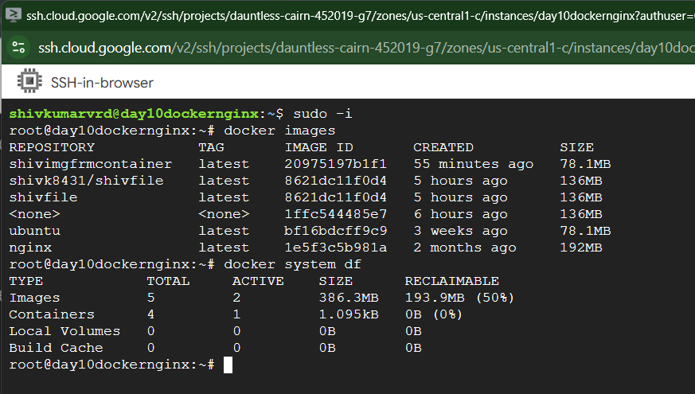

docker system prune – delete all containers. Not images.

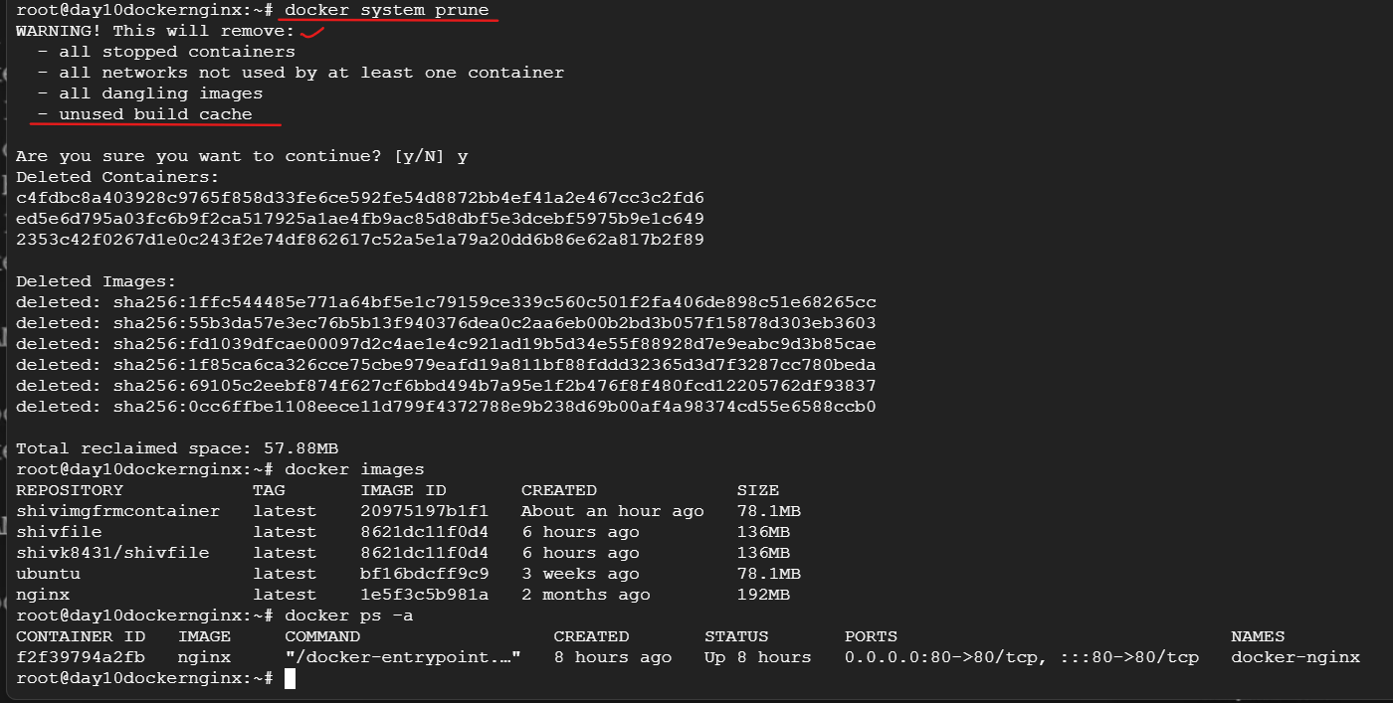

# KUBERNETES

Day 11

